Vibration diagnostic report 3502-2021
Project: BW Panther  IMO no: 9694464  Ordered by: BW Group | Date of measurement:  2021-09-09 | Place of measurement:  During normal operation

Measurement condition
Measurements were taken during normal operating condition.

Results presentation
Measured values are presented in the table below. Each machine if applicable is separated for driver (el. motor, diesel engine, etc.) and driven unit (pump, compressor, etc.). First column of the table consist name of the equipment. Second column contains the highest value of vibration velocity measured on the equipment in all measurement points. Third column contains classification of the vibration class according to proper ISO standard and other normative documents. Classification depends on highest reading of measured equipment only. Fourth column contains additional readings of enveloped value of acceleration, which is helpful in detection of early stage of bearing wear. Fifth column contains remarks and suggestions based on the analysis of vibration signal. This column can be taken as the final conclusion about machine condition. If cell is empty, it means that there is no existing problem or defect shown in vibration signal.

Vibration standards
Following standards may applied for assessment:
ISO 10816-3 | Mechanical vibration — Evaluation of machine vibration by measurements on non-rotating parts — Part 3: Industrial machines with nominal power above 15 kW and nominal speeds between 120 r/min and 15 000 r/min when measured in situ
ISO 20816-1 | Mechanical vibration — Measurement and evaluation of machine vibration — Part 1: General guidelines

Legend according to vibration class
Cl. A | Newly commissioned
Cl. B | Unrestricted
Cl. C | Restricted long-term operation
Cl. D | High probability of damage, action required
Cl. D | Vibrations over the limits but actions are not required.

Results
In table are presented only readings with max. RMS results for each device equipment:
Machine name | Velocity  RMS  (mm/s)  Max | ISO  standard | Bearing Envelope  0-Peak  (m/s2)  Max | Remarks and suggestions
Engine room
AE LO priming pumps
DG pre-lub pump no1 el. motor | 1,974 | Limit count error | -
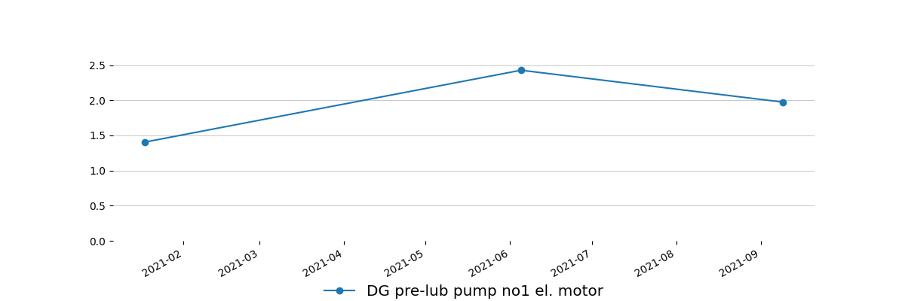

FO circulation pumps
FO circulation pump no1 el. motor | 7,393 | Limit count error | - | Trend should be controlled. Actions to be taken based on trend result.
FO circulation pump no1 | 2,444 | Limit count error | -
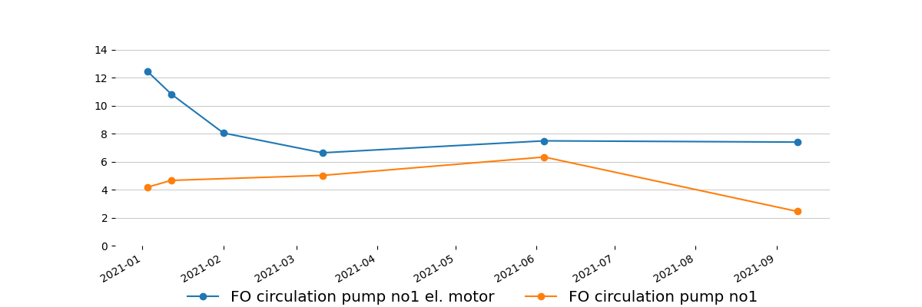

Steering gear hydraulic unit pumps
Steering gear hydraulic unit pump no1 el. motor | 2,366 | Limit count error | -
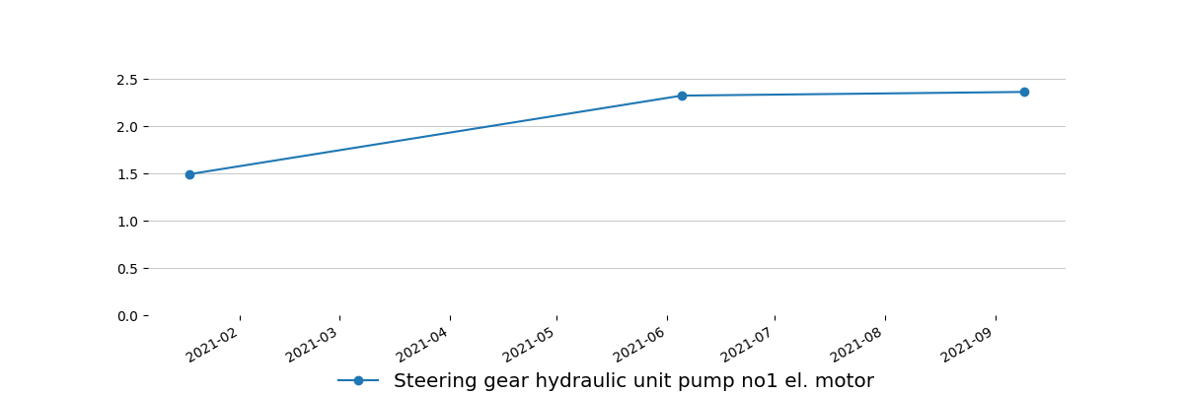

Steering gear hydraulic unit pump no2 el. motor | 2,516 | Limit count error | -
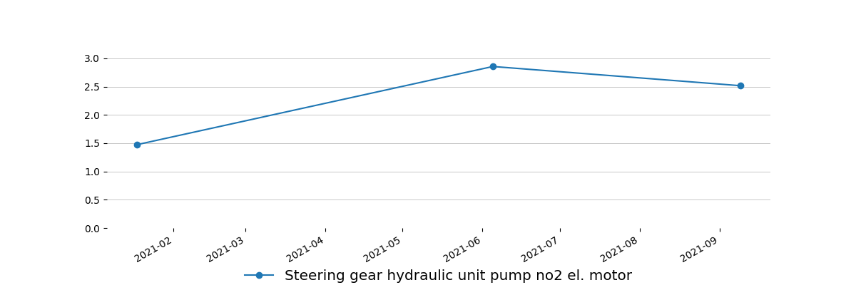

Measurement equipment:
Technical data
Maker: | Info Marine
Type: | MarVib DC750
Serial number: | 7506874
Measuring range: | 2Hz-30kHz / RPM = 60-20000
Indication error: | ± 0,5%
Equipment is calibrated, certificate for verification - if required.

Ship type:  Oil/Chemical Tanker | Main dimensions:  Length(b.p).......................................183,00 m  Breadth(B.)........................................32,00 m
Sea depth:
Least twice times greater than Vessel draught
Measurement method:
According to standard ISO 10816 : - procedure No. 2 Measurement report

Summary
Next measurements should be done in three month period to obtain trend value for each equipment, in some cases even one month period is preferable.
This report is prepared in good faith based on measurement diagnostic done on available running rotary machine and documentation submitted.

Prepared by: | Approved by:
Service Engineer | Tomasz Chuchra
Bogusław Steciak | mob: 0048 600052257

