Vibration diagnostic report 8047U-2026
Project: Hafnia Magellan  IMO no: 9725615  Ordered by: OSM Thome | Date of measurement:  2026-02-25 - 2026-02-26 | Place of measurement:  During normal operation

Measurement condition
Measurements were taken during normal operating condition.

Results presentation
Measured values are presented in the table below. Each machine if applicable is separated for driver (el. motor, diesel engine, etc.) and driven unit (pump, compressor, etc.). First column of the table consist name of the equipment. Second column contains the highest value of vibration velocity measured on the equipment in all measurement points. Third column contains classification of the vibration class according to proper ISO standard and other normative documents. Classification depends on highest reading of measured equipment only. Fourth column contains additional readings of enveloped value of acceleration, which is helpful in detection of early stage of bearing wear. Fifth column contains remarks and suggestions based on the analysis of vibration signal. This column can be taken as the final conclusion about machine condition. If cell is empty, it means that there is no existing problem or defect shown in vibration signal.

Vibration standards
Following standards may applied for assessment:
ISO 10816-7 | Mechanical vibration — Evaluation of machine vibration by measurements on non-rotating parts — Part 7: Rotodynamic pumps for industrial applications, including measurements on rotating shafts
ISO 14694 | Industrial fans - Specifications for balance quality and vibration levels
ISO 20816-1 | Mechanical vibration — Measurement and evaluation of machine vibration — Part 1: General guidelines
ISO 20816-3 | Mechanical vibration — Measurement and evaluation of machine vibration — Part 3: Industrial machinery with a power rating above 15 kW and operating speeds between 120 r/min and 30 000 r/min
ISO 8528-9 | Reciprocating internal combustion engine driven alternating current generating sets — Part 9: Measurement and evaluation of mechanical vibrations

Legend according to vibration class

Cl. A | Newly commissioned
Cl. B | Unrestricted
Cl. C | Restricted long-term operation
Cl. D | High probability of damage, action required
Cl. D | Vibrations over the limits but actions are not required.

V. I | Unrestricted
V. II | Restricted long-term operation
V. III | High probability of damage, action required
V. III | Vibrations over the limits but actions are not required.

In limit | Unrestricted
Out of limit | High probability of damage, action required
Out of limit | Vibrations over the limits but actions are not required.

Results
In table are presented only readings with max. RMS results for each device equipment:
Machine name | Velocity  RMS  (mm/s)  Max | ISO  standard | Bearing Envelope  0-Peak  (m/s2)  Max | Remarks and suggestions
DECK
Engine room fans
Engine room fan no3 el. motor | 1.715 | Cl. A | 21.442
-
-
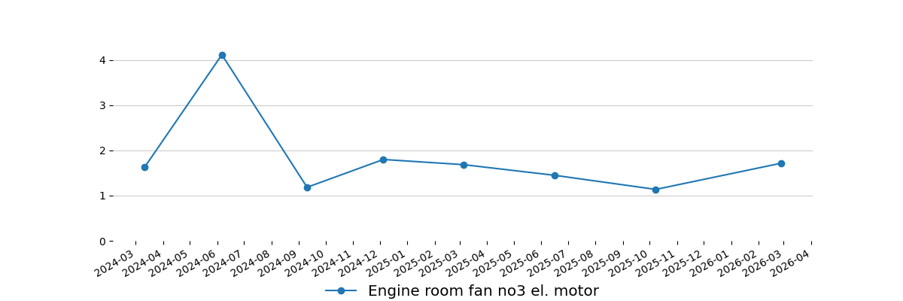
-
Engine room fan no4 el. motor | 1.908 | Cl. A | 18.996
-
-
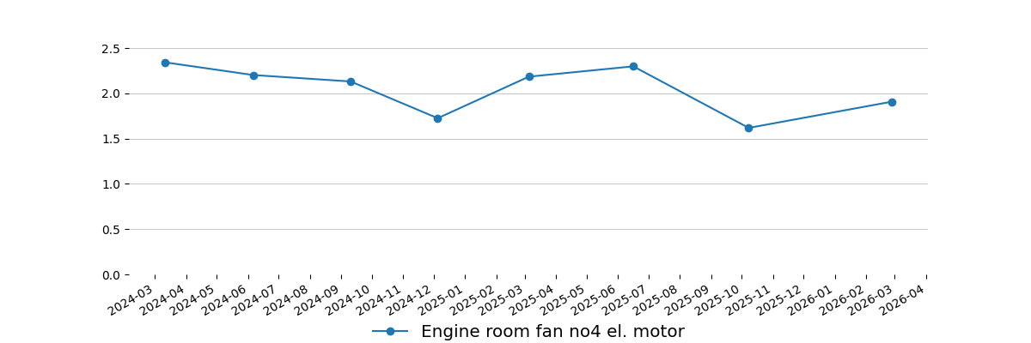
-
Purifier room exhaust fan
Purifier room exhaust fan el. motor | 0.937 | Cl. A | 9.408
-
-
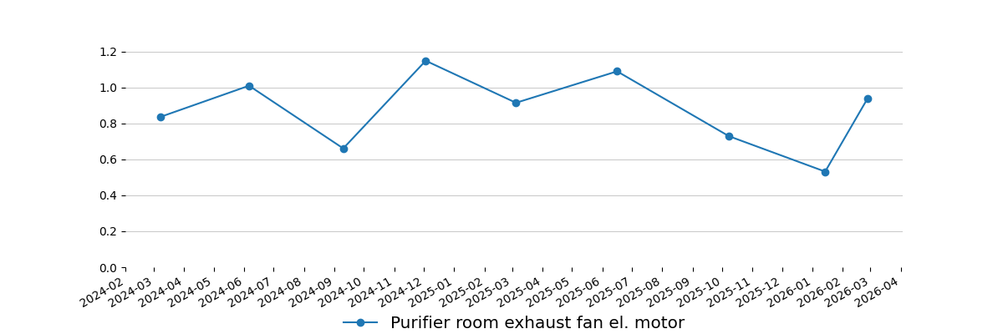
-
Galley supply fan
Galley supply fan el. motor | 1.814 | Cl. A | 21.692
-
-
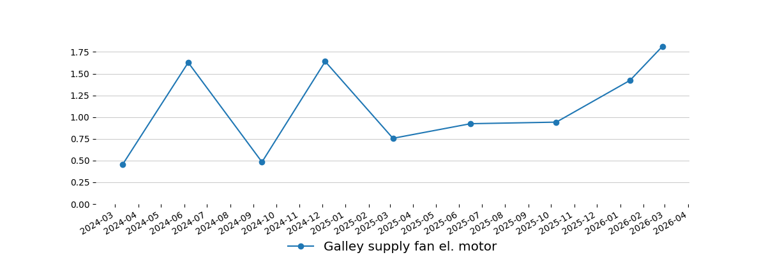
-
ENGINE ROOM
AE
Auxiliary Engine no1 | 4.560 | In limit | -
Auxiliary Engine no1 alternator | 12.358 | V. I | 89.684
-
-
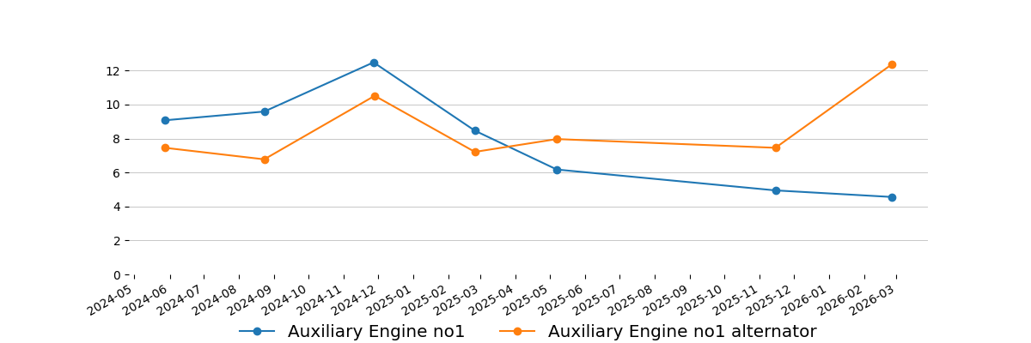
-
FO circulation pumps
FO circulation pump no2 el. motor | 3.903 | Cl. C | 222.368 | Envelope spectra show early signs of bearing's wear. Next measurement should be done up to week 11. Including pump. Please remember to always measure the whole set - el. motor and pump.
-
-
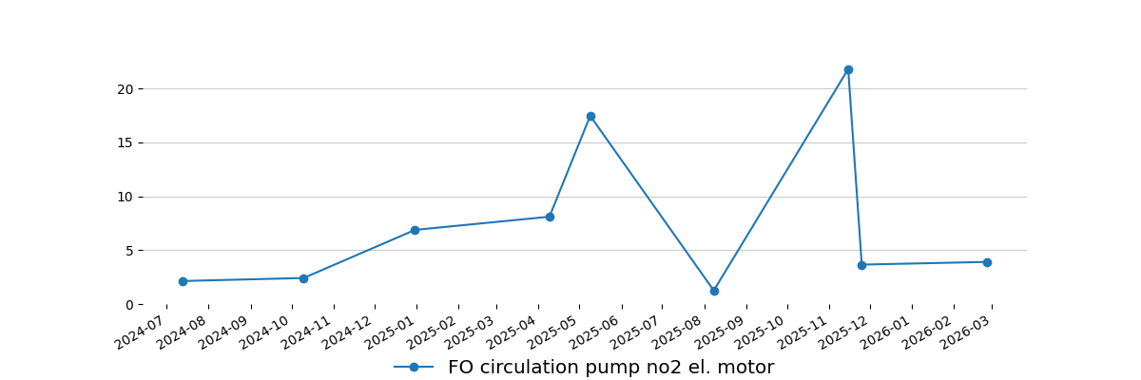
-
Purifiers supply pumps
LO purifier supply pump no1 el. motor | 3.806 | Cl. C | 8.854
LO purifier supply pump no1 | 1.537 | Cl. B | 14.354
-
-
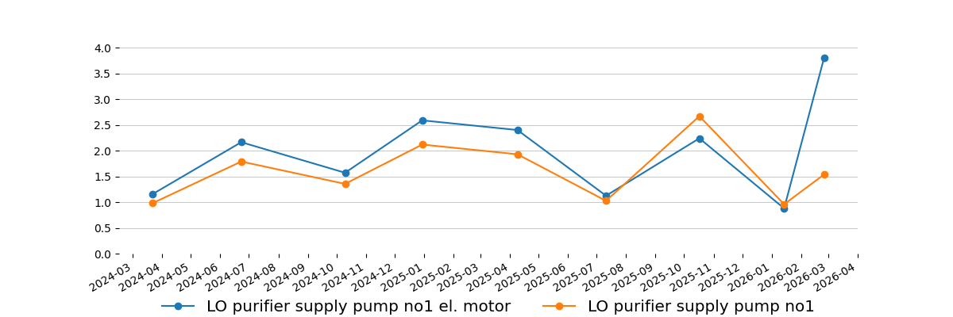
-
LO purifier supply pump no2 el. motor | 2.224 | Cl. B | 8.563
LO purifier supply pump no2 | 1.759 | Cl. B | 12.071
-
-
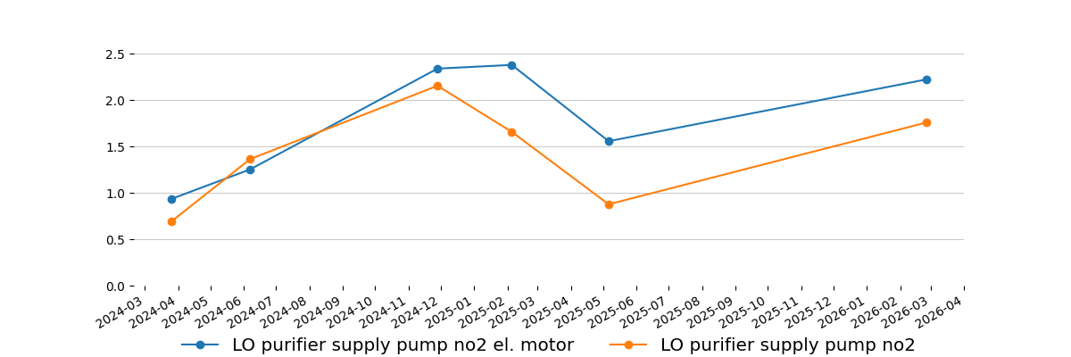
-
Composite boiler feed water pumps
Composite boiler feed water pump no1 el. motor | 2.360 | Cl. B | 24.954 | Suspicious bearing envelope signal, possible bearing frequencies. Next measurement should be done up to week 13. Including pump.
Composite boiler feed water pump no1 | 1.742 | Cl. A | 19.347
-
-
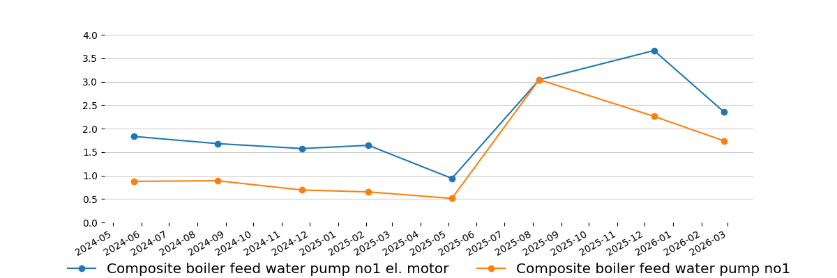
-
Composite boiler feed water pump no2 el. motor | 3.068 | Cl. C | 31.383 | Suspicious bearing envelope signal, possible bearing frequencies. Next measurement should be done up to week 13. Including pump.
Composite boiler feed water pump no2 | 2.465 | Cl. A | 15.374
-
-
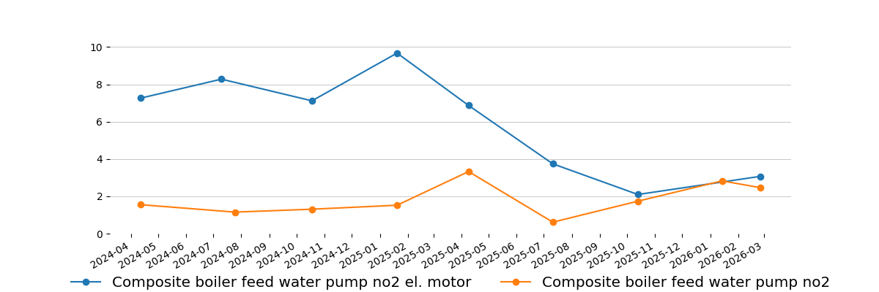
-
Cylinder oil shifting pump
Cylinder oil shifting pump el. motor | 3.169 | Cl. C | 78.918 | Increasing bearing envelope signal. Next measurement should be done up to week 13.
Cylinder oil shifting pump | 2.217 | Cl. B | 113.657 | Increasing bearing envelope signal. Next measurement should be done up to week 13.
-
-
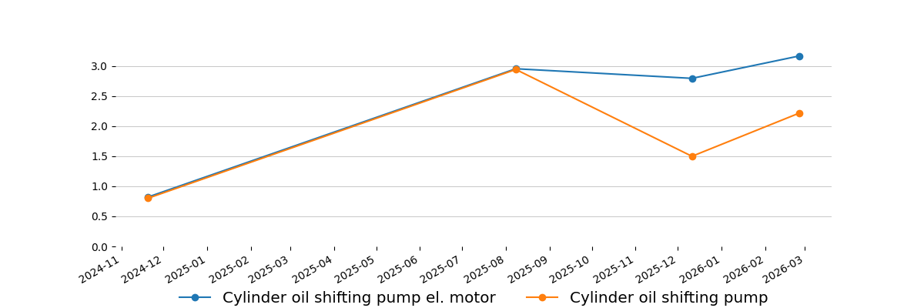
-
Stern tube LO pumps
Stern tube LO pump no1 el. motor | 0.736 | Cl. A | 6.502
Stern tube LO pump no1 | 0.444 | Cl. A | 7.565
-
-
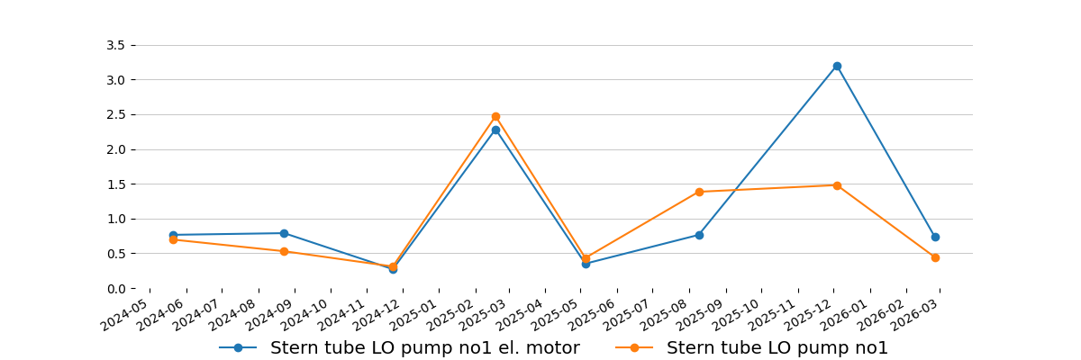
-
Stern tube LO pump no2 el. motor | 0.506 | Cl. A | 4.427
Stern tube LO pump no2 | 0.490 | Cl. A | 6.090
-
-
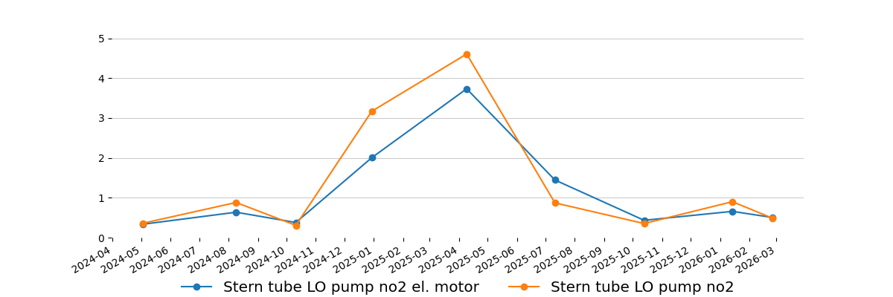
-
HT CFW pumps
HT cooling FW pump no1 el. motor | 1.508 | Cl. B | 8.369
HT cooling FW pump no1 | - | - | - | Measurement errors occurred. Next measurement should be repeated at the first possible opportunity. Including el. motor.
-
-
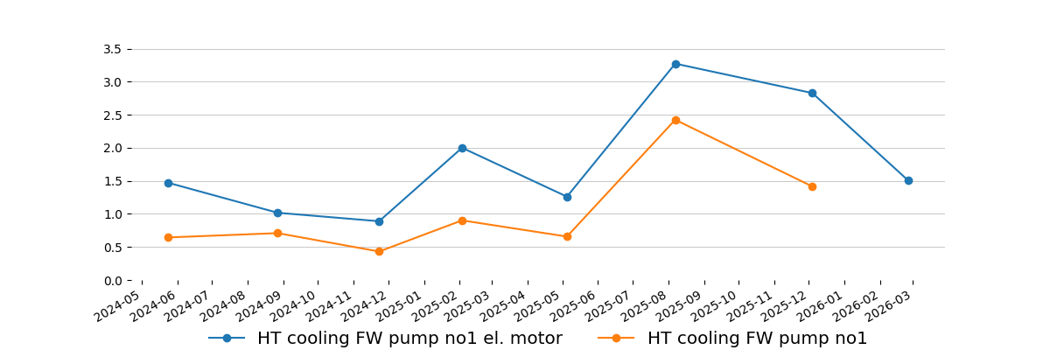
-
HT cooling FW pump no2 el. motor | 1.429 | Cl. B | 7.001
HT cooling FW pump no2 | 0.405 | Cl. A | 4.361
-
-
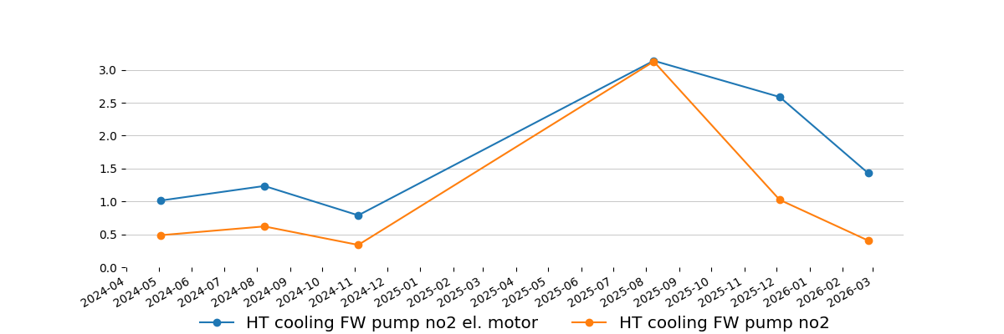
-
LT CFW pumps
LT cooling FW pump no3 el. motor | 3.100 | Cl. C | 6.829
LT cooling FW pump no3 | 1.059 | Cl. A | 16.781
-
-
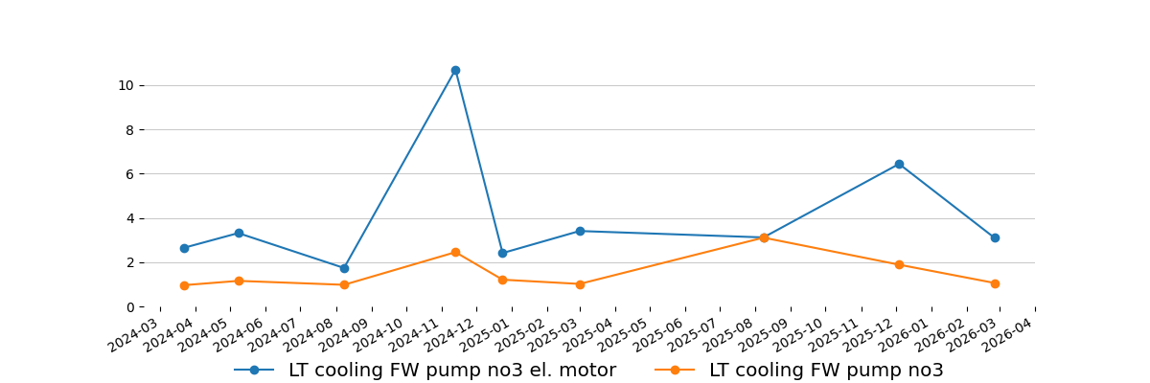
-
CSW pumps
Cooling sea water pump no1 el. motor | 4.345 | Cl. C | 66.482 | Increased bearing envelope signal. Next measurement should be done up to week 14. Including pump.
Cooling sea water pump no1 | 2.400 | Cl. A | 84.904
-
-
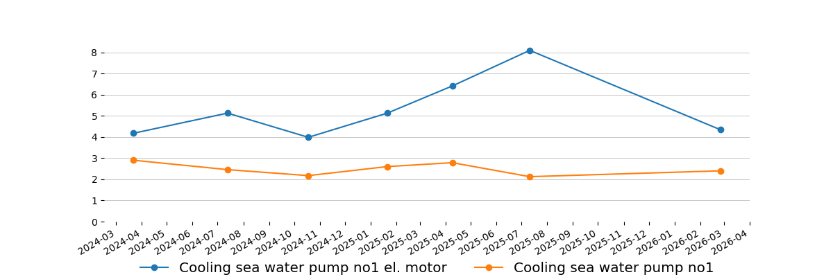
-
FW hydrophore pumps
FW hydrophore pump no1 el. motor | 1.245 | Cl. B | 87.469 | Possible signs of bearings wear. Next measurement should be done up to week 12. Including pump.
FW hydrophore pump no1 | 0.693 | Cl. A | 53.059
-
-
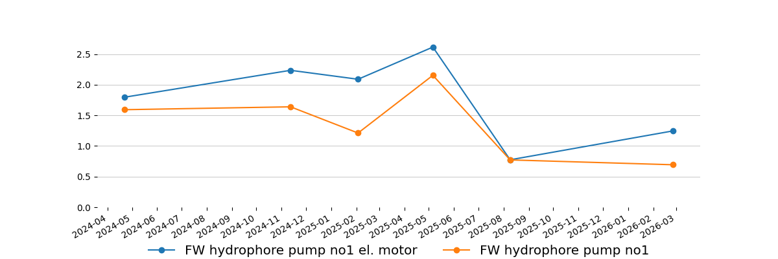
-
FW hydrophore pump no2 el. motor | 3.544 | Cl. C | 66.711
FW hydrophore pump no2 | 2.830 | Cl. A | 57.810
-
-
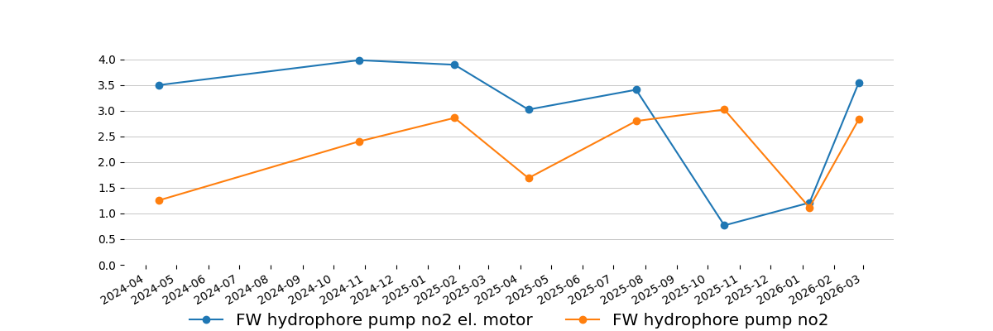
-
Work air compressor
Working air compressor el. motor | 3.721 | Cl. B | 46.354
Working air compressor | 5.210 | Cl. B | 155.111
-
-
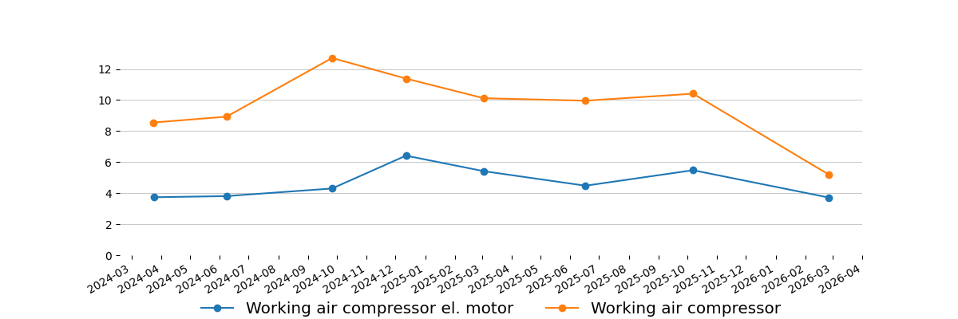
-
Deck seal water pumps
Deck water seal SW pump no2 el. motor | 3.679 | Cl. C | 37.050
Deck water seal SW pump no2 | 1.078 | Cl. A | 33.005
-
-
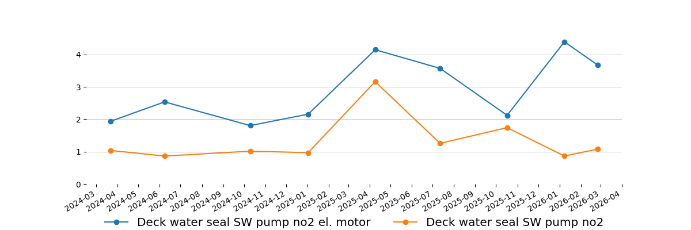
-
Fire GS pumps
Fire bilge GS pump no2 el. motor | 4.250 | Cl. C | 68.011
Fire bilge GS pump no2 | 3.330 | Cl. B | 69.118
-
-
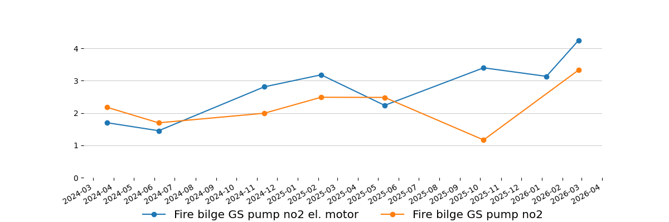
-

Measurement equipment:
Technical data
Maker:
Type: | [
Serial number: | "
Measuring range: | "
Indication error: | ,
Equipment is calibrated, certificate for verification - if required.

Ship type:  Chemical/Oil Products Tanker | Main dimensions:  Length(b.p).......................................184,00 m  Breadth(B.)........................................28,00 m
Sea depth:
Least twice times greater than Vessel draught
Measurement method:
According to standard ISO 10816 : - procedure No. 2 Measurement report

Summary
Next measurements should be done in three month period to obtain trend value for each equipment, in some cases even one month period is preferable.
This report is prepared in good faith based on measurement diagnostic done on available running rotary machine and documentation submitted.

Prepared by: | Approved by:
Service Engineer | Tomasz Chuchra
Eliza Nieradko | mob: 0048 600052257

