TICKET – IDEAS

Spis treści
1 Quick, auto closing of Places & Groups 3

Poprawki
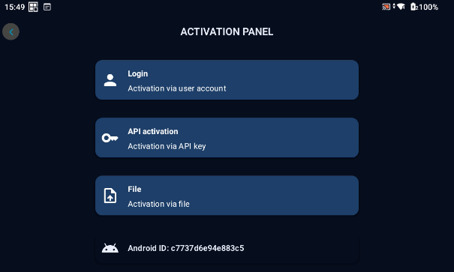
- Login Activation
- API Activation
- Files Activation

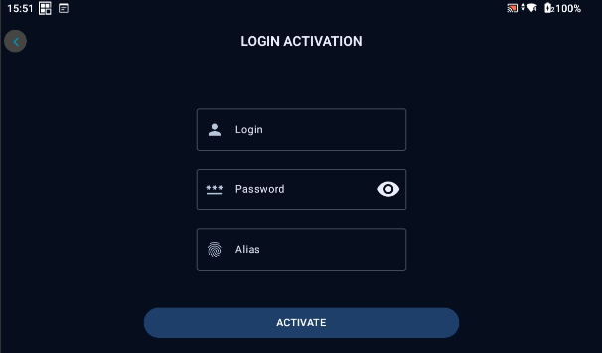
- Alias – Location Name (Symbol statku/Symboli budynku)

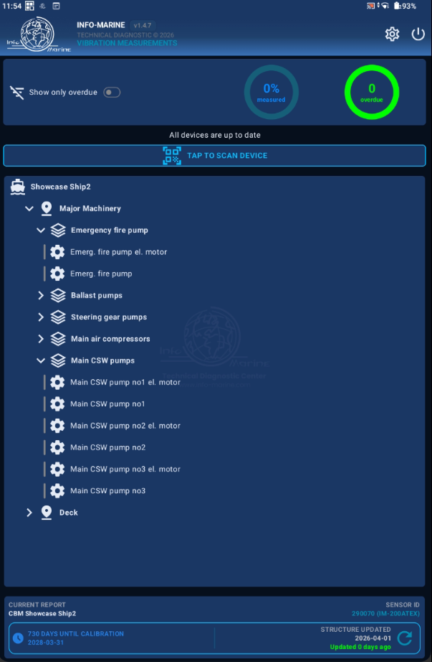
- SHOW ONLY OVERDUE
- MEASURED
- OVERDUE

- UPDATE „” DAYS AGO

