Vibration diagnostic report 4951U-2023
Project: BW Wren  IMO no: 9713856  Ordered by: BW Group | Date of measurement:  2023-03-29 - 2023-03-31 | Place of measurement:  During normal operation

Measurement condition
Measurements were taken during normal operating condition.

Results presentation
Measured values are presented in the table below. Each machine if applicable is separated for driver (el. motor, diesel engine, etc.) and driven unit (pump, compressor, etc.). First column of the table consist name of the equipment. Second column contains the highest value of vibration velocity measured on the equipment in all measurement points. Third column contains classification of the vibration class according to proper ISO standard and other normative documents. Classification depends on highest reading of measured equipment only. Fourth column contains additional readings of enveloped value of acceleration, which is helpful in detection of early stage of bearing wear. Fifth column contains remarks and suggestions based on the analysis of vibration signal. This column can be taken as the final conclusion about machine condition. If cell is empty, it means that there is no existing problem or defect shown in vibration signal.

Vibration standards
Following standards may applied for assessment:
ISO 10816-3 | Mechanical vibration — Evaluation of machine vibration by measurements on non-rotating parts — Part 3: Industrial machines with nominal power above 15 kW and nominal speeds between 120 r/min and 15 000 r/min when measured in situ
ISO 10816-7 | Mechanical vibration — Evaluation of machine vibration by measurements on non-rotating parts — Part 7: Rotodynamic pumps for industrial applications, including measurements on rotating shafts
ISO 14694 | Industrial fans - Specifications for balance quality and vibration levels
ISO 20816-1 | Mechanical vibration — Measurement and evaluation of machine vibration — Part 1: General guidelines
ISO 8528-9 | Reciprocating internal combustion engine driven alternating current generating sets — Part 9: Measurement and evaluation of mechanical vibrations
SAUER | Vibration of compressors CB 05-13
WESTFALIA | Westfalia separator mineraloil systems manual

Legend according to vibration class

Cl. A | Newly commissioned
Cl. B | Unrestricted
Cl. C | Restricted long-term operation
Cl. D | High probability of damage, action required
Cl. D | Vibrations over the limits but actions are not required.

V. I | Unrestricted
V. II | Restricted long-term operation
V. III | High probability of damage, action required
V. III | Vibrations over the limits but actions are not required.

In limit | Unrestricted
Out of limit | High probability of damage, action required
Out of limit | Vibrations over the limits but actions are not required.

Results
In table are presented only readings with max. RMS results for each device equipment:
Important machinery with Class D and machinery with action required.
Machine name | Velocity  RMS  (mm/s)  Max | ISO  standard | Bearing Envelope  0-Peak  (m/s2)  Max | Remarks and suggestions
ENGINE ROOM
ME HPS pumps
ME HPS pump no1 el. motor | 8.635 | Cl. D | 52.247 | High signal comes from flow pulsation. Trend should be controlled. Actions to be taken based on trend result. Next measurement needs to be done up to week 19.
-
-
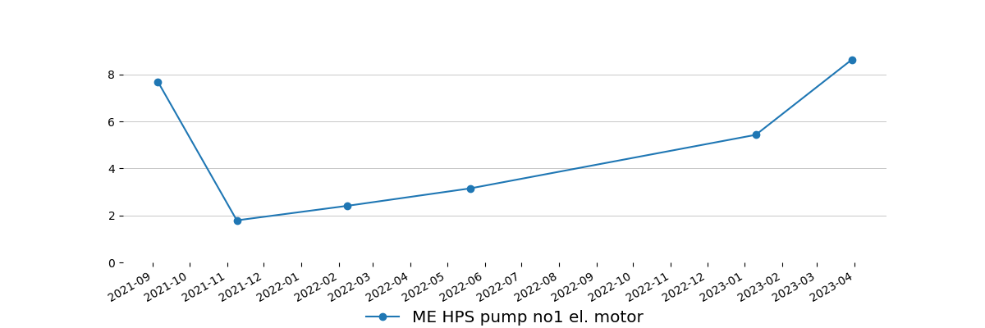
-
Main CSW pumps
Main CSW pump no1 el. motor | 8.015 | Cl. D | 1.583 | High signal comes from environment. Trend should be controlled. Actions to be taken based on trend result.
Main CSW pump no1 | 4.582 | Cl. B | 1.583
-
-
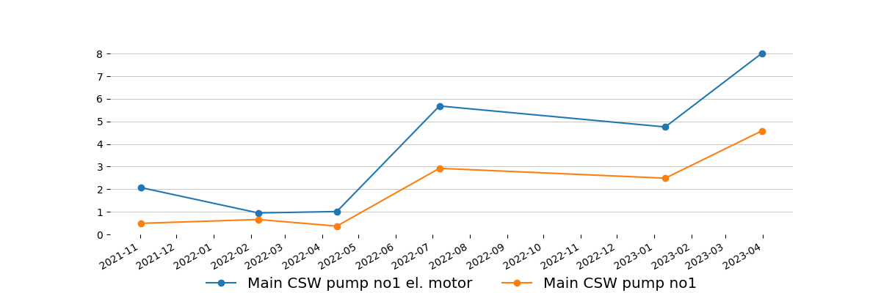
-
FWG ejector pump
FW generator ejector pump el. motor | 4.537 | Cl. D | 3.903 | High signal only in one point comes from environment. Trend should be controlled. Actions to be taken based on trend result.
FW generator ejector pump | 2.694 | Cl. A | 6.112
-
-
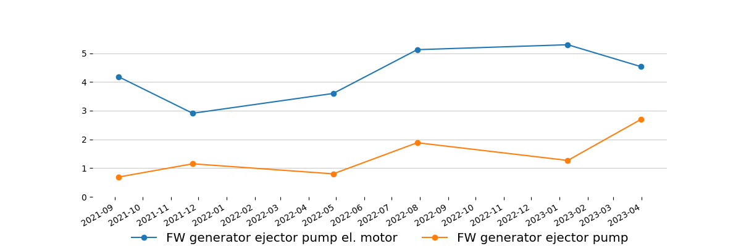
-
Separators
LO purifier no1 el. motor | 3.491 | Cl. C | 25.627
LO purifier no1 | 6.827 | Cl. D | - | Trend should be controlled. Actions to be taken based on trend result.
-
-
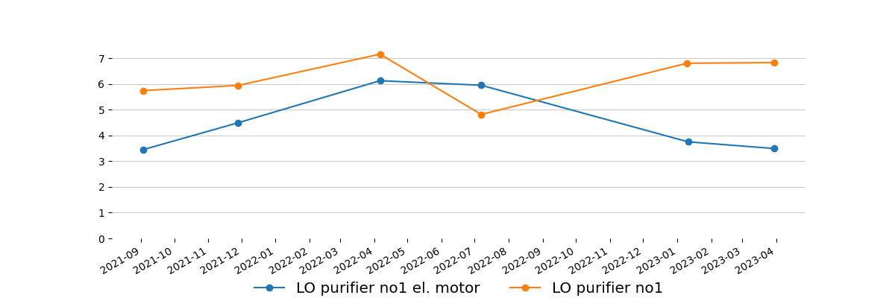
-
Important machinery below Class D and rest of machinery with no action required.
Auxiliary Engines
Auxiliary engine no2 engine | 10.365 | In limit | -
Auxiliary engine no2 alternator | 21.225 | V. II | -
-
-
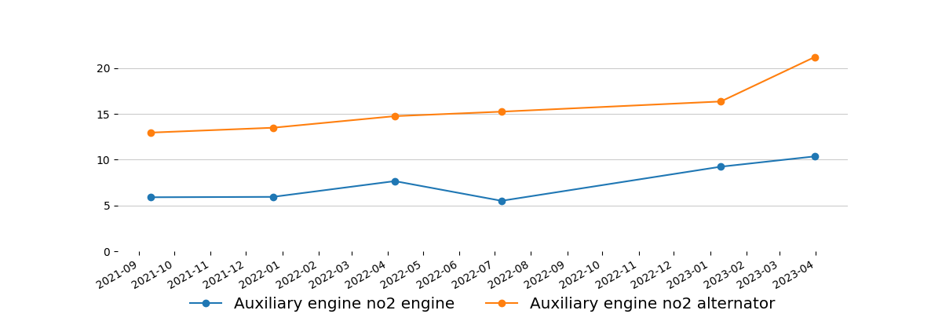
-
AE LO priming pumps
AE LO priming pump no1 el. motor | 3.774 | Cl. C | 34.537 | Vibration reduced from last reading. Please advise if any maintenance was carried out since 05.03.2023 or the working parameters are different.
AE LO priming pump no1 | 4.453 | Cl. C | 37.667 | Vibration reduced from last reading. Please advise if any maintenance was carried out since 05.03.2023 or the working parameters are different.
-
-
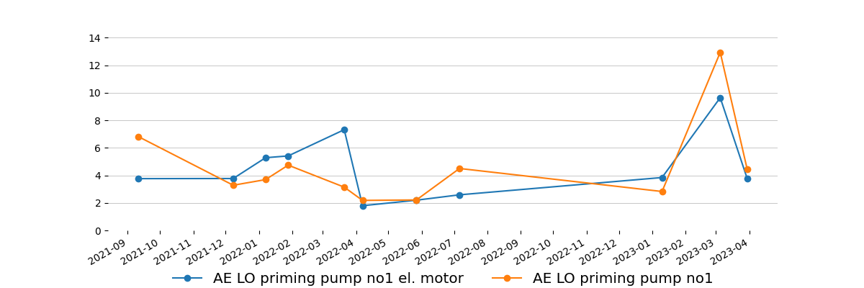
-
AE LO priming pump no2 el. motor | 2.628 | Cl. B | 22.055
AE LO priming pump no2 | 4.643 | Cl. D | 33.690 | High signal only in one point. Trend should be controlled. Actions to be taken based on trend result.
-
-
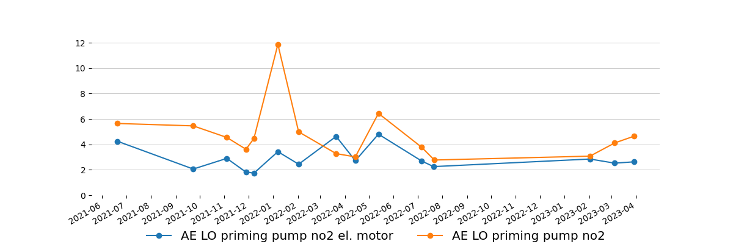
-
AE LO priming pump no3 el. motor | 5.352 | Cl. D | 41.201 | Trend should be controlled. Actions to be taken based on trend result.
AE LO priming pump no3 | 10.639 | Cl. D | 176.846 | Trend should be controlled. Actions to be taken based on trend result. Next measurement needs to be done up to week 18. Including el. motor.
-
-
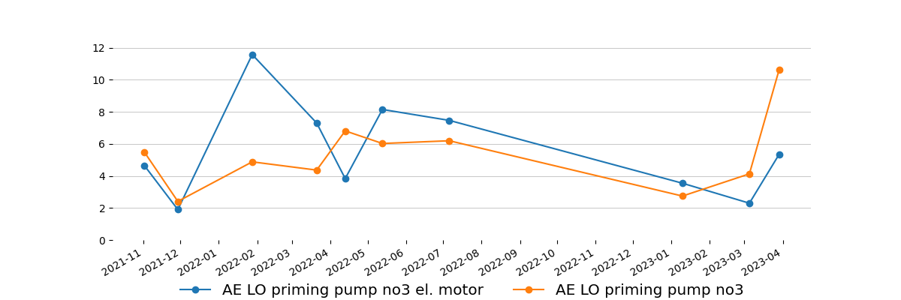
-
IG deck seal water pumps
IG deck seal water pump no1 el. motor | 3.643 | Cl. C | 6.848
IG deck seal water pump no1 | 2.712 | Cl. A | 9.315
-
-
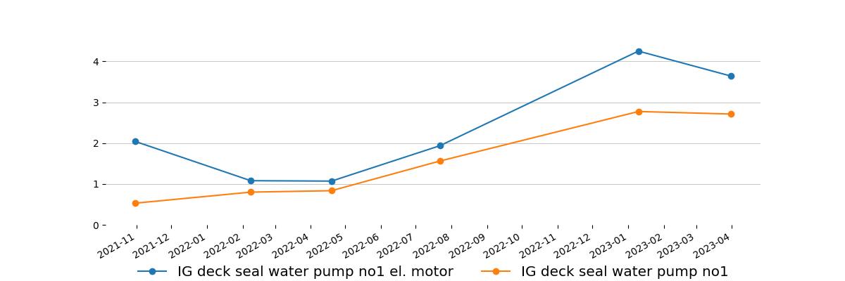
-
IG deck seal water pump no2 el. motor | 3.907 | Cl. C | 14.581
IG deck seal water pump no2 | 3.056 | Cl. A | 4.124
-
-
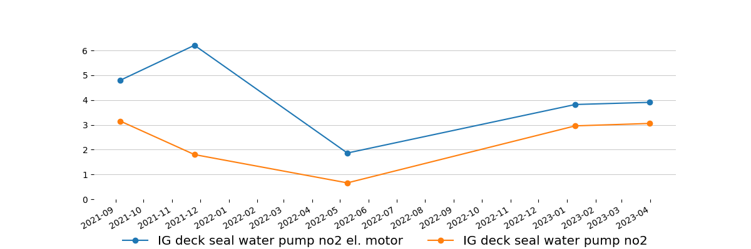
-
LT CFW pumps
LT CFW pump no1 el. motor | 4.499 | Cl. C | 8.505
LT CFW pump no1 | 4.947 | Cl. B | 8.616
-
-
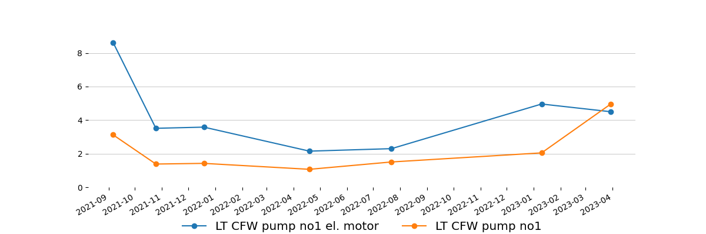
-
LT CFW pump no2 el. motor | 3.775 | Cl. C | 4.750
LT CFW pump no2 | 2.775 | Cl. A | 2.651
-
-
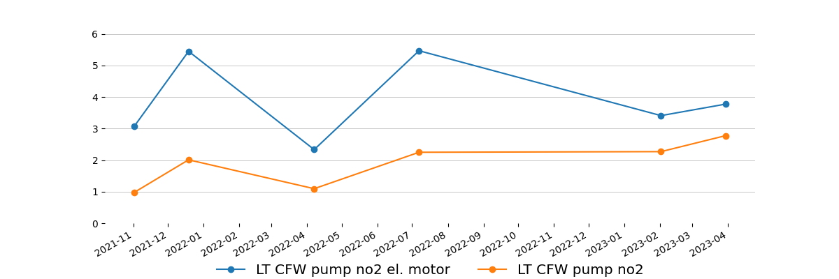
-
Composite boiler feed water pumps
Composite boiler feed water pump no1 el. motor | 4.325 | Cl. C | 8.027
Composite boiler feed water pump no1 | 1.661 | Cl. A | 7.143
-
-
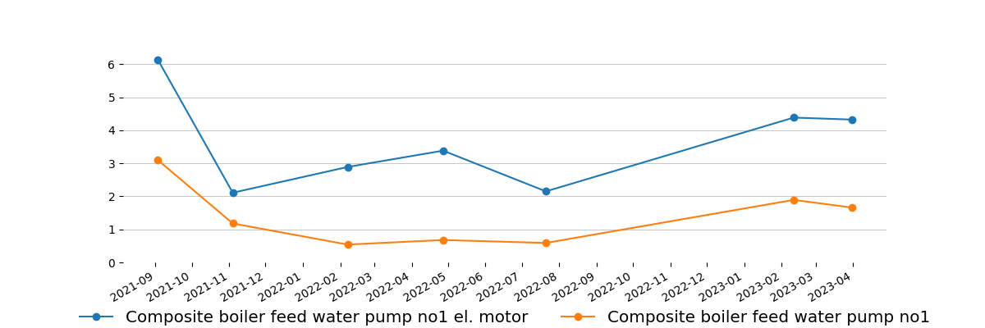
-
Composite boiler feed water pump no2 el. motor | 3.274 | Cl. C | 12.850
Composite boiler feed water pump no2 | 1.704 | Cl. A | 7.364
-
-
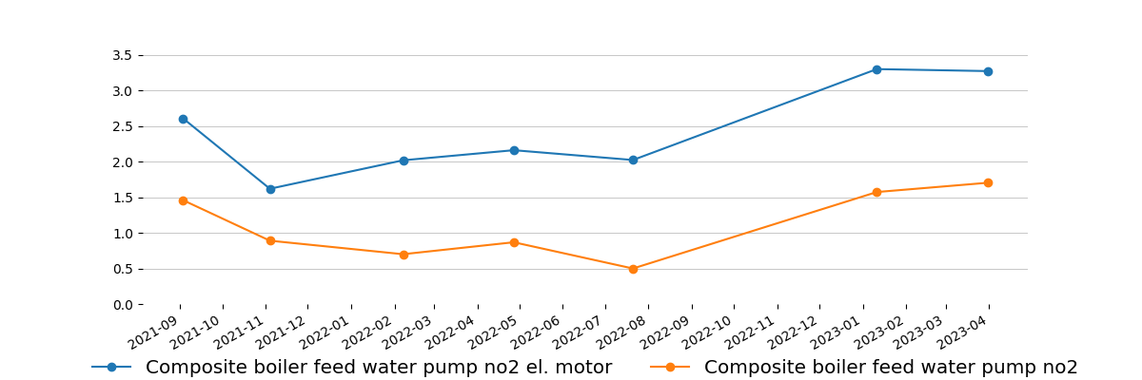
-
Composite boiler FO pumps
Composite boiler FO pump no1 el. motor | 3.226 | Cl. C | 4.492
Composite boiler FO pump no1 | 0.831 | Cl. A | 1.731
-
-
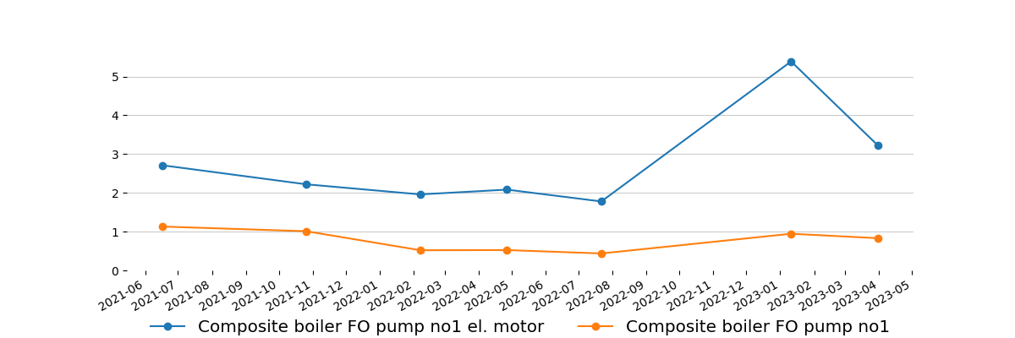
-
Composite boiler FO pump no2 el. motor | 3.692 | Cl. C | 7.106
Composite boiler FO pump no2 | 0.806 | Cl. A | 1.804
-
-
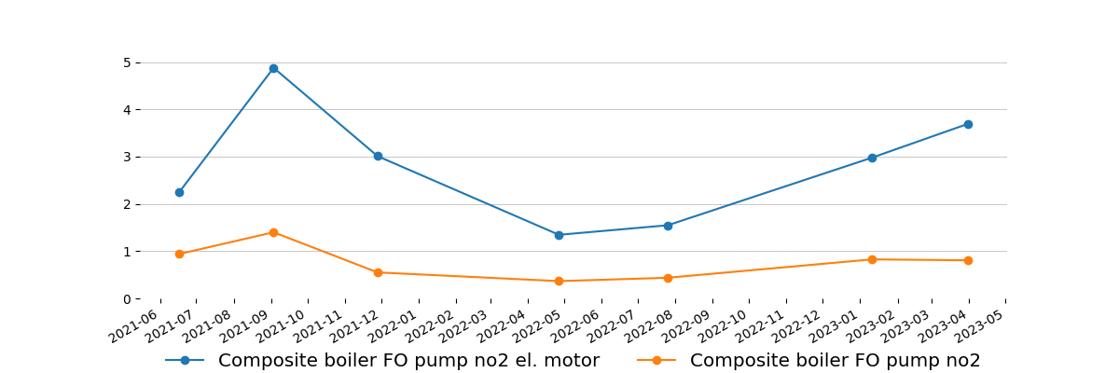
-
FO supply pumps
FO supply pump no1 el. motor | 2.751 | Cl. B | 12.040
FO supply pump no1 | 0.956 | Cl. A | 5.192
-
-
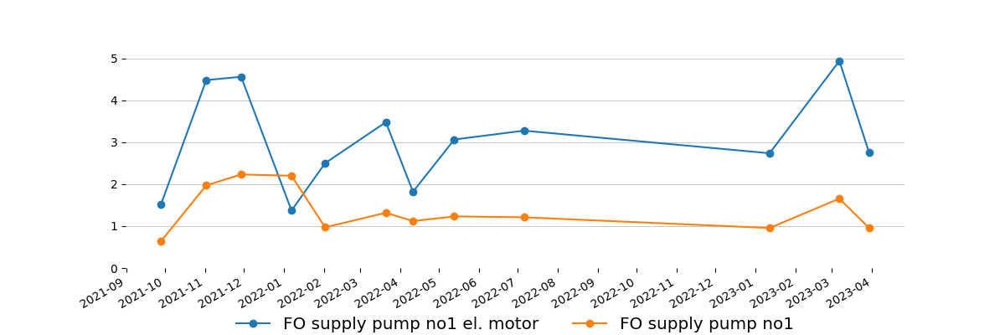
-
FO supply pump no2 el. motor | 4.206 | Cl. C | 28.720
FO supply pump no2 | 1.998 | Cl. B | 24.227
-
-
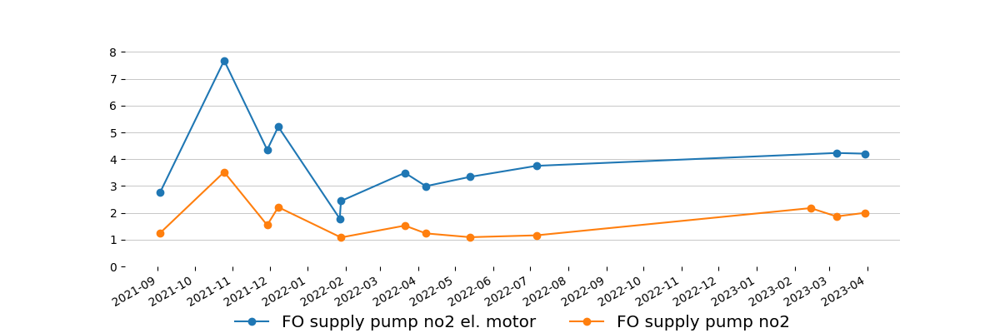
-
FO circulation pumps
FO circulation pump no1 el. motor | 5.740 | Cl. D | 21.319 | Trend should be controlled. Actions to be taken based on trend result.
FO circulation pump no1 | 3.081 | Cl. C | 17.931
-
-
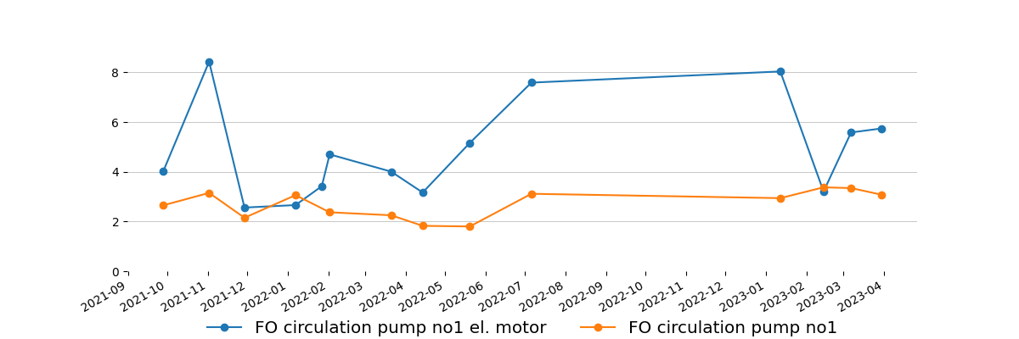
-
FO circulation pump no2 el. motor | 5.715 | Cl. D | 22.202 | Trend should be controlled. Actions to be taken based on trend result.
FO circulation pump no2 | 3.846 | Cl. C | 32.549
-
-
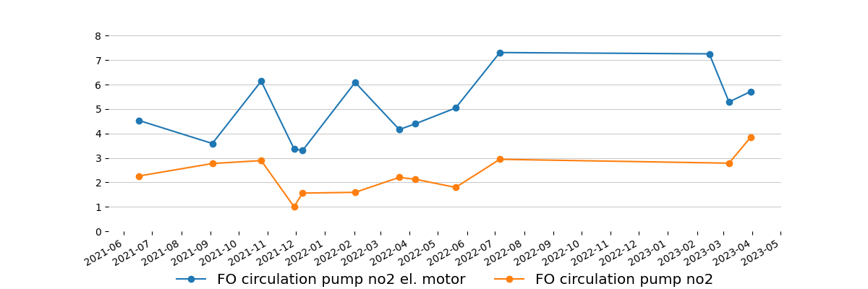
-
Separators
LO purifier no2 el. motor | 2.199 | Cl. B | 15.648
LO purifier no2 | 2.583 | Cl. B | -
-
-
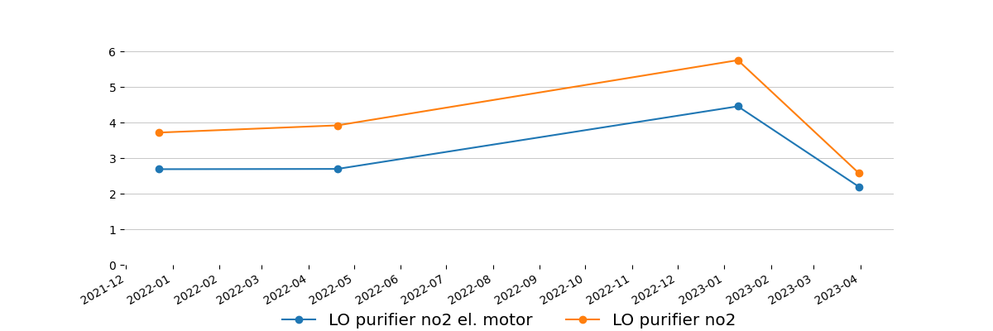
-
Framo feed pump
Framo feed pump no1 el. motor | 3.197 | Cl. C | 24.227
-
-
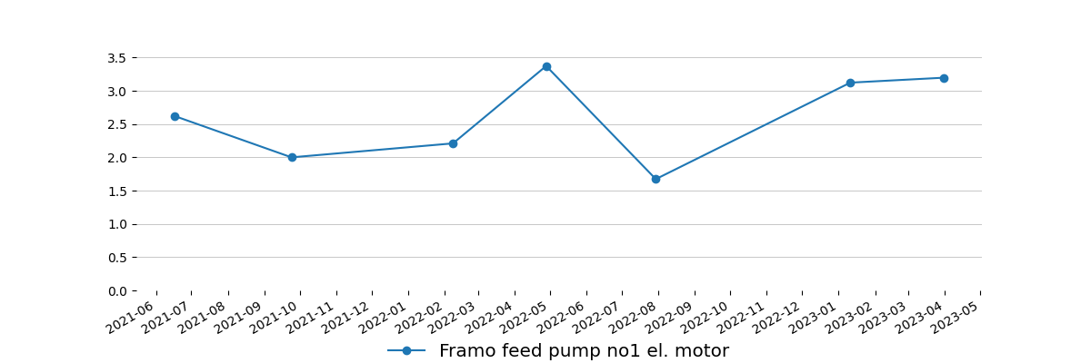
-
Framo feed pump no2 el. motor | 2.351 | Cl. B | 10.236
-
-
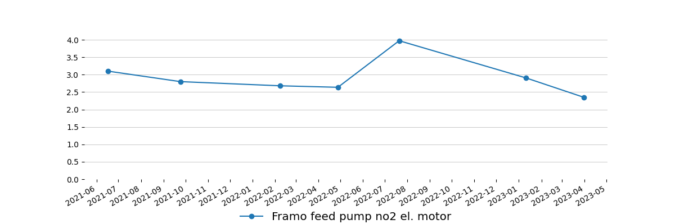
-
Framo feed pump no3 el. motor | 3.222 | Cl. C | 10.604
-
-
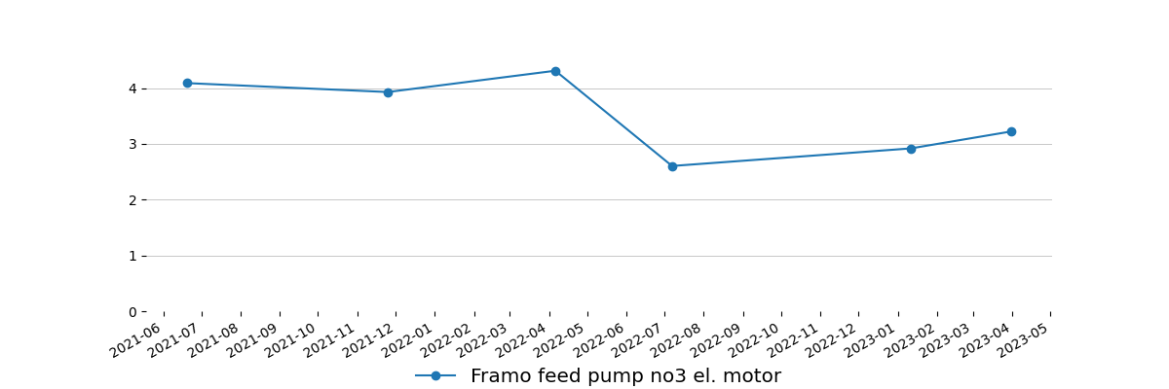
-
Main air compressors
Main air compressor no1 el. motor | 9.142 | In limit | 37.925
Main air compressor no1 | 14.813 | In limit | 33.212
-
-
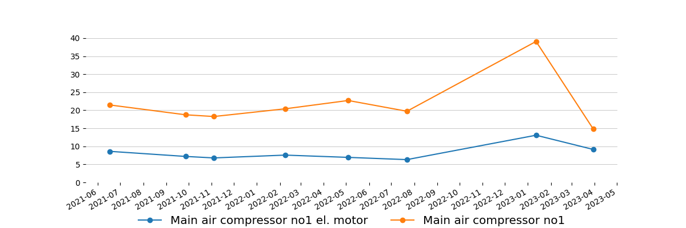
-
Main air compressor no2 el. motor | 8.268 | In limit | 35.862
Main air compressor no2 | 15.371 | In limit | 81.519
-
-
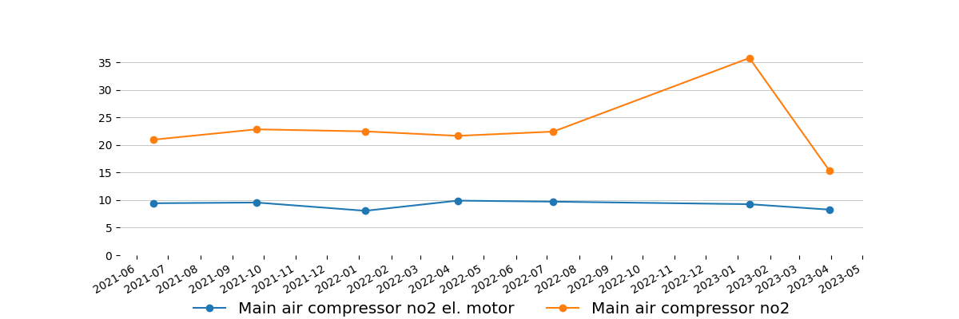
-
Steering gear pumps
Steering gear no2 el. motor | 2.994 | Cl. C | 9.868
-
-
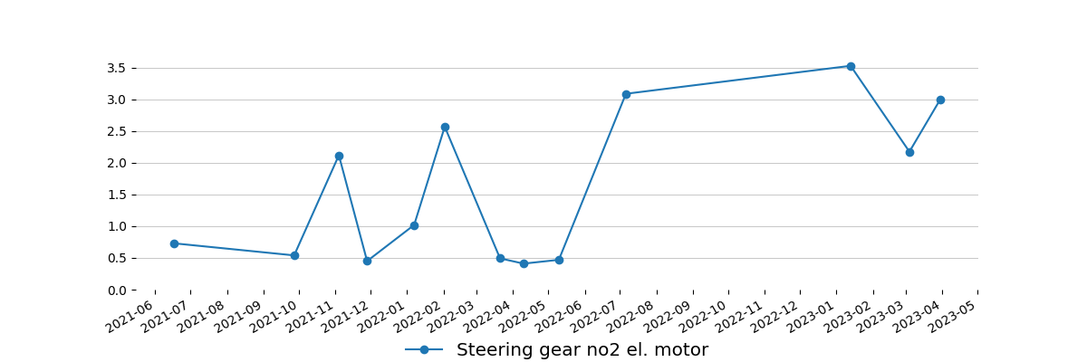
-
ER ventilation fans
Engine room fan no1 el. motor | 4.321 | Cl. A | 22.828
-
-
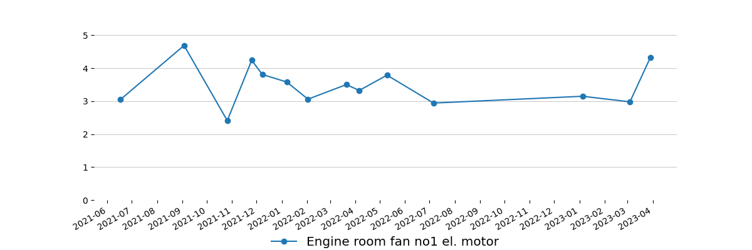
-
Engine room fan no2 el. motor | 3.597 | Cl. A | 30.008
-
-
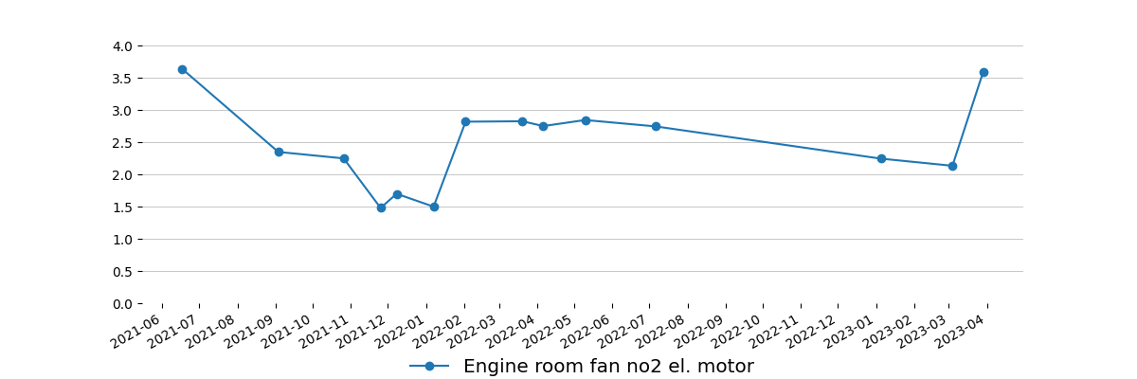
-
Engine room fan no3 el. motor | 3.757 | Cl. A | 24.853
-
-
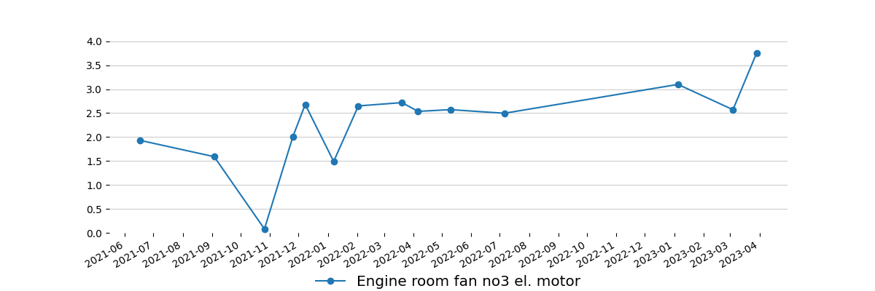
-
Engine room fan no4 el. motor | 2.603 | Cl. A | 19.073
-
-
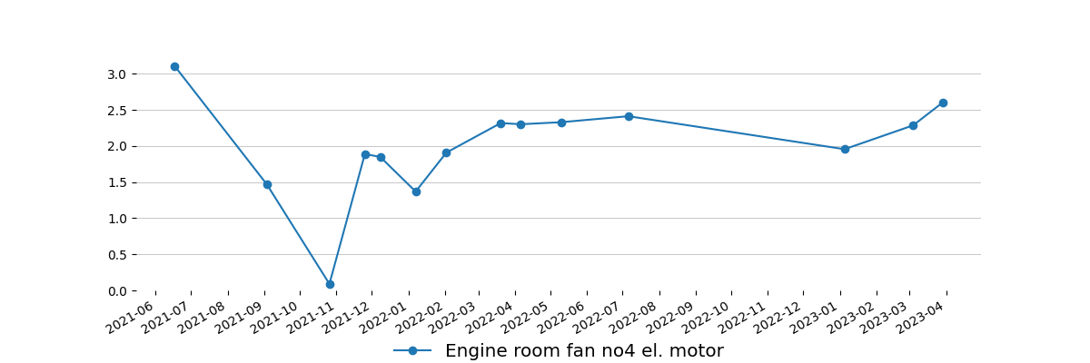
-

Measurement equipment:
Technical data
Maker: | Info Marine
Type: | MarVib DC750
Serial number: | 7507024
Measuring range: | 2Hz-30kHz / RPM = 60-20000
Indication error: | ± 0,5%
Equipment is calibrated, certificate for verification - if required.

Ship type:  Oil Chemical Tanker | Main dimensions:  Length(b.p).......................................183,05 m  Breadth(B.)........................................32,23 m
Sea depth:
Least twice times greater than Vessel draught
Measurement method:
According to standard ISO 10816 : - procedure No. 2 Measurement report

Summary
Next measurements should be done in three month period to obtain trend value for each equipment, in some cases even one month period is preferable.
This report is prepared in good faith based on measurement diagnostic done on available running rotary machine and documentation submitted.

Prepared by: | Approved by:
Service Engineer | Tomasz Chuchra
Senapathi Venkata Saikumar | mob: 0048 600052257

