Vibration diagnostic report 4948U-2023
Project: BW Tiger  IMO no: 9635846  Ordered by: BW Group | Date of measurement:  2023-03-24 - 2023-03-31 | Place of measurement:  During normal operation

Measurement condition
Measurements were taken during normal operating condition.

Results presentation
Measured values are presented in the table below. Each machine if applicable is separated for driver (el. motor, diesel engine, etc.) and driven unit (pump, compressor, etc.). First column of the table consist name of the equipment. Second column contains the highest value of vibration velocity measured on the equipment in all measurement points. Third column contains classification of the vibration class according to proper ISO standard and other normative documents. Classification depends on highest reading of measured equipment only. Fourth column contains additional readings of enveloped value of acceleration, which is helpful in detection of early stage of bearing wear. Fifth column contains remarks and suggestions based on the analysis of vibration signal. This column can be taken as the final conclusion about machine condition. If cell is empty, it means that there is no existing problem or defect shown in vibration signal.

Vibration standards
Following standards may applied for assessment:
ISO 10816-3 | Mechanical vibration — Evaluation of machine vibration by measurements on non-rotating parts — Part 3: Industrial machines with nominal power above 15 kW and nominal speeds between 120 r/min and 15 000 r/min when measured in situ
ISO 10816-6 | Mechanical vibration - Evaluation of machine vibration by measurements on nonrotating parts - Part 6: Reciprocating machines with power ratings above 100 kW
ISO 10816-7 | Mechanical vibration — Evaluation of machine vibration by measurements on non-rotating parts — Part 7: Rotodynamic pumps for industrial applications, including measurements on rotating shafts
ISO 14694 | Industrial fans - Specifications for balance quality and vibration levels
ISO 20816-1 | Mechanical vibration — Measurement and evaluation of machine vibration — Part 1: General guidelines
SAUER | Vibration of compressors CB 05-13
WESTFALIA | Westfalia separator mineraloil systems manual

Legend according to vibration class

Cl. A | Newly commissioned
Cl. B | Unrestricted
Cl. C | Restricted long-term operation
Cl. D | High probability of damage, action required
Cl. D | Vibrations over the limits but actions are not required.

In limit | Unrestricted
Out of limit | High probability of damage, action required
Out of limit | Vibrations over the limits but actions are not required.

Results
In table are presented only readings with max. RMS results for each device equipment:
Important machinery with Class D and machinery with action required.
Machine name | Velocity  RMS  (mm/s)  Max | ISO  standard | Bearing Envelope  0-Peak  (m/s2)  Max | Remarks and suggestions
Engine room
LO pumps
Main LO pump no2 el. motor | 20.436 | Cl. D | 8.578 | High signal caused by insufficient stiffness. Please take measurements every month to control influence of vibrations on bearings condition. Including pump.
Main LO pump no2 | 1.814 | Cl. A | 7.097
-
-
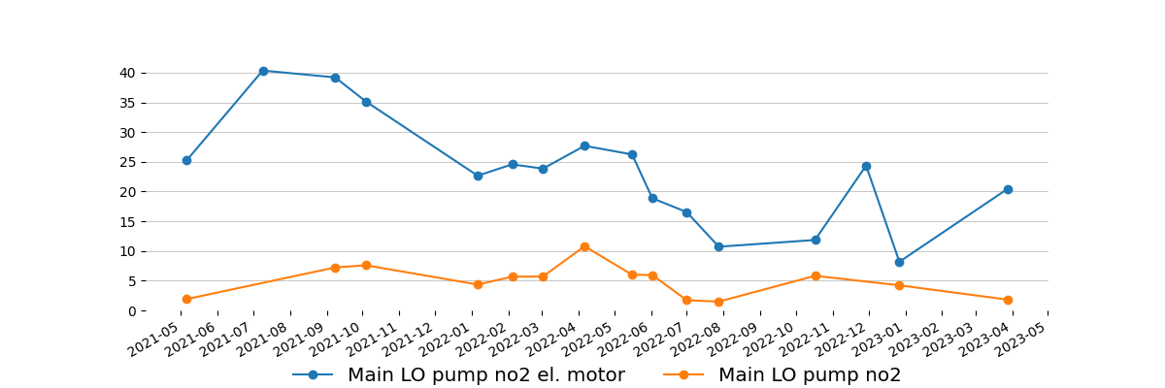
-
ME HPS pumps
ME HPS pump no1 el. motor | 5.535 | Cl. D | 54.843 | Trend should be controlled. Actions to be taken based on trend result.
-
-
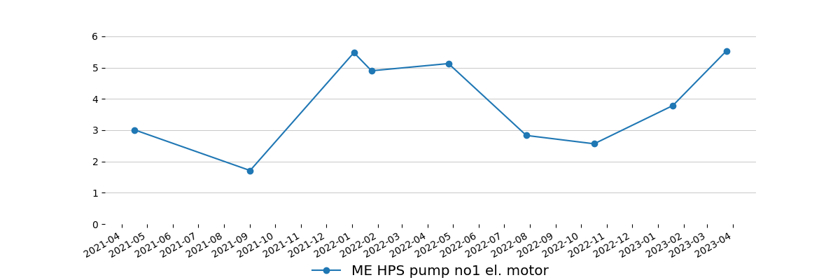
-
LT CFW pumps
LT CFW pump no1 el. motor | 10.124 | Cl. D | 8.008 | Trend should be controlled. Actions to be taken based on trend result. Next measurement needs to be done up to week 18. Including pump.
LT CFW pump no1 | 1.986 | Cl. A | 8.653
-
-
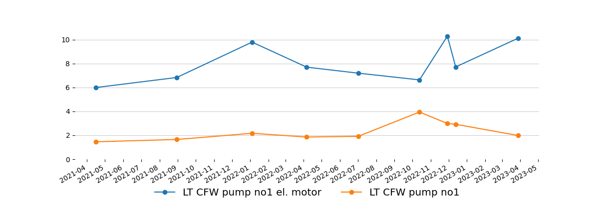
-
Separators
LO separator no1 el. motor | 8.787 | Cl. D | 70.670 | Trend should be controlled. Actions to be taken based on trend result.
LO separator no1 | 12.442 | Cl. D | - | Please advise if recommendation from report 4677-2022 was performed.  1. Condition of rubber feet should be checked.  2. Next measurement should be done after performing work (please send with feedback). Including el. motor.
-
-
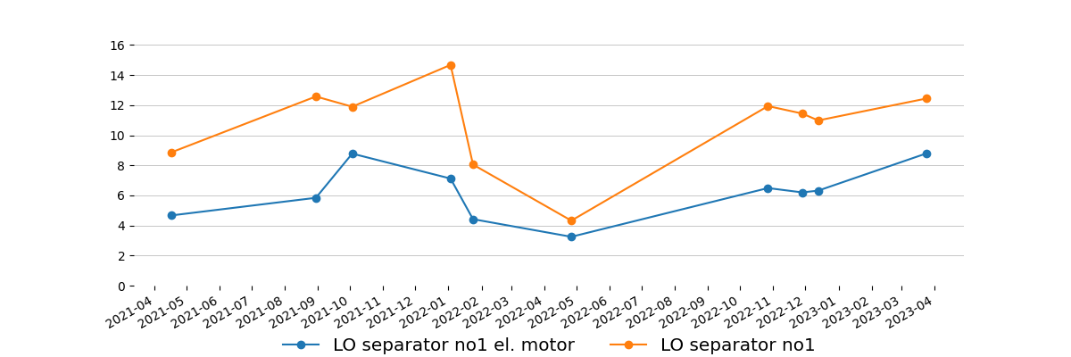
-
LO separator no2 el. motor | 12.738 | Cl. D | 99.021 | Trend should be controlled. Actions to be taken based on trend result. Next measurement should be done together with separator after performing recommended maintenance jobs.
LO separator no2 | 23.001 | Cl. D | - | Please advise if recommendation from report 4677-2022 was performed:  1. All bolts responsible for stiffness of structure should be checked/retightened.  2. Purifier should be checked/cleaned  3. Next measurement should be done after performing work (please send with feedback). Including el. motor.
-
-
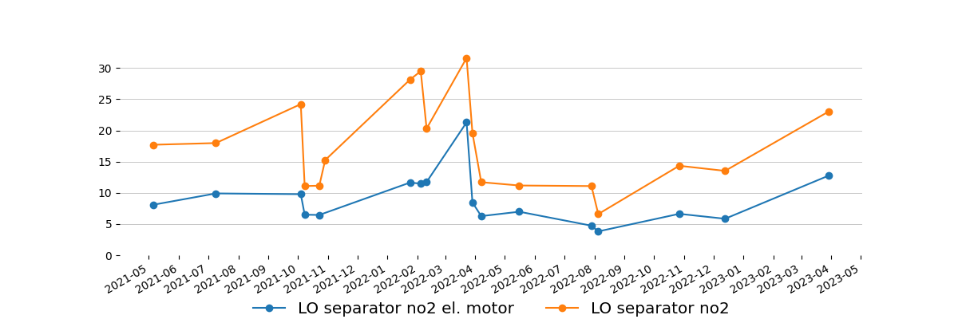
-
HFO separator no1 el. motor | 4.161 | Cl. C | 24.480
HFO separator no1 | 6.777 | Cl. D | - | Trend should be controlled. Actions to be taken based on trend result. Next measurement needs to be done up to week 18. Including el. motor.
-
-
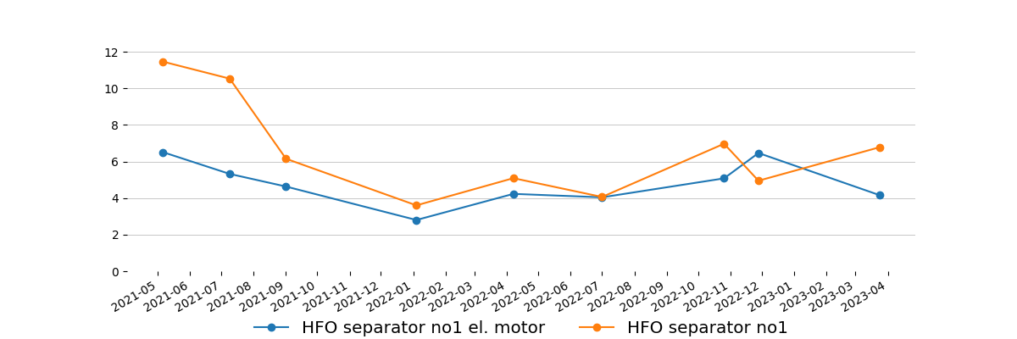
-
HFO separator no2 el. motor | - | - | -
HFO separator no2 | 10.115 | Cl. D | - | Trend should be controlled. Actions to be taken based on trend result. Next measurement needs to be done up to week 18. Including el. motor. Please always measure full set - motor and purifier.
-
-
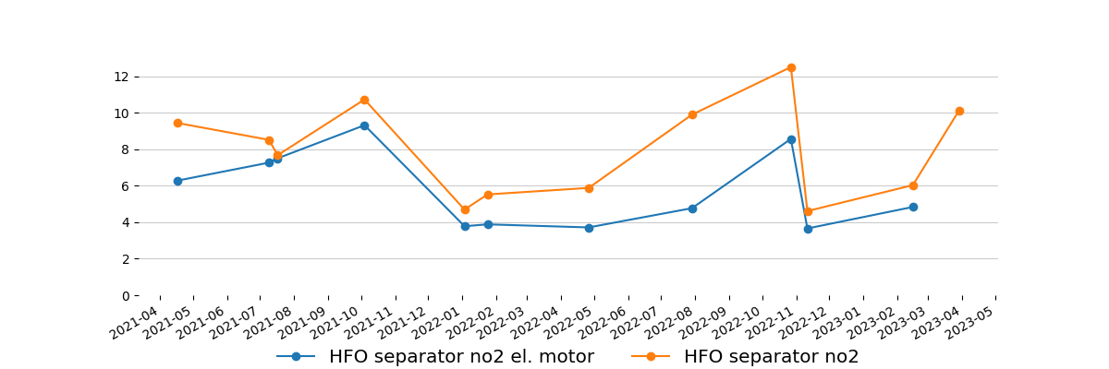
-
Framo pumps
Framo pump no3 | 12.370 | Cl. D | 55.906 | High signal comes from flow pulsation. Trend should be controlled. Actions to be taken based on trend result. Next measurement including engine should be done during next cargo operation. Please advise load, suction and discharge pressure during next measurement.
-
-
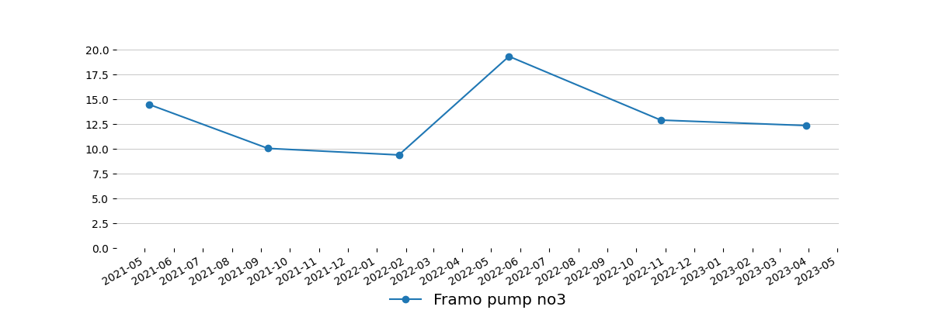
-
Framo pump no4 | 12.798 | Cl. D | 55.716 | High signal comes from flow pulsation. Trend should be controlled. Actions to be taken based on trend result.Next measurement including engine should be done during next cargo operation. Please advise load, suction and discharge pressure during next measurement.
-
-
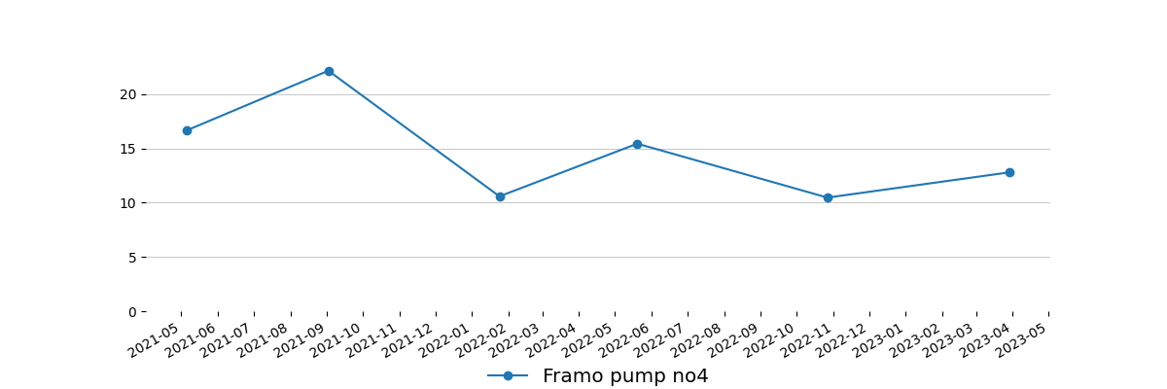
-
Deck Air Compressor
Deck air compressor el. motor | 4.938 | Cl. D | 66.571 | Trend should be controlled. Actions to be taken based on trend result.
-
-
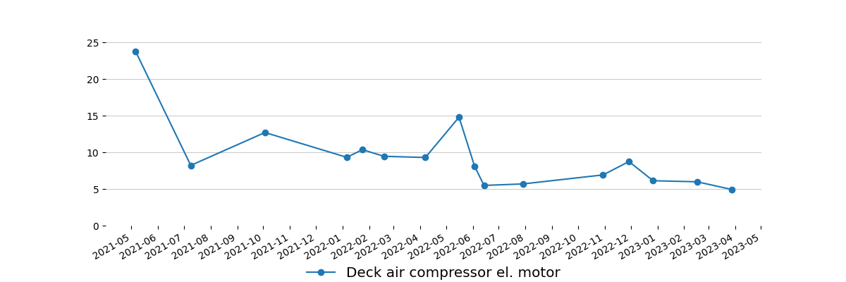
-
Important machinery below Class D and rest of machinery with no action required.
ME HPS pumps
ME HPS pump no2 el. motor | 4.125 | Cl. C | 53.059
-
-
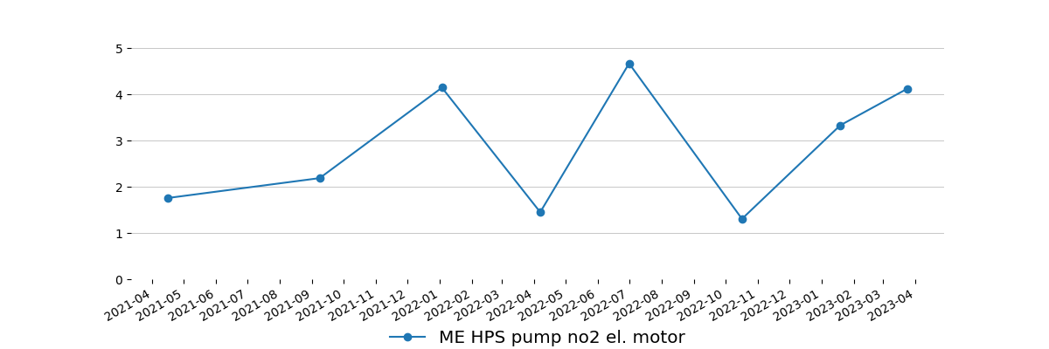
-
AE LO priming pumps
DG pre-lub pump no2 el. motor | 3.276 | Cl. C | 16.510
-
-
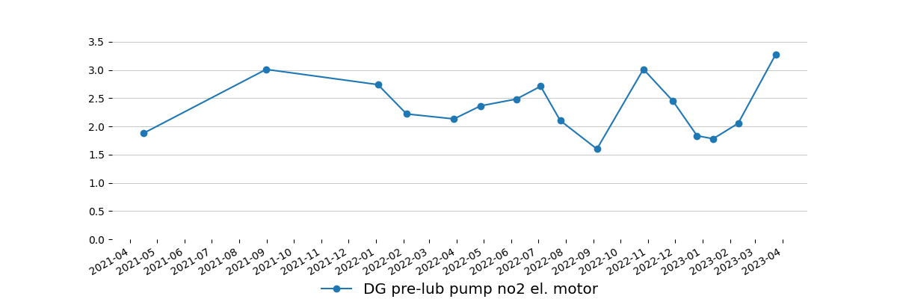
-
DG pre-lub pump no3 el. motor | 2.120 | Cl. B | 14.422
-
-
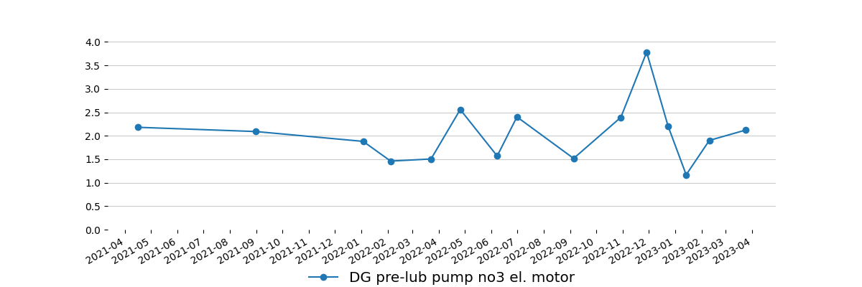
-
Deck seal water pumps
Deck seal water pump no1 el. motor | 9.093 | Cl. D | 136.937 | Trend should be controlled. Actions to be taken based on trend result. Next measurement needs to be done up to week 18. Including pump.
Deck seal water pump no1 | 5.883 | Cl. C | 63.990
-
-
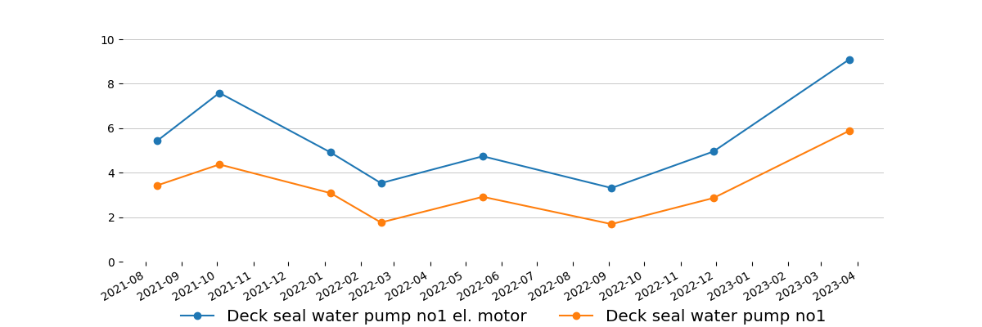
-
ME jacket cool pumps
ME jacket cool pump no1 el. motor | 3.100 | Cl. C | 4.820
ME jacket cool pump no1 | 1.019 | Cl. A | 4.934
-
-
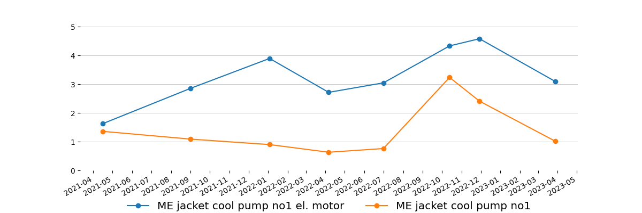
-
Composite BLR feed water pumps
Feed water pump for comp. boiler no1 el. motor | 7.714 | Cl. D | 4.706 | Trend should be controlled. Actions to be taken based on trend result.
Feed water pump for comp. boiler no1 | 3.383 | Cl. B | 4.744
-
-
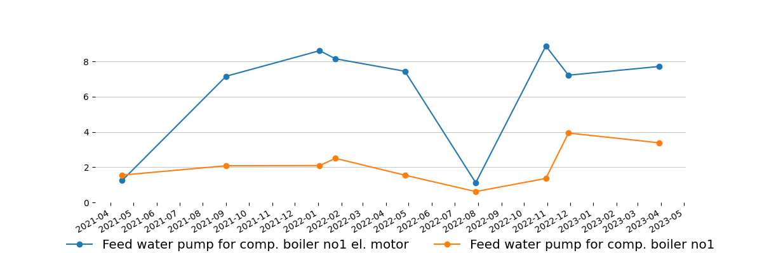
-
Aux BLR FO pumps
FO unit pump for aux. boiler no1 el. motor | 2.133 | Cl. B | 17.952
FO unit pump for aux. boiler no1 | 0.903 | Cl. A | 7.705
-
-
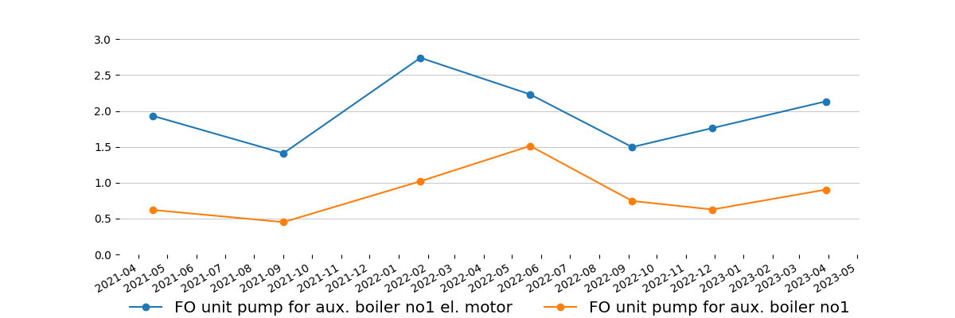
-
FO unit pump for aux. boiler no2 el. motor | 2.185 | Cl. B | 5.959
FO unit pump for aux. boiler no2 | 0.991 | Cl. A | 4.289
-
-
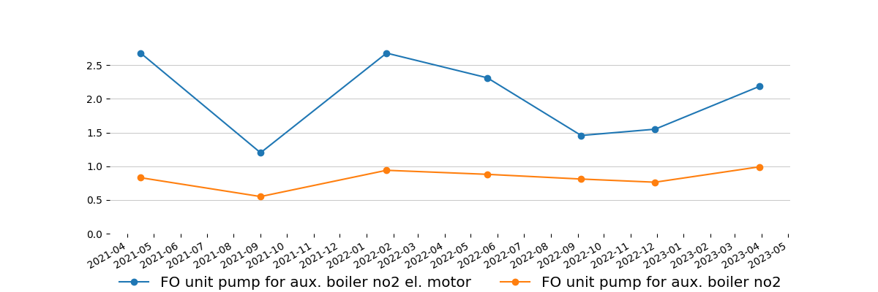
-
FO supply pumps
FO supply pump no1 el. motor | 3.851 | Cl. C | 13.208
FO supply pump no1 | 4.358 | Cl. C | 17.952
-
-
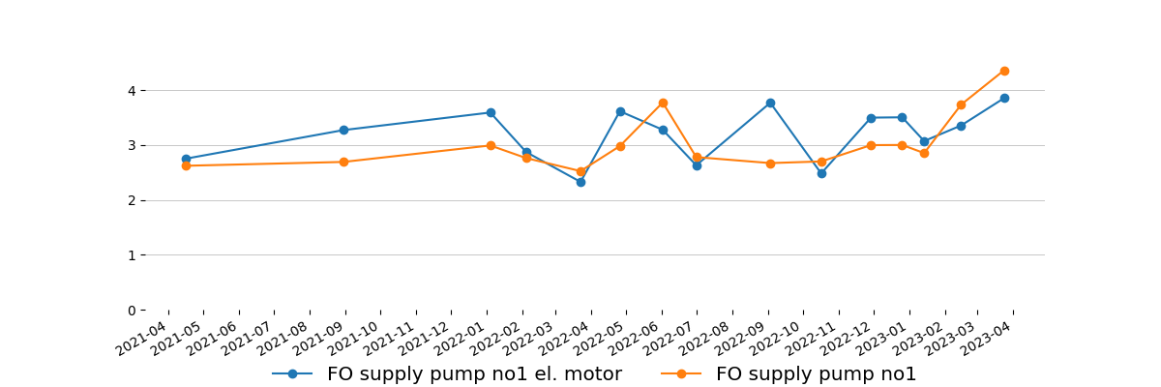
-
FO supply pump no2 el. motor | 3.761 | Cl. C | 20.685
FO supply pump no2 | 3.222 | Cl. C | 24.518
-
-
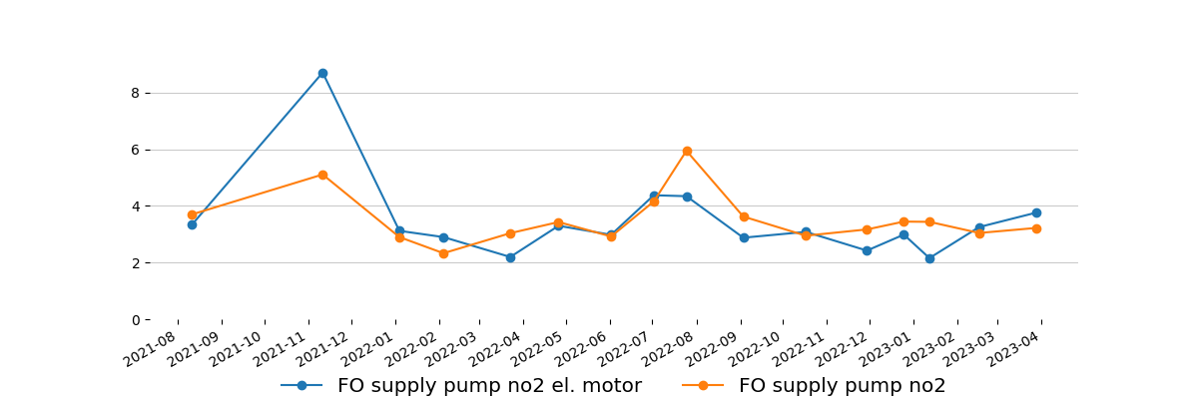
-
FO circulation pumps
FO circulation pump no1 el. motor | 4.805 | Cl. D | 43.799 | High signal only in one point. Trend should be controlled. Actions to be taken based on trend result.
FO circulation pump no1 | 4.806 | Cl. D | 34.538 | Trend should be controlled. Actions to be taken based on trend result.
-
-
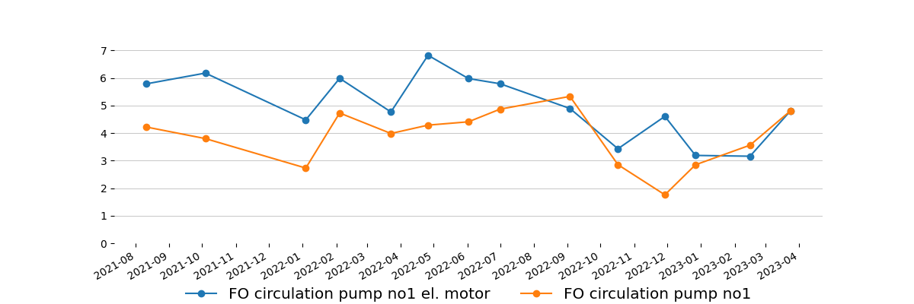
-
FO circulation pump no2 el. motor | 5.231 | Cl. D | 35.183 | High signal only in one point. Trend should be controlled. Actions to be taken based on trend result.
FO circulation pump no2 | 5.337 | Cl. D | 41.218 | Trend should be controlled. Actions to be taken based on trend result.
-
-
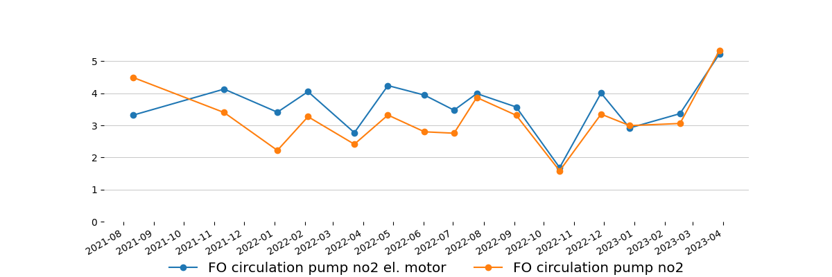
-
Framo pumps
Framo pump no3 diesel engine | 45.0(VSG) | Cl. C | -
-
-
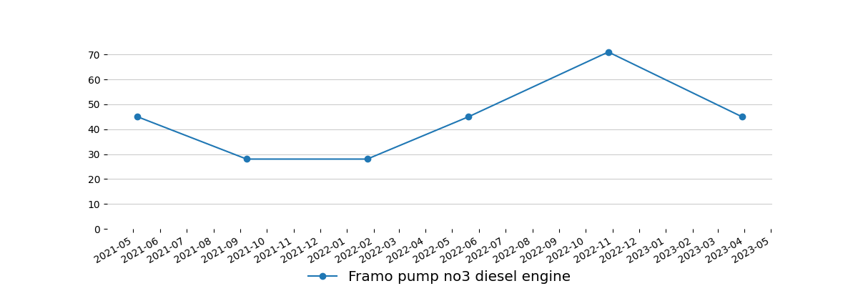
-
Framo pump no4 diesel engine | 28.0(VSG) | Cl. B | -
-
-
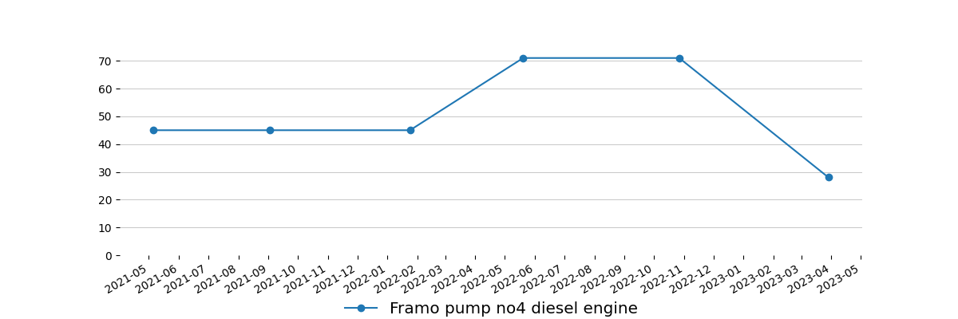
-
Main air compressors
Main air compressor no2 el. motor | 11.669 | In limit | 76.325
Main air compressor no2 | 17.141 | In limit | 82.587
-
-
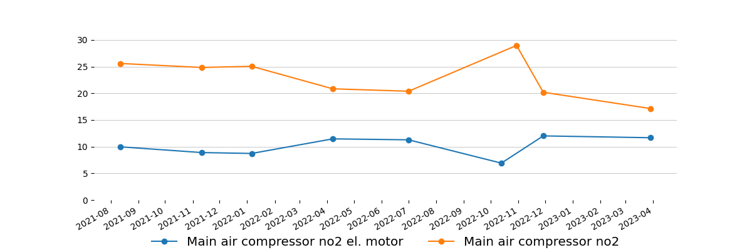
-
Air Condition compressors
Air cond. compressor no1 el. motor | 3.288 | Cl. B | 19.432
Air cond. compressor no1 | 6.262 | Cl. B | 63.800
-
-
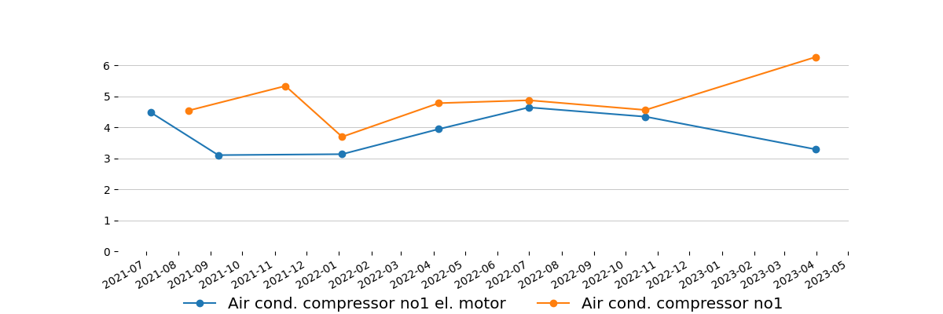
-
Air cond. compressor no2 el. motor | 3.815 | Cl. B | 36.284
Air cond. compressor no2 | 3.866 | Cl. B | 20.988
-
-
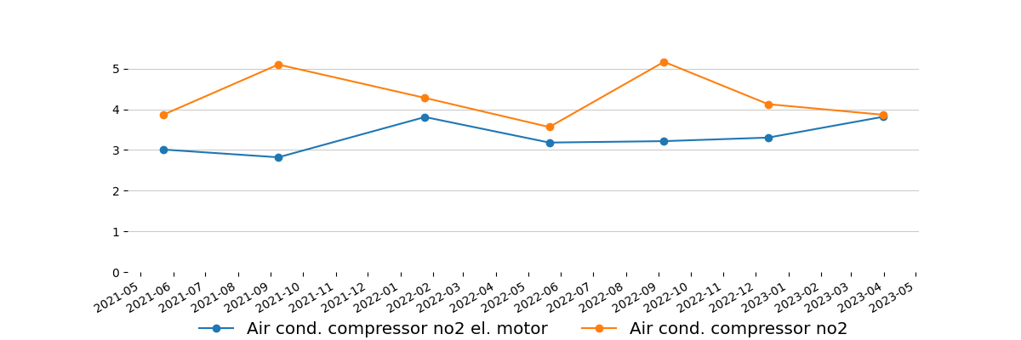
-
Provision compressor
Provision ref. compressor no1 el. motor | 4.357 | Cl. C | 23.569
Provision ref. compressor no1 | 3.812 | Cl. B | 30.135
-
-
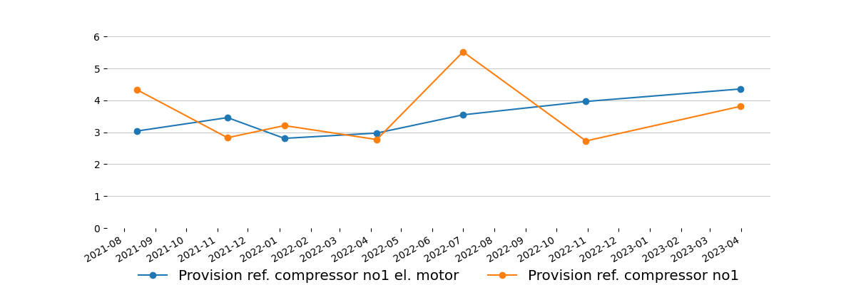
-
Steering gear hydraulic unit pumps
Steering gear hydraulic unit pump no1 el. motor | 2.737 | Cl. B | 20.078
-
-
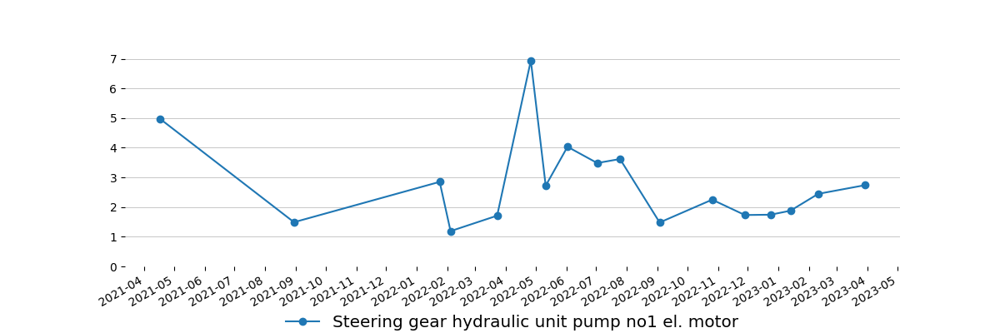
-
Steering gear hydraulic unit pump no2 el. motor | 3.508 | Cl. C | 50.175
-
-
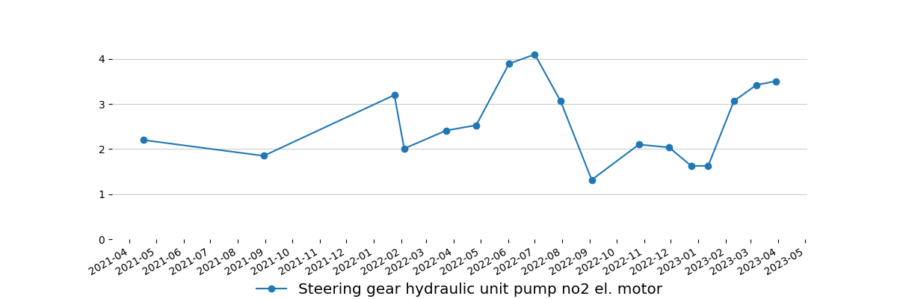
-
Aux boiler FD fan
Aux boiler FD fan el. motor | 5.245 | Cl. B | 32.792
-
-
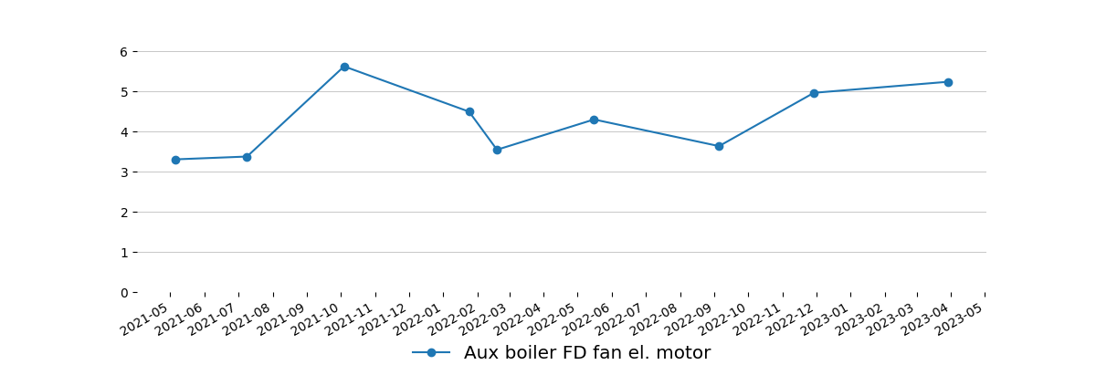
-
ER ventilation fans
Engine room fan no1 el. motor | 2.255 | Cl. A | 29.224
-
-
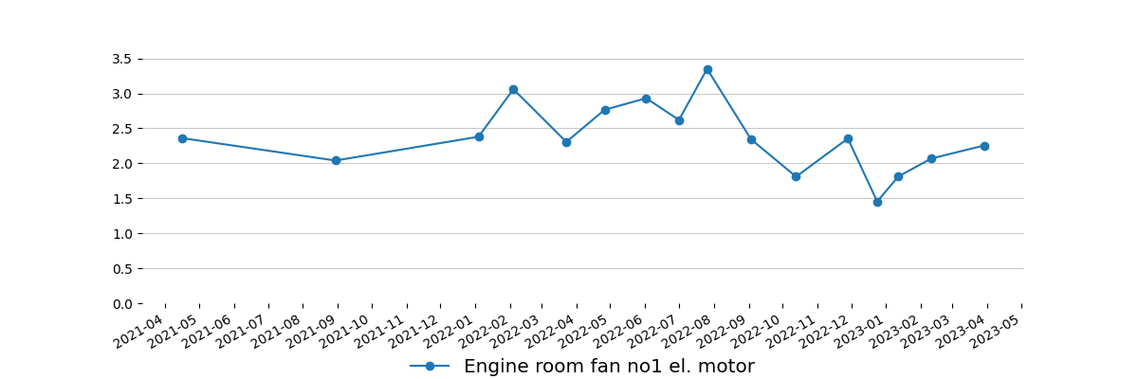
-
Engine room fan no2 el. motor | 2.331 | Cl. A | 28.921
-
-
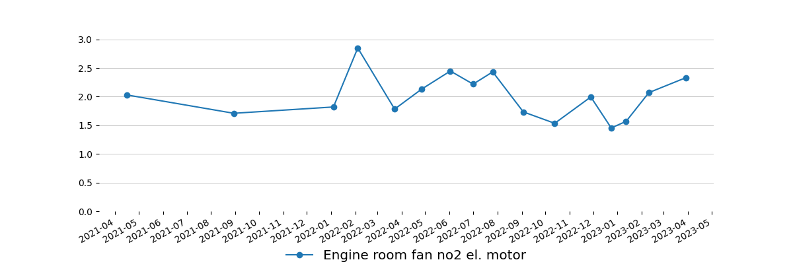
-
Engine room fan no3 el. motor | 2.677 | Cl. A | 40.686
-
-
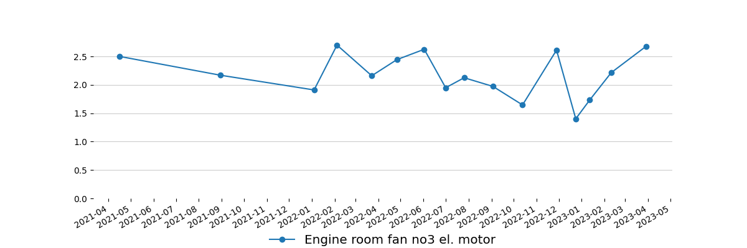
-
Engine room fan no4 el. motor | 2.756 | Cl. A | 28.617
-
-
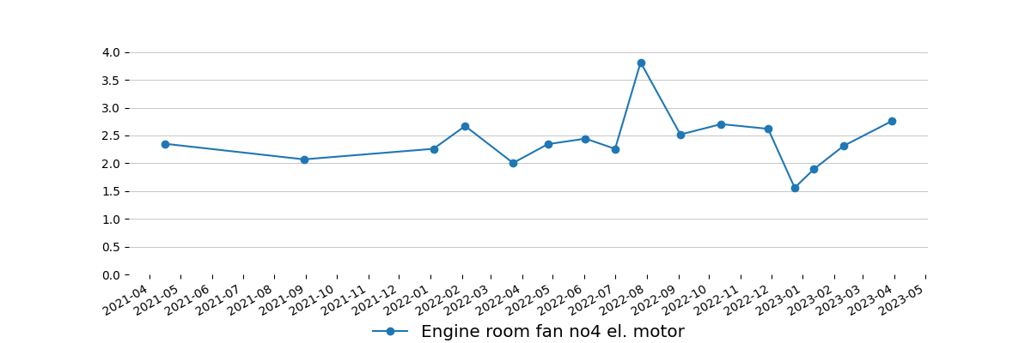
-
Sewage plant
Sewage plant areation blower el. motor | 4.538 | Cl. B | 12.031
Sewage plant areation blower | 3.903 | Cl. A | 6.642
-
-
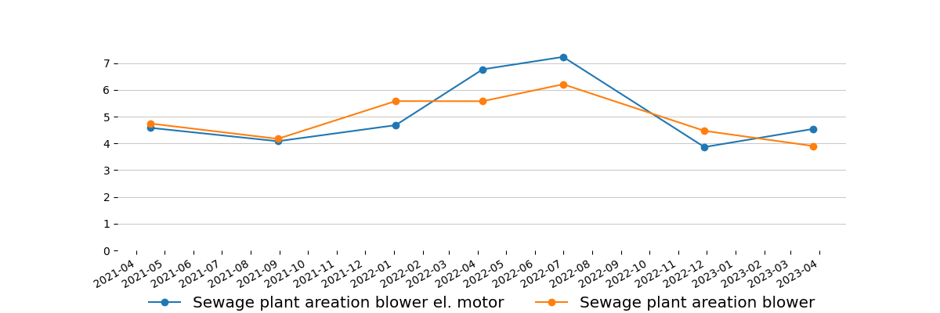
-

Measurement equipment:
Technical data
Maker: | Info Marine
Type: | MarVib DC750
Serial number: | 7506954
Measuring range: | 2Hz-30kHz / RPM = 60-20000
Indication error: | ± 0,5%
Equipment is calibrated, certificate for verification - if required.

Ship type:  Tanker | Main dimensions:  Length(b.p).......................................183,00 m  Breadth(B.)........................................32,00 m
Sea depth:
Least twice times greater than Vessel draught
Measurement method:
According to standard ISO 10816 : - procedure No. 2 Measurement report

Summary
Next measurements should be done in three month period to obtain trend value for each equipment, in some cases even one month period is preferable.
This report is prepared in good faith based on measurement diagnostic done on available running rotary machine and documentation submitted.

Prepared by: | Approved by:
Service Engineer | Tomasz Chuchra
Senapathi Venkata Saikumar | mob: 0048 600052257

