Vibration diagnostic report 4935U2-2023
Project: Hafnia Hong Kong  IMO no: 9830288  Ordered by: MMS Co. Ltd. | Date of measurement:  2023-03-11 - 2023-03-29 | Place of measurement:  During normal operation

Measurement condition
Measurements were taken during normal operating condition.

Results presentation
Measured values are presented in the table below. Each machine if applicable is separated for driver (el. motor, diesel engine, etc.) and driven unit (pump, compressor, etc.). First column of the table consist name of the equipment. Second column contains the highest value of vibration velocity measured on the equipment in all measurement points. Third column contains classification of the vibration class according to proper ISO standard and other normative documents. Classification depends on highest reading of measured equipment only. Fourth column contains additional readings of enveloped value of acceleration, which is helpful in detection of early stage of bearing wear. Fifth column contains remarks and suggestions based on the analysis of vibration signal. This column can be taken as the final conclusion about machine condition. If cell is empty, it means that there is no existing problem or defect shown in vibration signal.

Vibration standards
Following standards may applied for assessment:
ISO 10816-3 | Mechanical vibration — Evaluation of machine vibration by measurements on non-rotating parts — Part 3: Industrial machines with nominal power above 15 kW and nominal speeds between 120 r/min and 15 000 r/min when measured in situ
ISO 10816-7 | Mechanical vibration — Evaluation of machine vibration by measurements on non-rotating parts — Part 7: Rotodynamic pumps for industrial applications, including measurements on rotating shafts
ISO 14694 | Industrial fans - Specifications for balance quality and vibration levels
ISO 20816-1 | Mechanical vibration — Measurement and evaluation of machine vibration — Part 1: General guidelines
ISO 8528-9 | Reciprocating internal combustion engine driven alternating current generating sets — Part 9: Measurement and evaluation of mechanical vibrations
And makers recommendations

Legend according to vibration class

Cl. A | Newly commissioned
Cl. B | Unrestricted
Cl. C | Restricted long-term operation
Cl. D | High probability of damage, action required
Cl. D | Vibrations over the limits but actions are not required.

V. I | Unrestricted
V. II | Restricted long-term operation
V. III | High probability of damage, action required
V. III | Vibrations over the limits but actions are not required.

In limit | Unrestricted
Out of limit | High probability of damage, action required
Out of limit | Vibrations over the limits but actions are not required.

Results
In table are presented only readings with max. RMS results for each device equipment:
Machine name | Velocity  RMS  (mm/s)  Max | ISO  standard | Bearing Envelope  0-Peak  (m/s2)  Max | Remarks and suggestions
ENGINE ROOM
Hydraulic oil pump for ME
Hydraulic oil pump for ME no1 el. motor | 2.382 | Cl. B | 14.461
-
-
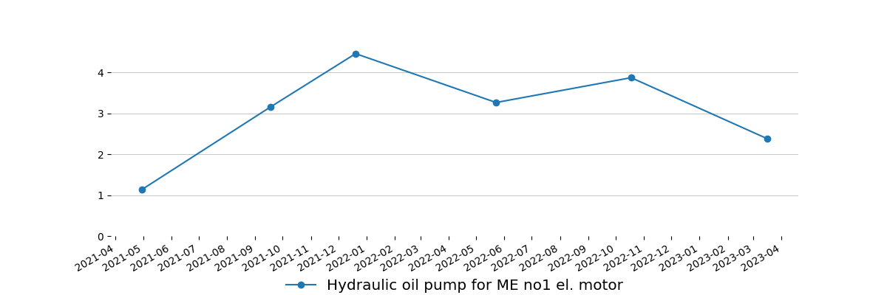
-
Diesel Generators
Auxiliary Engine no2 | 20.382 | In limit | -
Auxiliary Engine alternator no2 | 7.136 | V. I | -
-
-
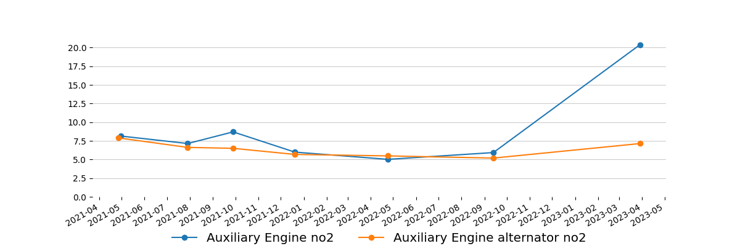
-
AE LO Pre Lubricating pumps
Pre lubrication oil pump for AE2 el. motor | 2.408 | Cl. B | 39.345 | Next measurement needs to be done up to week 19. Including pump. Please advise type of bearings.
Pre lubrication oil pump for AE2 | 1.791 | Cl. B | 20.615
-
-
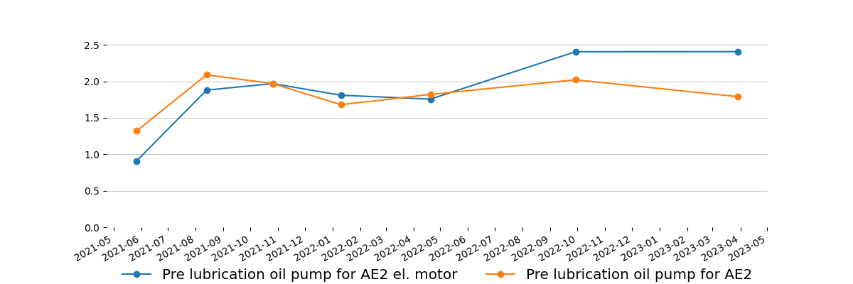
-
FO supply pumps
FO supply pump no2 el. motor | 2.233 | Cl. B | 16.922
FO supply pump no2 | 1.448 | Cl. B | 25.576
-
-
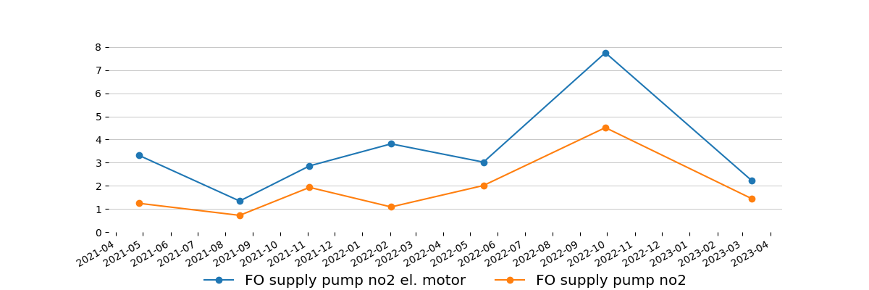
-
ME LO purifier
ME LO purifier no2 el. motor | 4.678 | Cl. D | 57.344 | High signal only in one point. Trend should be controlled. Actions to be taken based on trend result.
ME LO purifier no2 | 3.556 | Cl. B | -
-
-
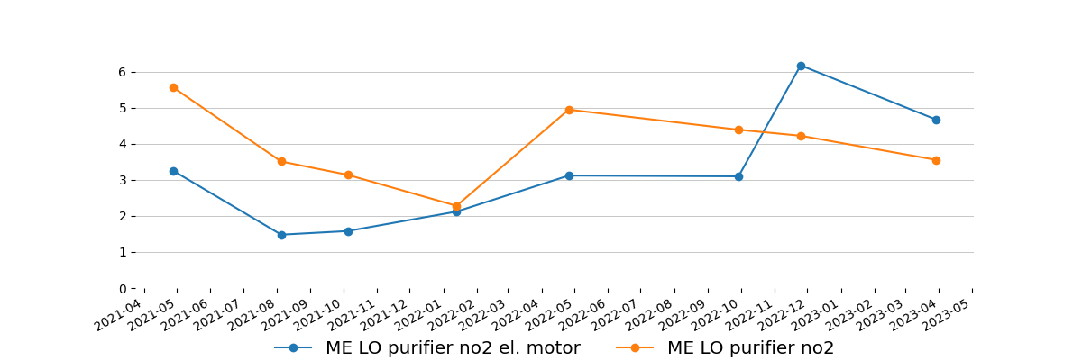
-
Composite boiler feed water pumps
Composite boiler feed water pump no1 el. motor | 8.886 | Cl. D | 3.923 | High signal comes from environment. Trend should be controlled. Actions to be taken based on trend result. Next measurement needs to be done up to week 18. Including pump.
Composite boiler feed water pump no1 | 2.158 | Cl. A | 4.577
-
-
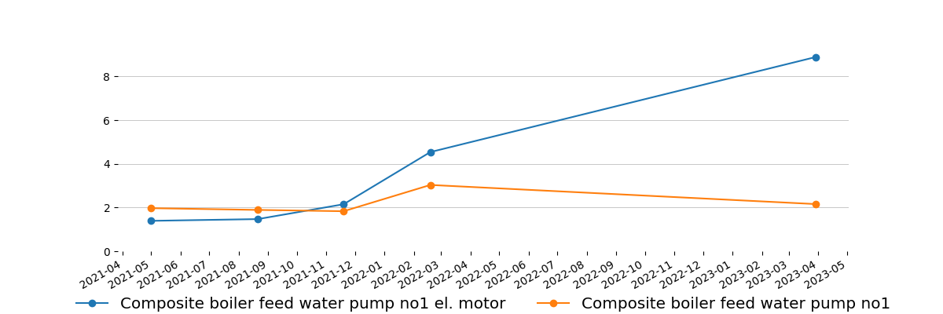
-
LT booster pump
LT booster pump no1 el. motor | 0.779 | Cl. A | 14.538
LT booster pump no1 | 0.341 | Cl. A | 6.384
-
-
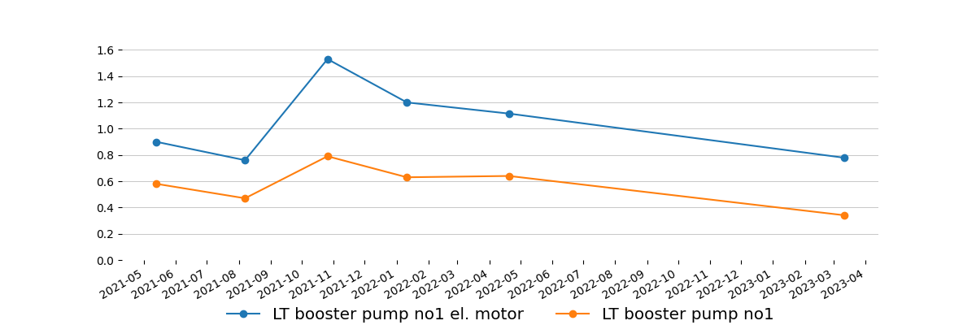
-
CSW pumps
Cooling SW pump no1 el. motor | 1.232 | Cl. A | 5.154
Cooling SW pump no1 | 0.700 | Cl. A | 6.038
-
-
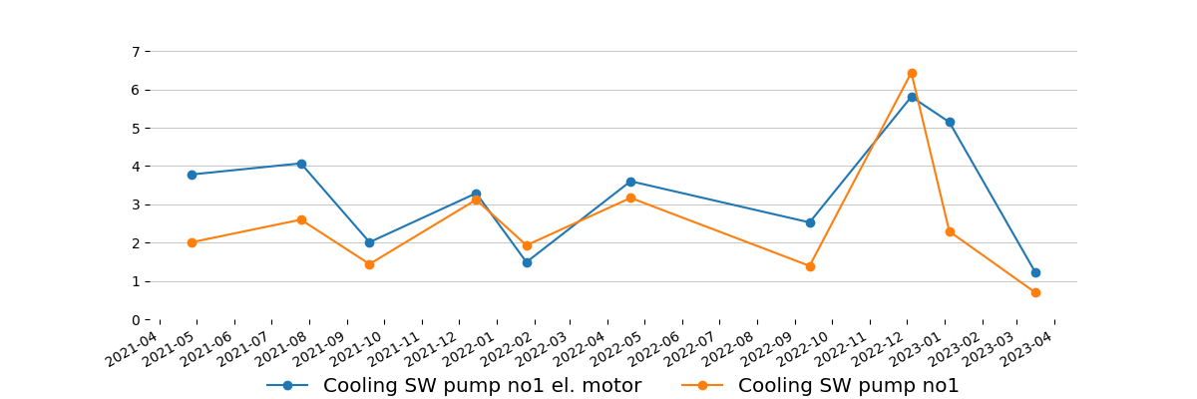
-
Cooling SW pump no2 el. motor | 4.365 | Cl. C | 3.538
Cooling SW pump no2 | 1.961 | Cl. A | 7.154
-
-
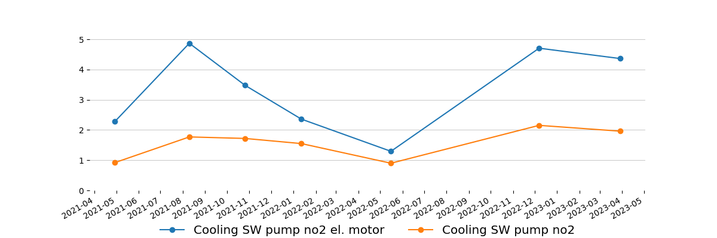
-
FWG distillate pump
FWG distillate pump el. motor | 4.497 | Cl. C | 28.884
FWG distillate pump | 2.688 | Cl. A | 25.345
-
-
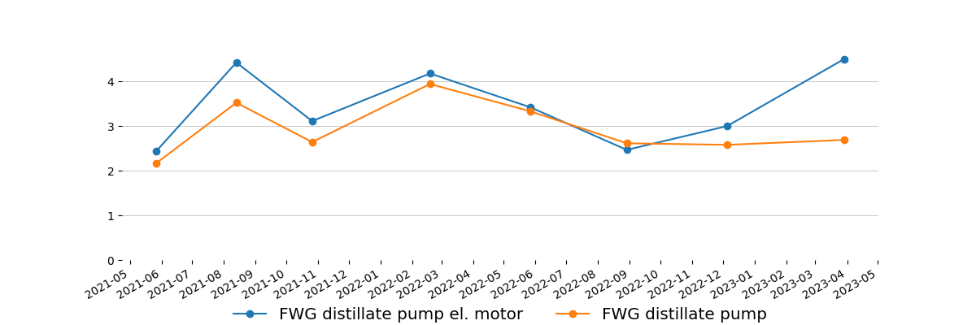
-
FWG ejector
FWG ejector pump el. motor | 4.970 | Cl. D | 47.883 | High signal comes from environment. Trend should be controlled. Actions to be taken based on trend result. Next measurement needs to be done up to week 17. Including pump.
FWG ejector pump | 2.232 | Cl. A | 30.499
-
-
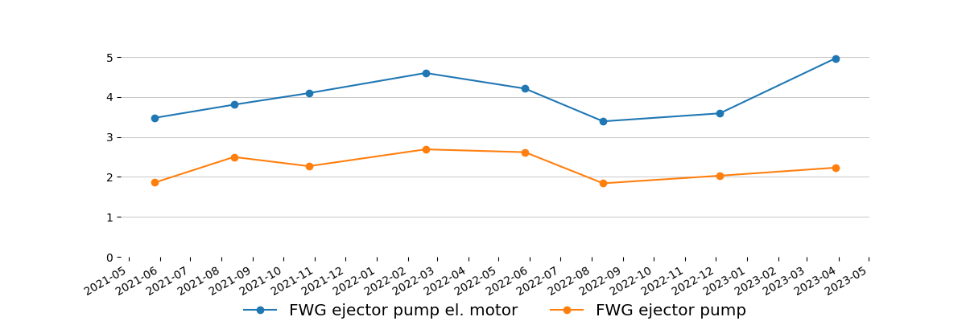
-
Main air compressors
Main air compressor no1 el. motor | 13.569 | Cl. C | 22.922
-
-
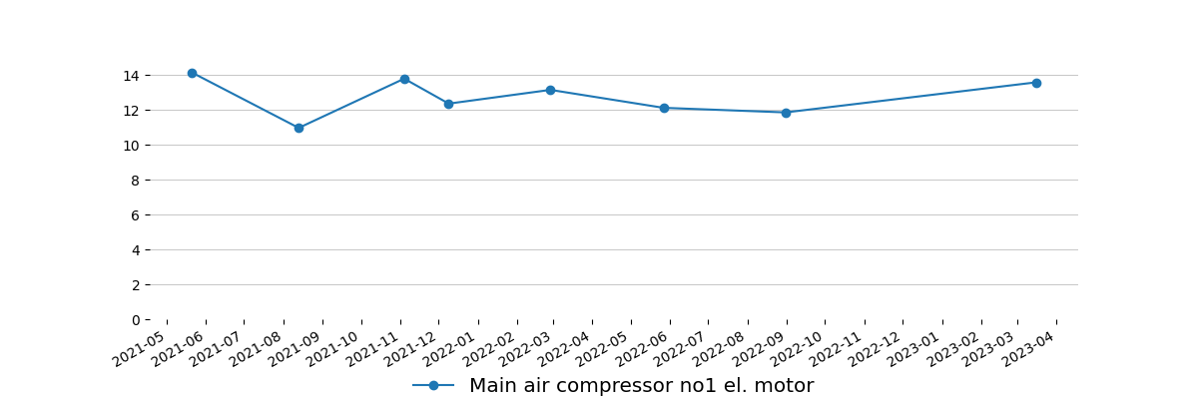
-
Main air compressor no2 el. motor | 13.888 | Cl. C | 26.268
-
-
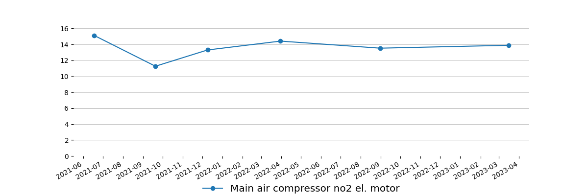
-
Vacuum pumps
Vacuum pump no2 el. motor | 5.877 | Cl. D | 84.689 | Trend should be controlled. Actions to be taken based on trend result.
Vacuum pump no2 | 7.832 | Cl. D | 45.844 | Trend should be controlled. Actions to be taken based on trend result.
-
-
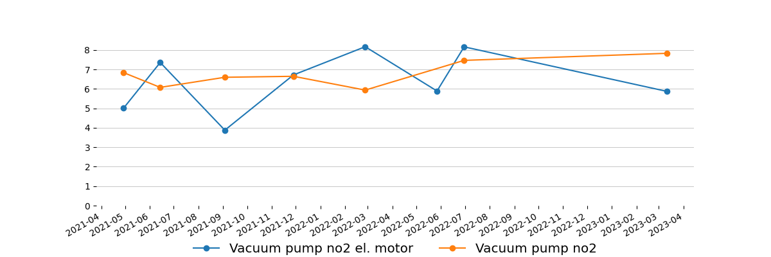
-
Hydraulic oil pumps AFT
Hydraulic pump AFT no1 el. motor | 9.080 | Cl. D | 174.378 | Trend should be controlled. Actions to be taken based on trend result. Next measurement needs to be done up to week 18.
Hydraulic pump AFT no1 | 18.358 | Cl. D | 158.110 | High signal comes from flow pulsation. Trend should be controlled. Actions to be taken based on trend result. Next measurement needs to be done up to week 18.
-
-
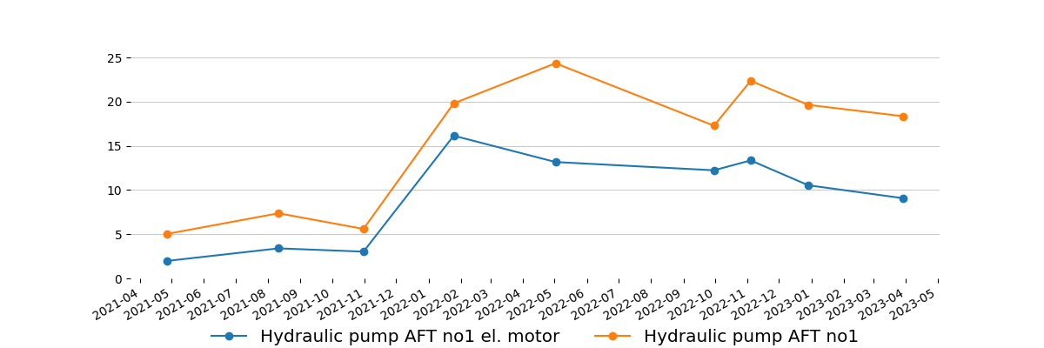
-
Hydraulic pump AFT no2 el. motor | 6.616 | Cl. D | 63.382 | Trend should be controlled. Actions to be taken based on trend result.
Hydraulic pump AFT no2 | 16.979 | Cl. D | 96.996 | 1. All bolts responsible for stiffness of structure should be checked/retightened.  2. Next measurement should be done after performing work (please send with feedback). Including el. motor.
-
-
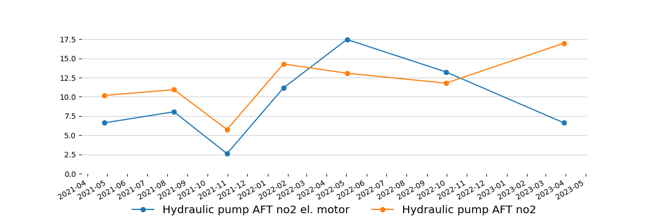
-
AFT hydraulic cooling pump el. motor | 8.156 | Cl. D | 41.268 | Trend should be controlled. Actions to be taken based on trend result.
AFT hydraulic cooling pump | 8.813 | Cl. D | 63.036 | Trend should be controlled. Actions to be taken based on trend result. Next measurement needs to be done up to week 18. Including el. motor.
-
-
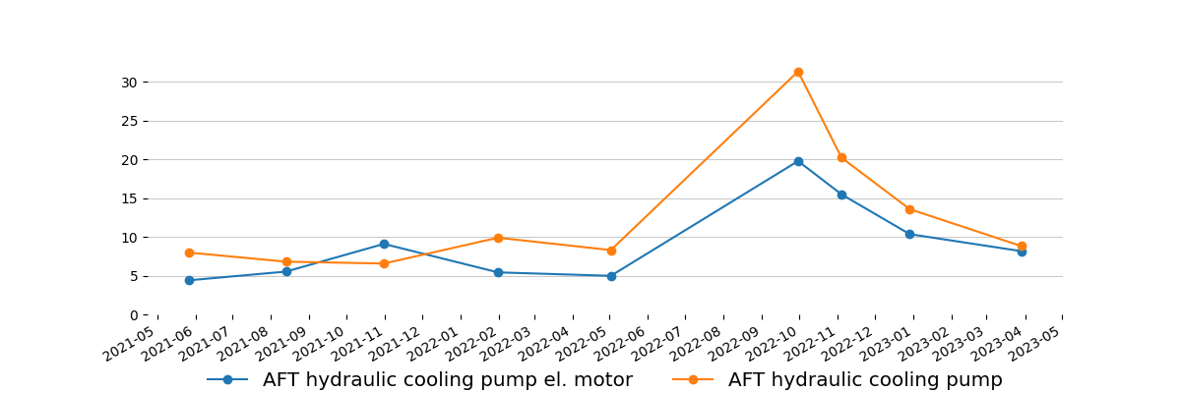
-
Incinerator Sludge circulation pump
Incinerator sludge circulation pump el. motor | 2.129 | Cl. B | 11.769
-
-
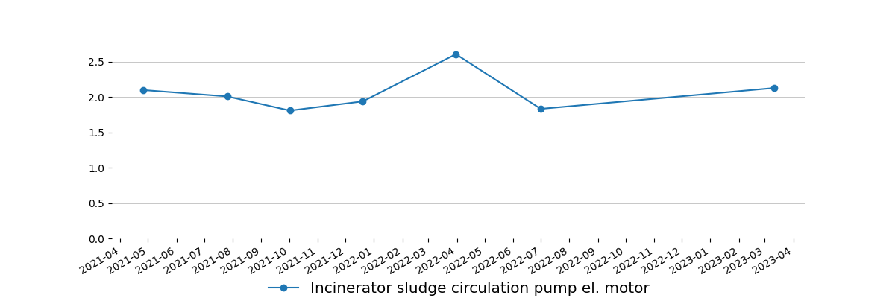
-
Incinerator Sludge dosing pump
Incinerator sludge dosing pump el. motor | 4.062 | Cl. C | 16.115
Incinerator sludge dosing pump | 2.693 | Cl. B | 6.884
-
-
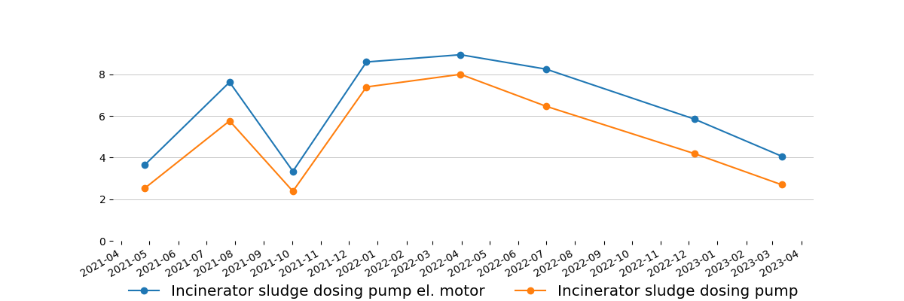
-
Composite boiler FD fan
Composite boiler FD fan el. motor | 6.022 | Cl. B | 37.653
-
-
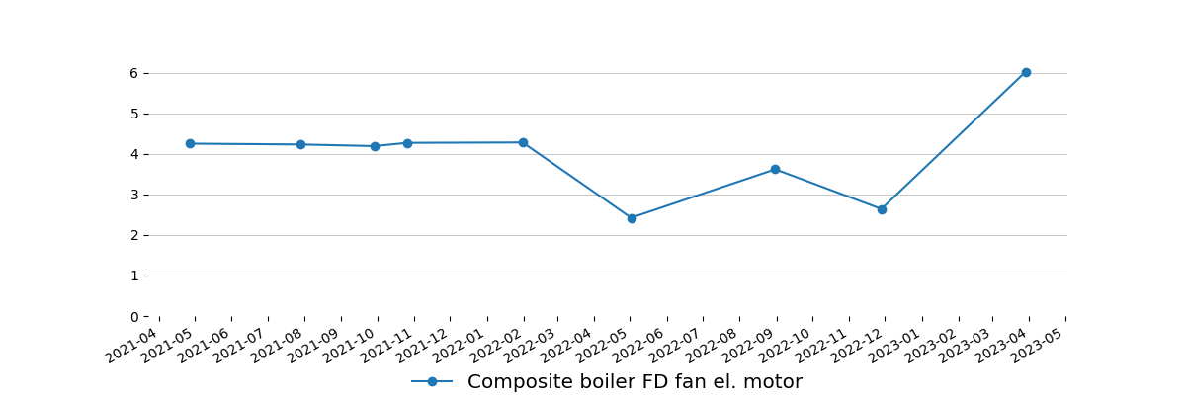
-

Measurement equipment:
Technical data
Maker: | Info Marine
Type: | MarVib DC750
Serial number: | 7506584
Measuring range: | 2Hz-30kHz / RPM = 60-20000
Indication error: | ± 0,5%
Equipment is calibrated, certificate for verification - if required.

Ship type:  Oil Chemical Tanker | Main dimensions:  Length(b.p).......................................228,00 m  Breadth(B.)........................................38,00 m
Sea depth:
Least twice times greater than Vessel draught
Measurement method:
According to standard ISO 10816 : - procedure No. 2 Measurement report

Summary
Next measurements should be done in three month period to obtain trend value for each equipment, in some cases even one month period is preferable.
This report is prepared in good faith based on measurement diagnostic done on available running rotary machine and documentation submitted.

Prepared by: | Approved by:
Service Engineer | Tomasz Chuchra
Nagoor Basha Kalluri | mob: 0048 600052257

