- HOME PAGE PRZED I PO ZALOGOWANIU
- zmiana tekstu i ogólnego wyglądu strony
- usunięcie zakładki ‘how to use e-learning platform’ ze strony https://e-learning.info-marine.com/ (przed zalogowaniem).
WIZUALIZACJA
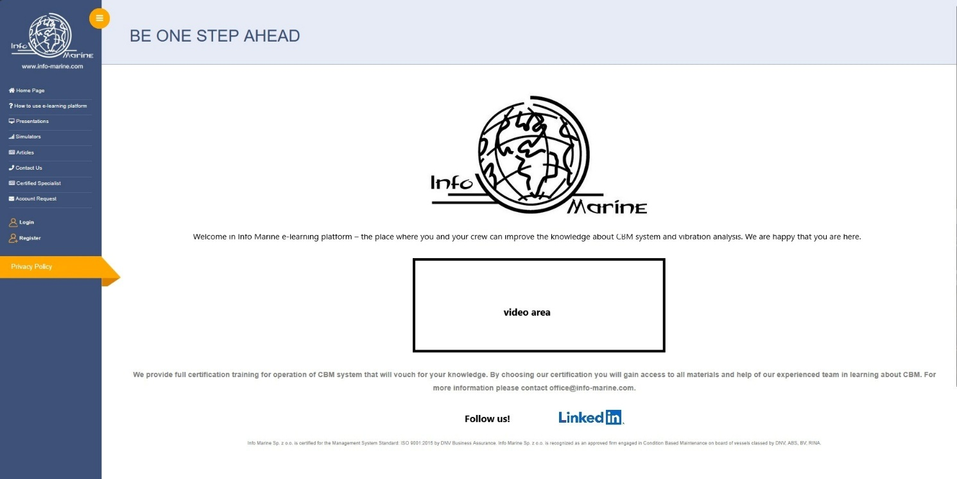

Welcome to the Info Marine e-learning platform – a place where you and your Crew can expand your knowledge of CBM system and vibration analysis. We are pleased to have you here.
[VIDEO – dostępne na google drive: https://drive.google.com/drive/folders/1xr7JIywILAZQoDiGYxSF1s_B40CFWybx
Lub serwerze
\\192.168.8.10\Info Marine\I-M BIURO\D I-M MARKETING MATERIALS\1. I-M SERVICES\A Vibration measurements - equipment /nazwa:20251027_RGD_Video_Info Marine CS_ENG/]

We provide full certification training for operation of CBM system that will vouch for your knowledge. By choosing our certification program, you will gain access to all materials and the support of our experienced team, who will guide you throughout understanding of CBM. For more information please contact e-learning@info-marine.com.

[Follow Us! / linked in (odsyłają do stron po kliknięciu)
 
https://www.info-marine.com/
https://pl.linkedin.com/company/info-marine-technical-diagnostic-center]

Info Marine Sp. z o.o. is certified for the Management System Standard: ISO 9001:2015 by DNV Business Assurance. Info Marine Sp. z o.o. is recognized as an approved firm engaged in Condition Based Maintenance on board of vessels classed by DNV, ABS, BV, RINA.

- OPIS PRZED TESTEM (w takiej formie, że wyświetla się okienku po kliknięciu start test i po kliknięciu start/ok wyświetla się już egzamin)
w zakładce https://e-learning.info-marine.com/test-list

Before you start:
- The test consists of 20 questions.
- Every question has one correct answer.
- Always stay on the test page and within the browser window. Leaving the test page 3 times for more than 20 seconds will immediately end your attempt.
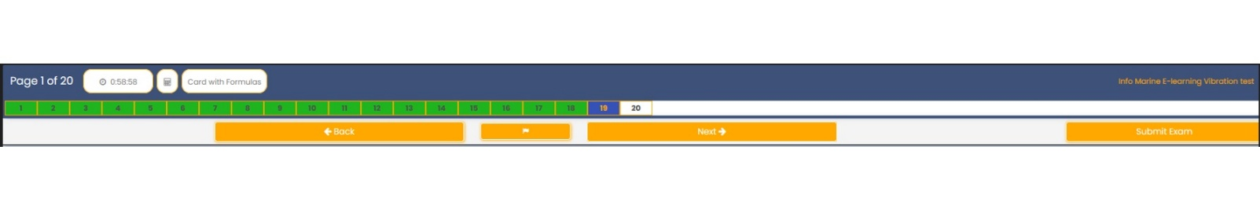
Submit exam button
Navigation button
Flag button
Navigation button
Progress bar
Card with formulas button
Calculator button
Time counter

- The test must be finished within 60 minutes. Time counter is visible on the top left part of the screen throughout the whole time of test progress.
- Two buttons are located next to the time counter. First one opens the calculator, the 2nd opens card with formulas required to solve some questions.
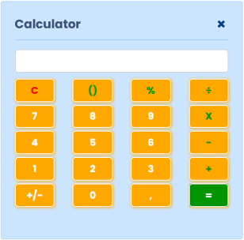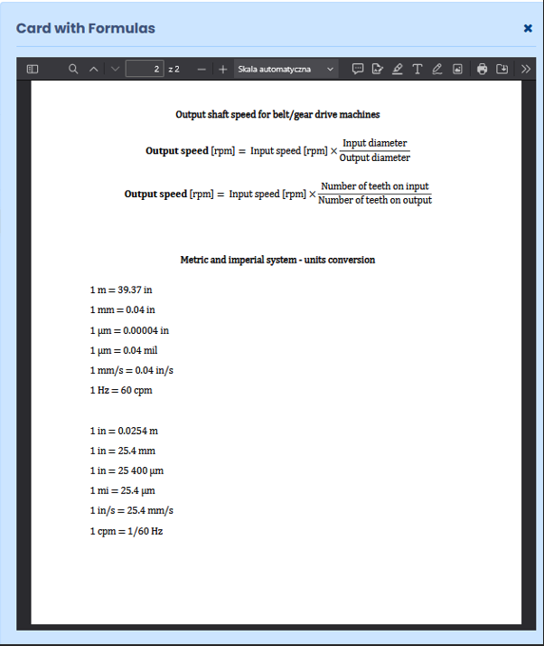
- The progress bar shows the question you are currently answering (highlighted in blue) and the questions you have already answered (marked in green). You can use it to navigate through the test.
- Additional option to navigate through the test is using navigate buttons “Back” and “Next”.
- If an error encounters, it is possible to report the question by using flag button.
- In “Opinion/comment on the question” feel free to leave feedback. Your opinion is important to us.
- Click “Submit exam” if you finish the test in less than 60-minutes limit.
- At the end of the test, you will be asked whether you agree to have your name added to the List of Certified Specialist. Please choose “yes” or “no”. Remember – you can change you decision anytime by writing to us at e-learning@info-marine.com
Good luck!

- PO TEŚCIE
w zakładce https://e-learning.info-marine.com/test-list
Thank you for completing the test.
Your answers have been successfully submitted. The evaluation process may take up to one week.
Please leave your opinion about training program and e-learning platform by clicking this link. [zamiast tego zdania z linkiem pole do wystawienia opinii

