[video]
https://drive.google.com/drive/u/0/folders/1i0h_GpdJKuRkCSRNVpRrWfWqs-cmdGGy?q=sharedwith:public%20parent:1i0h_GpdJKuRkCSRNVpRrWfWqs-cmdGGy

At Info Marine, our goal is to deliver a reliable and effective Condition-Based Maintenance (CBM) system that meets our clients’ expectations. Since vibration measurements are often performed onboard by the crew, we want you to feel like an important part of the CBM process.
By expanding your knowledge of machinery diagnostics, vibration measurements, and maintenance strategies, you will be able to operate the CBM system with greater confidence and contribute to safer and more reliable machinery performance. To support your learning, we created an online e-learning platform where all essential training materials are available in one place.
When visiting the platform, you will find a selection of free materials available to all users, including presentations, simulations, articles, and videos.
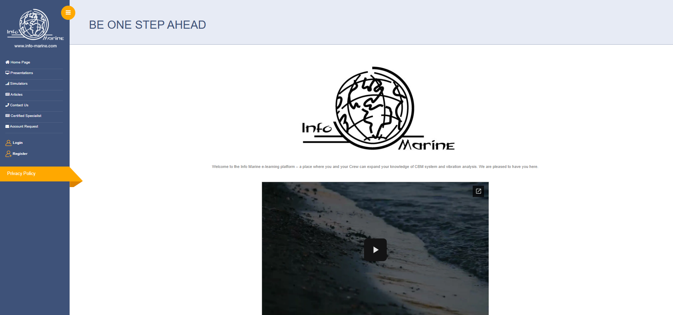
If you have created an account, you can log in to access the full training database, including specially designed training courses that guide you step-by-step through the operation of the CBM system. After successfully completing the training and examination, you will receive a certificate confirming your knowledge of condition monitoring.

We highly recommend logging in to access the complete range of training materials.

To access those materials, , click on the “Login” option.
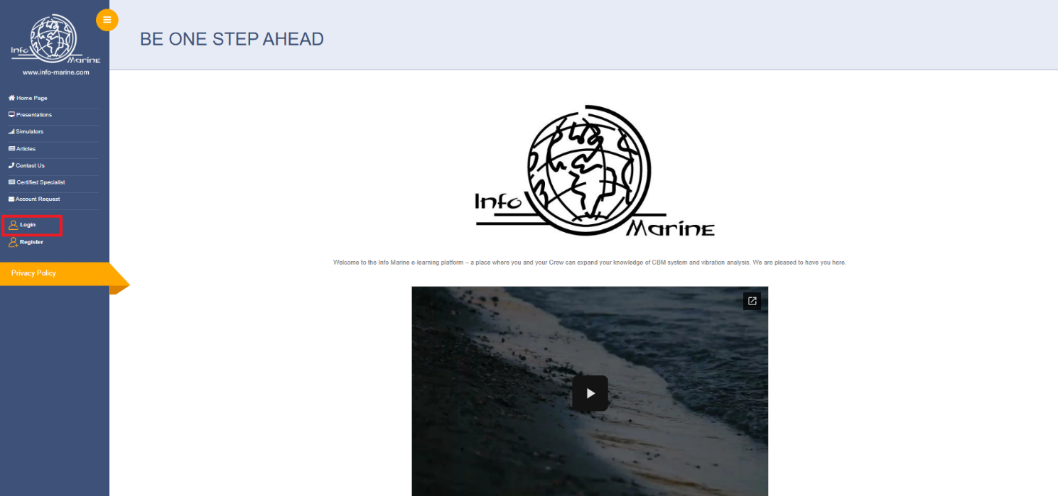
Next, enter your username and password, then select “Sign In”.
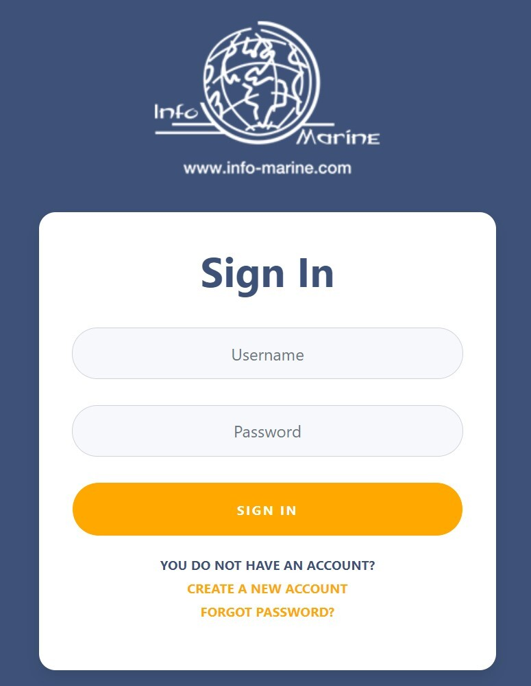
After logging in, you will see the same website interface, but with full access to all training materials.
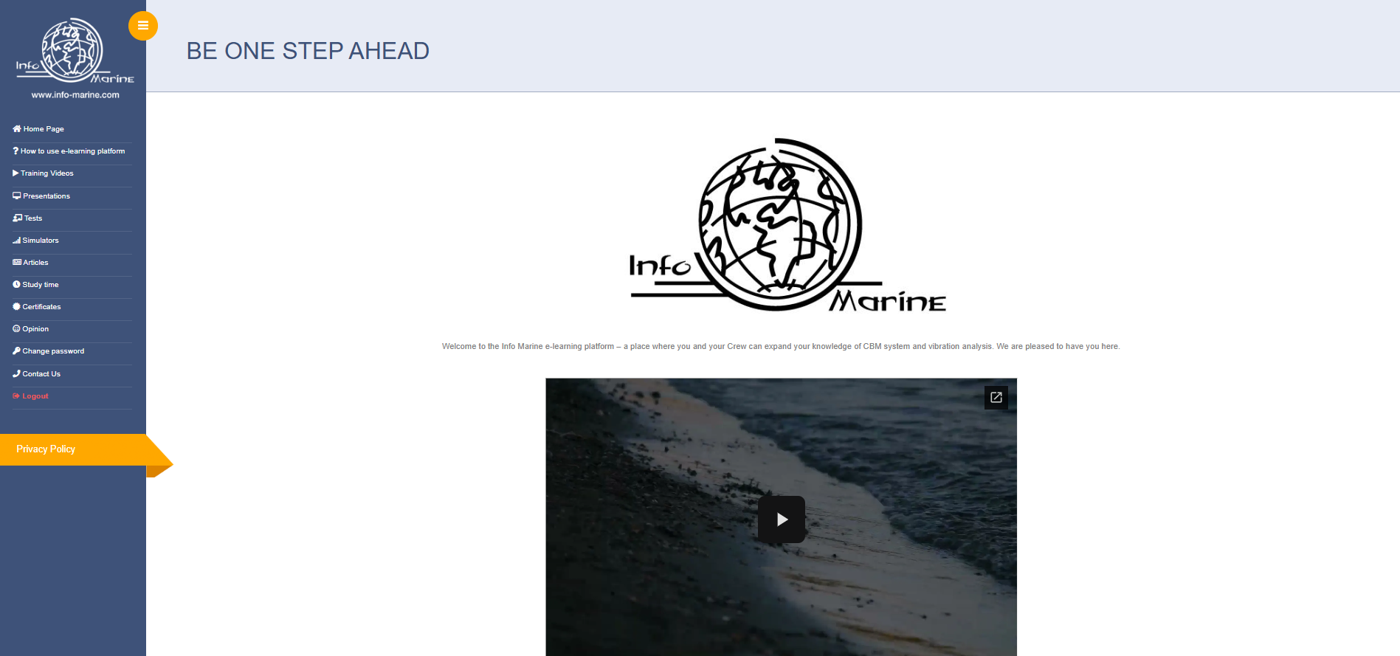
The platform includes:
- Simulators that help you understand FFT spectrum and time waveform analysis, as well as how different graph configurations affect vibration results.
- Articles covering various topics related to condition monitoring.
- Presentations containing training courses with practical and easy-to-understand explanations.
- Training videos demonstrating the operation of the CBM system and the use of our MarVib vibration meter.
Tests that allow you to verify your knowledge and qualify for certification.
To start the test, select the “Test” button.
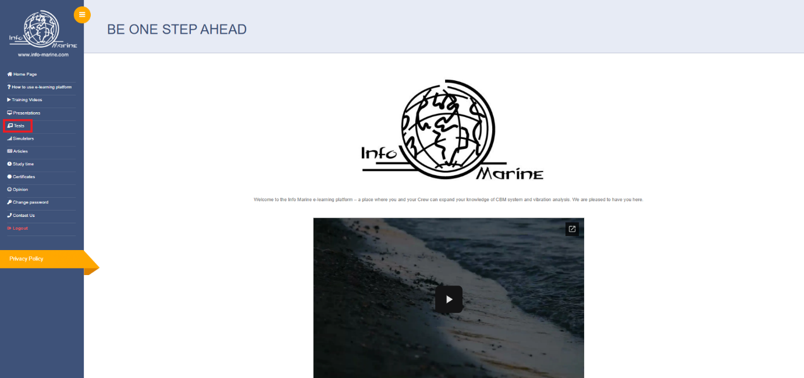
You will then see a list of available tests along with instructions on how to complete the examination process.

Additionally, the e-learning platform allows you to:
- Add information about your experience with condition monitoring systems while creating and account, which may be useful when applying for ISO 18436-2 certification.
- Change your password.
- Track the amount of time spent on training courses, also important for ISO 18436-2 certification requirements.
- Download your available certificates.
- Share your feedback about the e-learning system.
- Contact our team directly with any questions or support requests.
If you have any suggestions or comments about the platform, we encourage you to share them in the Opinion section. All feedback submitted there is completely anonymous.

Thank you for choosing Info Marine, and we wish you a successful learning experience.

