Dynamic Motor Test report 5387BD-2023 | Stanford Bateleur | Date of measurement:  28.08.2023
Owner: Scorpio ship management  Vessel: STI Le Rocher | IMO no:  9645762 | Place of measurement: Iwakuni - Oita

Content List
1. Introduction 2
2. Measurement results 3
2.1. LT CFW pump no1 el. motor 3
2.2. LT CFW pump no3 el. motor 5
2.3. Main air compressor no1 el. motor 7
2.4. Main air compressor no2 el. motor 9
2.5. Main CSW pump no1 el. motor 11
2.6. Main CSW pump no2 el. motor 13
2.7. Main CSW pump no3 el. motor 15
2.8. Main LO no1 pump el. motor 17
2.9. Scrubber CSW pump el. motor 19
3. Summary and Recommendation 21

Introduction

Test subject | Electric motors
Place of measurement | Motors were measured during voyage from Iwakuni to Oita
Preparation for measurement | - All current and voltage connections were made in dedicated cabinets.  - No interruption in operation of electric motor was done.
After measurement | - All connections were disconnected and switchboards were closed.
Measurement and analysis | According to IEEE 1415-2006

Measurement device:

Dynamic Motor Analyzer EXP4000 | SN: 12856
Maker | Megger-Baker
Date of manufacture | 2015

Measurement results

LT CFW pump no1 el. motor
 | Name Plate | Measured
Output Power [hp] | 49.60 | 45.24
Speed [RPM] | 1775 | 1777.31
RMS [V] | 440 | 449.16
RMS [A] | 60.30 | 51.73
pf [p.u.] | N/A | 0.89
Nema Derating [p.u.] | 1.0 | 1.00
Torque [[ft-lb]] | 146.82 | 133.75
Efficiency | N/A | 93.95
Percent Load | N/A | 91.21

Test | Value | Status | Caut. Level | Warn. Level
Voltage Level (Over) [%] | 102.08 | Good | 110.00 | 120.00
Voltage Level (Under) [%] | 102.08 | Good | 95.00 | 90.00
Voltage Unbalance [%] | 0.11 | Good | 2.00 | 3.50
THD [% of fund.] | 0.26 | Good | 7.00 | 9.00
Total Distortion [% of fund.] | 0.45 | Good | 10.00 | 12.00
Current Level [%] | 86.09 | Good | 110.00 | 120.00
Current Unbalance [%] | 0.60 | Good | 10.00 | 20.00
Load [%] | 91.21 | Good | 110.00 | 125.00
Ef. Service Factor [p.u.] | 0.91 | Good | 1.10 | 1.25
Rotor Bar [db] | -55.93 | Good | -45.00 | -36.00
Op. Point [%] | 0.00 | Good | 20.00 | 30.00
Loss Difference [%] | 0.00 | Good | 25.00 | 50.00
Payback [Months] | 0.00 | Good | 60.00 | 24.00

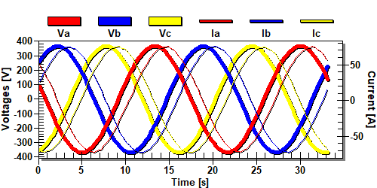
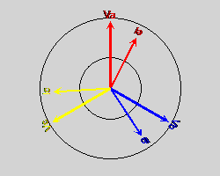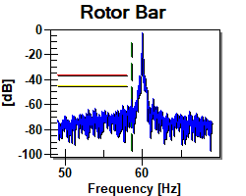
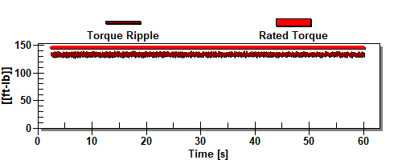

LT CFW pump no3 el. motor
 | Name Plate | Measured
Output Power [hp] | 49.60 | 43.77
Speed [RPM] | 1775 | 1778.72
RMS [V] | 440 | 449.48
RMS [A] | 60.30 | 50.24
pf [p.u.] | N/A | 0.89
Nema Derating [p.u.] | 1.0 | 1.00
Torque [[ft-lb]] | 146.82 | 129.30
Efficiency | N/A | 93.96
Percent Load | N/A | 88.25

Test | Value | Status | Caut. Level | Warn. Level
Voltage Level (Over) [%] | 102.15 | Good | 110.00 | 120.00
Voltage Level (Under) [%] | 102.15 | Good | 95.00 | 90.00
Voltage Unbalance [%] | 0.11 | Good | 2.00 | 3.50
THD [% of fund.] | 0.33 | Good | 7.00 | 9.00
Total Distortion [% of fund.] | 0.43 | Good | 10.00 | 12.00
Current Level [%] | 83.67 | Good | 110.00 | 120.00
Current Unbalance [%] | 0.51 | Good | 10.00 | 20.00
Load [%] | 88.25 | Good | 110.00 | 125.00
Ef. Service Factor [p.u.] | 0.88 | Good | 1.10 | 1.25
Rotor Bar [db] | -47.62 | Good | -45.00 | -36.00
Op. Point [%] | 0.00 | Good | 20.00 | 30.00
Loss Difference [%] | 0.00 | Good | 25.00 | 50.00
Payback [Months] | 0.00 | Good | 60.00 | 24.00

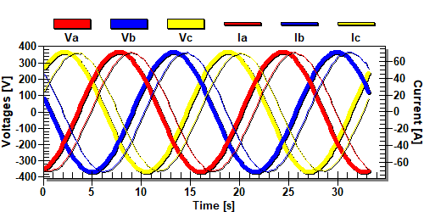
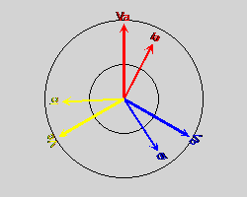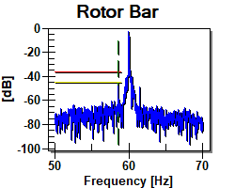
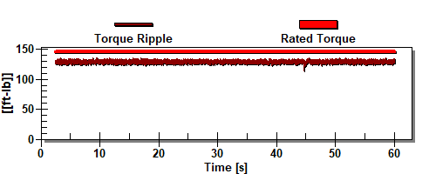

Main air compressor no1 el. motor

 | Name Plate | Measured
Output Power [hp] | 49.60 | 38.75
Speed [RPM] | 1760 | 1779.83
RMS [V] | 440 | 446.59
RMS [A] | 63.00 | 46.84
pf [p.u.] | N/A | 0.85
Nema Derating [p.u.] | 1.0 | 1.00
Torque [[ft-lb]] | 148.07 | 114.39
Efficiency | N/A | 93.96
Percent Load | N/A | 78.12

Test | Value | Status | Caut. Level | Warn. Level
Voltage Level (Over) [%] | 101.50 | Good | 110.00 | 120.00
Voltage Level (Under) [%] | 101.50 | Good | 95.00 | 90.00
Voltage Unbalance [%] | 0.23 | Good | 2.00 | 3.50
THD [% of fund.] | 0.39 | Good | 7.00 | 9.00
Total Distortion [% of fund.] | 0.73 | Good | 10.00 | 12.00
Current Level [%] | 74.82 | Good | 110.00 | 120.00
Current Unbalance [%] | 0.63 | Good | 10.00 | 20.00
Load [%] | 78.12 | Good | 110.00 | 125.00
Ef. Service Factor [p.u.] | 0.78 | Good | 1.10 | 1.25
Rotor Bar [db] | -59.16 | Good | -45.00 | -36.00
Op. Point [%] | 0.00 | Good | 20.00 | 30.00
Loss Difference [%] | 0.00 | Good | 25.00 | 50.00
Payback [Months] | 0.00 | Good | 60.00 | 24.00

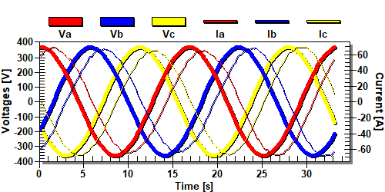
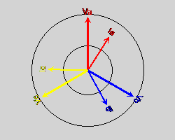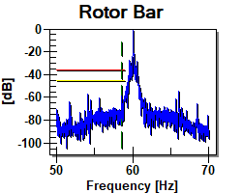
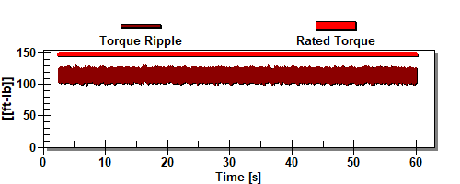

Main air compressor no2 el. motor
 | Name Plate | Measured
Output Power [hp] | 49.60 | 36.74
Speed [RPM] | 1760 | 1781.46
RMS [V] | 440 | 447.50
RMS [A] | 63.00 | 43.88
pf [p.u.] | N/A | 0.86
Nema Derating [p.u.] | 1.0 | 1.00
Torque [[ft-lb]] | 148.07 | 108.37
Efficiency | N/A | 94.24
Percent Load | N/A | 74.08

Test | Value | Status | Caut. Level | Warn. Level
Voltage Level (Over) [%] | 101.70 | Good | 110.00 | 120.00
Voltage Level (Under) [%] | 101.70 | Good | 95.00 | 90.00
Voltage Unbalance [%] | 0.16 | Good | 2.00 | 3.50
THD [% of fund.] | 0.42 | Good | 7.00 | 9.00
Total Distortion [% of fund.] | 0.65 | Good | 10.00 | 12.00
Current Level [%] | 75.55 | Good | 110.00 | 120.00
Current Unbalance [%] | 16.16 | Caution | 10.00 | 20.00
Load [%] | 74.08 | Good | 110.00 | 125.00
Ef. Service Factor [p.u.] | 0.74 | Good | 1.10 | 1.25
Rotor Bar [db] | -50.11 | Good | -45.00 | -36.00
Op. Point [%] | 0.00 | Good | 20.00 | 30.00
Loss Difference [%] | 0.00 | Good | 25.00 | 50.00
Payback [Months] | 0.00 | Good | 60.00 | 24.00

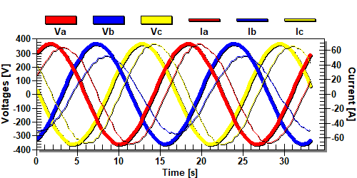
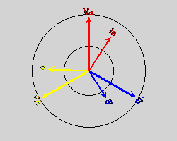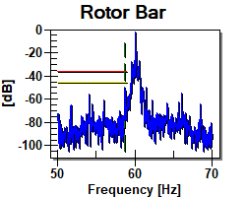
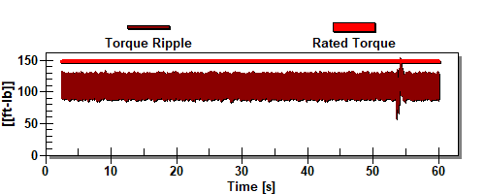

Main CSW pump no1 el. motor
 | Name Plate | Measured
Output Power [hp] | 40.21 | 31.82
Speed [RPM] | 1770 | 1782.62
RMS [V] | 440 | 449.21
RMS [A] | 49.80 | 37.69
pf [p.u.] | N/A | 0.86
Nema Derating [p.u.] | 1.0 | 1.00
Torque [[ft-lb]] | 119.38 | 93.79
Efficiency | N/A | 93.94
Percent Load | N/A | 79.13

Test | Value | Status | Caut. Level | Warn. Level
Voltage Level (Over) [%] | 102.09 | Good | 110.00 | 120.00
Voltage Level (Under) [%] | 102.09 | Good | 95.00 | 90.00
Voltage Unbalance [%] | 0.12 | Good | 2.00 | 3.50
THD [% of fund.] | 0.35 | Good | 7.00 | 9.00
Total Distortion [% of fund.] | 0.46 | Good | 10.00 | 12.00
Current Level [%] | 76.29 | Good | 110.00 | 120.00
Current Unbalance [%] | 0.81 | Good | 10.00 | 20.00
Load [%] | 79.13 | Good | 110.00 | 125.00
Ef. Service Factor [p.u.] | 0.79 | Good | 1.10 | 1.25
Rotor Bar [db] | -63.48 | Good | -45.00 | -36.00
Op. Point [%] | 0.00 | Good | 20.00 | 30.00
Loss Difference [%] | 0.00 | Good | 25.00 | 50.00
Payback [Months] | 0.00 | Good | 60.00 | 24.00

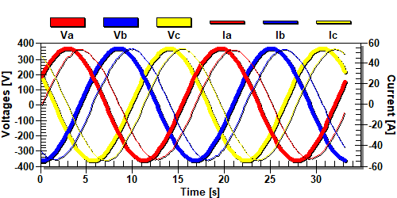
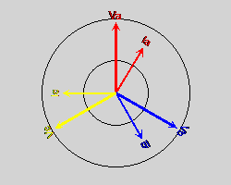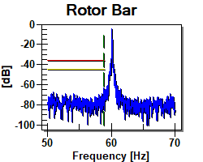
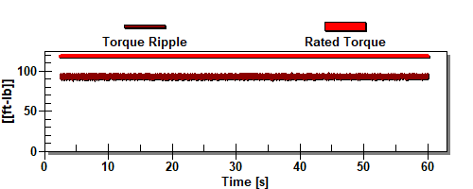

Main CSW pump no2 el. motor
 | Name Plate | Measured
Output Power [hp] | 40.21 | 33.73
Speed [RPM] | 1770 | 1773.93
RMS [V] | 440 | 449.54
RMS [A] | 49.80 | 39.31
pf [p.u.] | N/A | 0.88
Nema Derating [p.u.] | 1.0 | 1.00
Torque [[ft-lb]] | 119.38 | 99.91
Efficiency | N/A | 93.80
Percent Load | N/A | 83.87

Test | Value | Status | Caut. Level | Warn. Level
Voltage Level (Over) [%] | 102.17 | Good | 110.00 | 120.00
Voltage Level (Under) [%] | 102.17 | Good | 95.00 | 90.00
Voltage Unbalance [%] | 0.10 | Good | 2.00 | 3.50
THD [% of fund.] | 0.34 | Good | 7.00 | 9.00
Total Distortion [% of fund.] | 0.45 | Good | 10.00 | 12.00
Current Level [%] | 79.61 | Good | 110.00 | 120.00
Current Unbalance [%] | 0.84 | Good | 10.00 | 20.00
Load [%] | 83.87 | Good | 110.00 | 125.00
Ef. Service Factor [p.u.] | 0.84 | Good | 1.10 | 1.25
Rotor Bar [db] | -63.05 | Good | -45.00 | -36.00
Op. Point [%] | 0.00 | Good | 20.00 | 30.00
Loss Difference [%] | 0.00 | Good | 25.00 | 50.00
Payback [Months] | 0.00 | Good | 60.00 | 24.00

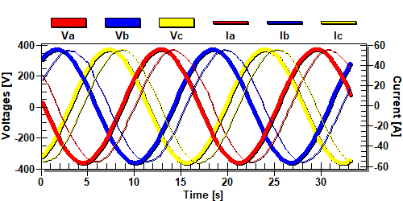
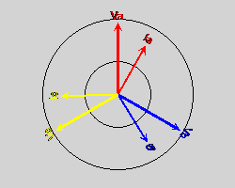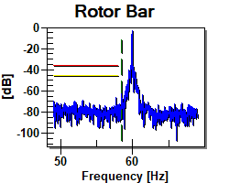
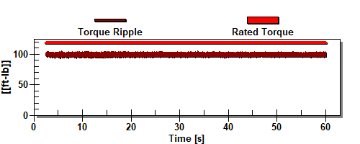

Main CSW pump no3 el. motor
 | Name Plate | Measured
Output Power [hp] | 40.21 | 30.24
Speed [RPM] | 1770 | 1785.90
RMS [V] | 440 | 448.80
RMS [A] | 49.80 | 36.50
pf [p.u.] | N/A | 0.84
Nema Derating [p.u.] | 1.0 | 1.00
Torque [[ft-lb]] | 119.38 | 88.97
Efficiency | N/A | 94.12
Percent Load | N/A | 75.19

Test | Value | Status | Caut. Level | Warn. Level
Voltage Level (Over) [%] | 102.00 | Good | 110.00 | 120.00
Voltage Level (Under) [%] | 102.00 | Good | 95.00 | 90.00
Voltage Unbalance [%] | 0.19 | Good | 2.00 | 3.50
THD [% of fund.] | 0.35 | Good | 7.00 | 9.00
Total Distortion [% of fund.] | 0.69 | Good | 10.00 | 12.00
Current Level [%] | 74.27 | Good | 110.00 | 120.00
Current Unbalance [%] | 1.33 | Good | 10.00 | 20.00
Load [%] | 75.19 | Good | 110.00 | 125.00
Ef. Service Factor [p.u.] | 0.75 | Good | 1.10 | 1.25
Rotor Bar [db] | -51.74 | Good | -45.00 | -36.00
Op. Point [%] | 0.00 | Good | 20.00 | 30.00
Loss Difference [%] | 0.00 | Good | 25.00 | 50.00
Payback [Months] | 0.00 | Good | 60.00 | 24.00

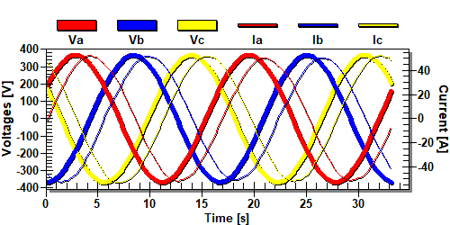
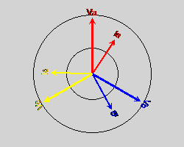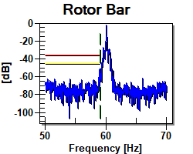
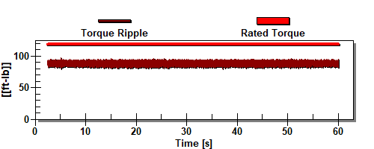

Main LO no1 pump el. motor
 | Name Plate | Measured
Output Power [kW] | 73.73 | 58.67
Speed [RPM] | 1775 | 1784.14
RMS [V] | 440 | 449.23
RMS [A] | 89.00 | 67.70
pf [p.u.] | N/A | 0.88
Nema Derating [p.u.] | 1.0 | 1.00
Torque [[Nm]] | 218.25 | 172.79
Efficiency | N/A | 94.53
Percent Load | N/A | 79.58

Test | Value | Status | Caut. Level | Warn. Level
Voltage Level (Over) [%] | 102.10 | Good | 110.00 | 120.00
Voltage Level (Under) [%] | 102.10 | Good | 95.00 | 90.00
Voltage Unbalance [%] | 0.13 | Good | 2.00 | 3.50
THD [% of fund.] | 0.33 | Good | 7.00 | 9.00
Total Distortion [% of fund.] | 0.43 | Good | 10.00 | 12.00
Current Level [%] | 76.66 | Good | 110.00 | 120.00
Current Unbalance [%] | 1.03 | Good | 10.00 | 20.00
Load [%] | 79.58 | Good | 110.00 | 125.00
Ef. Service Factor [p.u.] | 0.80 | Good | 1.10 | 1.25
Rotor Bar [db] | -56.78 | Good | -45.00 | -36.00
Op. Point [%] | 0.00 | Good | 20.00 | 30.00
Loss Difference [%] | 0.00 | Good | 25.00 | 50.00
Payback [Months] | 0.00 | Good | 60.00 | 24.00

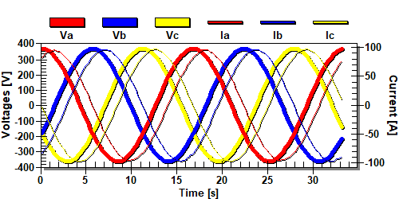
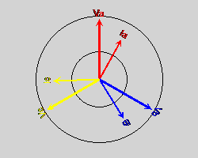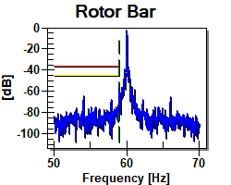
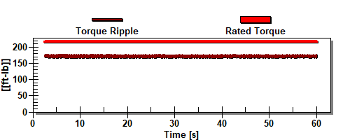

Scrubber CSW pump el. motor
 | Name Plate | Measured
Output Power [kW] | 73.73 | 65.35
Speed [RPM] | 1775 | 1782.07
RMS [V] | 440 | 449.65
RMS [A] | 89.00 | 74.33
pf [p.u.] | N/A | 0.89
Nema Derating [p.u.] | 1.0 | 1.00
Torque [[Nm]] | 218.25 | 192.69
Efficiency | N/A | 94.33
Percent Load | N/A | 88.64

Test | Value | Status | Caut. Level | Warn. Level
Voltage Level (Over) [%] | 102.19 | Good | 110.00 | 120.00
Voltage Level (Under) [%] | 102.19 | Good | 95.00 | 90.00
Voltage Unbalance [%] | 0.09 | Good | 2.00 | 3.50
THD [% of fund.] | 0.36 | Good | 7.00 | 9.00
Total Distortion [% of fund.] | 0.43 | Good | 10.00 | 12.00
Current Level [%] | 83.73 | Good | 110.00 | 120.00
Current Unbalance [%] | 0.29 | Good | 10.00 | 20.00
Load [%] | 88.64 | Good | 110.00 | 125.00
Ef. Service Factor [p.u.] | 0.89 | Good | 1.10 | 1.25
Rotor Bar [db] | -58.53 | Good | -45.00 | -36.00
Op. Point [%] | 0.00 | Good | 20.00 | 30.00
Loss Difference [%] | 0.00 | Good | 25.00 | 50.00
Payback [Months] | 0.00 | Good | 60.00 | 24.00

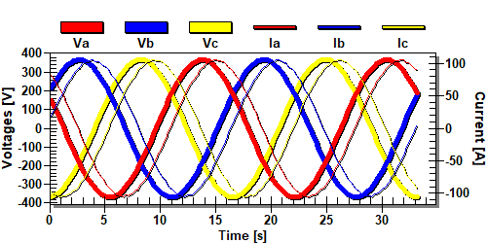
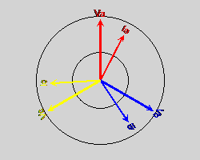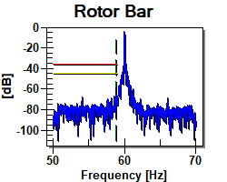
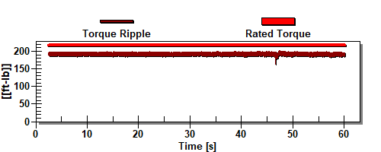

Summary and Recommendation
LT CFW pump no1 el. motor
- Voltage is stable on all phases, unbalance 0.11% at average voltage 449 V;
- Current unbalance is on acceptable level – 0,6 % at average current 51 A;
- Harmonics on acceptable level – 0,26 %,
- Total distortion is on acceptable level: 0,45%;
- No problem with harmonics.
- General device condition: good.
LT CFW pump no3 el. motor
- Voltage is stable on all phases, unbalance 0.11% at average voltage 449 V;
- Current unbalance is on acceptable level – 0,51 % at average current 50 A;
- Harmonics on acceptable level –0,33 %,
- Total distortion is on acceptable level: 0,43%;
- No problem with harmonics.
- General device condition: good.
Main air compressor no1 el. motor
- Voltage is stable on all phases, unbalance 0.23% at average voltage 446 V;
- Current unbalance is on acceptable level – 0,63 % at average current 47 A;
- Harmonics on low level – 0,39 %;
- Total distortion is on acceptable level: 0,73%;
- No problem with harmonics.
- General device condition: good
Main air compressor no2 el. motor
- Voltage is stable on all phases, unbalance 0.16% at average voltage 477 V;
- Current unbalance is too high – 16,16 % at average current 43 A;
- Harmonics on low level – 0,42 %;
- Total distortion is on acceptable level: 0,65%;
- No problem with harmonics.
- High torque ripple
- General device condition: inspection required

Main CSW pump no1 el. motor
- Voltage is stable on all phases, unbalance 0.12% at average voltage 449 V;
- Current unbalance is on acceptable level – 0,81 % at average current 37 A;
- Harmonics on low level – 0,35 %;
- Total distortion is on acceptable level: 0,46 %;
- No problem with harmonics.
- General device condition: good
Main CSW pump no2 el. motor
- Voltage is stable on all phases, unbalance 0.1% at average voltage 449 V;
- Current unbalance is on acceptable level – 0,84 % at average current 39 A;
- Harmonics on low level – 0,34%;
- Total distortion is on acceptable level: 0,45 %;
- No problem with harmonics.
- General device condition: good
Main CSW pump no3 el. motor
- Voltage is stable on all phases, unbalance 0,19% at average voltage 449 V;
- Current unbalance is on acceptable level – 0,69 % at average current 36 A;
- Harmonics on low level – 0,35 %;
- Total distortion is on acceptable level: 0,69%;
- No problem with harmonics.
- General device condition: good
Main LO no1 pump el. motor
- Voltage is stable on all phases, unbalance 0.13% at average voltage 449 V;
- Current unbalance is on acceptable level – 1,3 % at average current 68 A;
- Harmonics on low level – 0,33 %;
- Total distortion is on acceptable level: 0,43 %;
- No problem with harmonics.
- General device condition: good

Scrubber CSW pump el. motor
- Voltage is stable on all phases, unbalance 0.09% at average voltage 450 V;
- Current unbalance is on acceptable level – 0,29% at average current 74 A;
- Harmonics on low level – 0,36 %;
- Total distortion is on acceptable level: 0,43 %;
- No problem with harmonics.
- General device condition: good

All motors are operable except Main air compressor no2 el. motor
Please verify insulation condition in Main air compressor . Insulation static diagnostic is recommended.

Good power supply quality. Source voltage does not contain significant amount of harmonics and frequency is stable.

This report is prepared in good faith based on measurement diagnostic done on available machine and documentation submitted.

Prepared by: | Approved by:
Service Engineer | Mariusz Rosenkranc
Mateusz Prusak | mob: 0048 607345257

