Vibration diagnostic report 6442U-2024
Project: Golfstraum  IMO no: 9390991  Ordered by: Utkilen AS | Date of measurement:  2024-08-17 - 2024-08-25 | Place of measurement:  During normal operation

Measurement condition
Measurements were taken during normal operating condition.

Results presentation
Overall condition of machinery is presented in 4 states, marked with corresponding colours:

 | Normal – Good condition
 | Alert – Remark to machine, but no corrective actions required
 | Critical – Action required
 | No measurements

Machinery condition chart provides visual information about number of machines included in each group along with percent value in relation to all machines from report.

Below the chart there is a table with detailed results for each machine, identified by PMS number and name. If applicable, machinery is separated for driver (el. motor, diesel engine, etc.) and driven unit (pump, compressor, etc.).

The left part of the table contains:
• | dates of last three measurements for machine, presented from oldest to newest. Above date of measurement there is a coloured mark indicating state of machinery: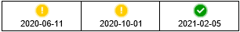
• | trend graph showing measured vibration values (velocity RMS) from last two years. Background is color-coded according to ISO vibration class:  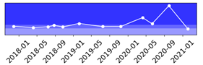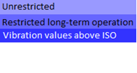

Right part of the table contains remarks and suggestions based on the analysis of vibration signal. This column can be taken as the final conclusion about machine condition. If this cell states “No remarks”, it means that there is no existing problem or defect shown in vibration signal.

Vibration standards
Following standards may applied for assessment:
ISO 10816-3 | Mechanical vibration — Evaluation of machine vibration by measurements on non-rotating parts — Part 3: Industrial machines with nominal power above 15 kW and nominal speeds between 120 r/min and 15 000 r/min when measured in situ
ISO 10816-7 | Mechanical vibration — Evaluation of machine vibration by measurements on non-rotating parts — Part 7: Rotodynamic pumps for industrial applications, including measurements on rotating shafts
ISO 20816-1 | Mechanical vibration — Measurement and evaluation of machine vibration — Part 1: General guidelines
ISO 8528-9 | Reciprocating internal combustion engine driven alternating current generating sets — Part 9: Measurement and evaluation of mechanical vibrations
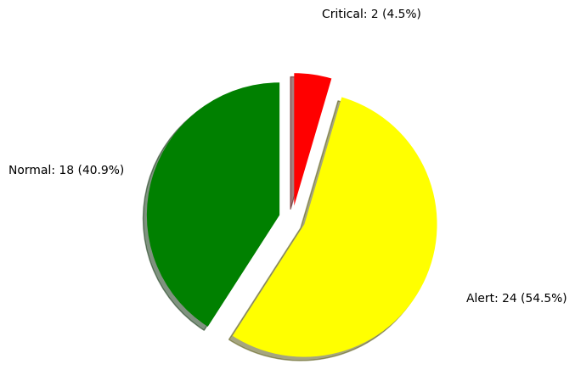
Batch 1
Cargo Heating pumps
PMS: 365.01 | Cargo Heating Pump No.1
2023-05-10 | 2024-06-03 | 2024-08-21 | High signal only in one point and main signal is related with rotational speed of machine. No signs of deterioration. Next measurement should be done according to regular interval.
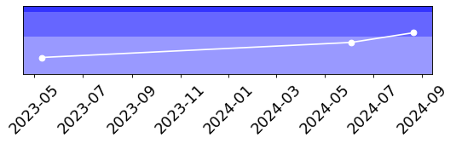
PMS: 365.01.01 | El.Motor Cargo Heating Pump No.1
2023-05-10 | 2024-06-03 | 2024-08-21 | Main signal is related with rotational speed of machine. No signs of deterioration. Next measurement should be done according to regular interval.
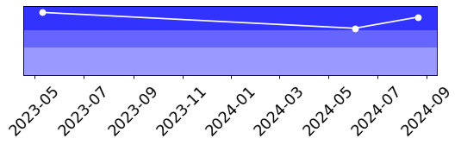
PMS: 365.02 | Cargo Heating Pump No.2
2024-06-03 | 2024-06-30 | 2024-08-21 | High signal only in one point and main signal is related with rotational speed of machine. No signs of deterioration. Next measurement should be done according to regular interval.
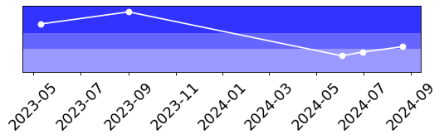
PMS: 365.02.01 | El.Motor Cargo Heating Pump No.2
2024-06-03 | 2024-06-30 | 2024-08-21 | Main signal is related with rotational speed of machine. No signs of deterioration. Next measurement should be done according to regular interval.
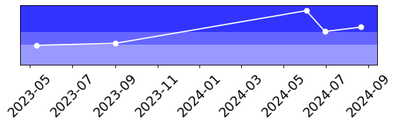
Reduction Gear ME
PMS: 637.01 | Reduction Gear ME
2023-08-26 | 2024-05-26 | 2024-08-18 | High vibration on LO pump and main signal is related with operation of the pump. No signs of deterioration. Next measurement should be done according to regular interval. Please always ensure to include information on suction and delivery pressure of the pump for accurate trend analysis.
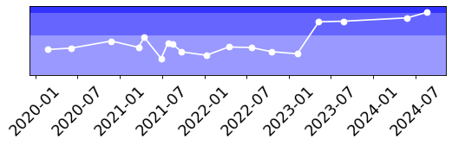
Emergency generator
PMS: 665.01.01 | Emergency Generator
2023-08-26 | 2024-05-25 | 2024-08-21 | No remark
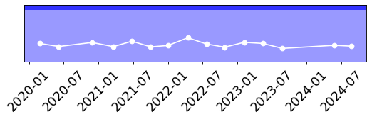
Shaft generator
PMS: 667.01 | Shaft Generator
2023-08-26 | 2024-05-26 | 2024-08-18 | No remark
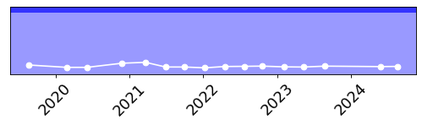
DO transfer pump
PMS: 701.25 | DO Transfer Pump
2023-08-30 | 2024-05-27 | 2024-08-25 | No remark
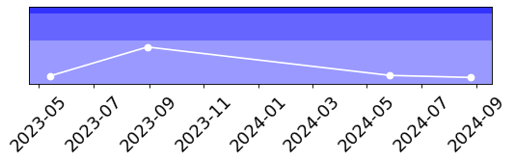
PMS: 701.25.01 | El.Motor DO Transfer Pump
2023-08-30 | 2024-05-27 | 2024-08-25 | No remark
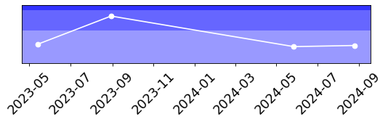
FO separator feed pumps
PMS: 702.01.01 | FO Separator Feed Pump No.1
2023-08-28 | 2024-05-24 | 2024-08-17 | No remark
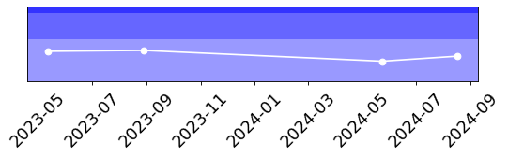
PMS: 702.01.01.01 | El.Motor FO separator feed pump No.1
2023-08-28 | 2024-05-24 | 2024-08-17 | No remark
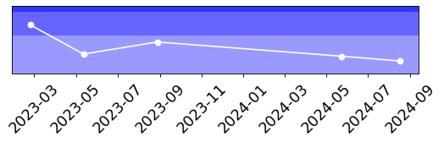
DO separator feed pump
PMS: 702.10 | DO Separator Pump
2023-08-30 | 2024-05-25 | 2024-08-17 | No remark
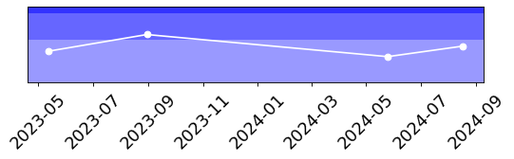
PMS: 702.10.01 | El.Motor DO Separator feed pump
2023-08-30 | 2024-05-25 | 2024-08-17 | High signal only in one point and main signal is related with rotational speed of machine. No signs of deterioration. Next measurement should be done according to regular interval.
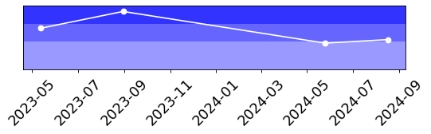
ME FO booster pumps
PMS: 703.03.01 | FO Booster Pump No.1 ME
2023-08-31 | 2024-05-24 | 2024-08-18 | No remark
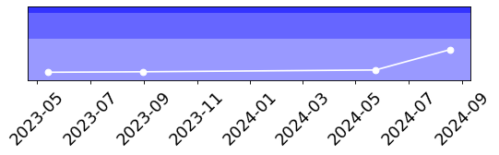
PMS: 703.03.01.01 | El.Motor ME booster pump No.1
2023-08-31 | 2024-05-24 | ERROR | Measurement errors occurred. Next measurement should be done at the first possible opportunity. Including pump.
PMS: 703.03.02 | FO Booster Pump No.2 ME
2023-08-28 | 2024-05-24 | 2024-08-18 | No remark
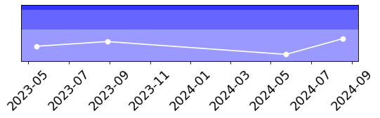
PMS: 703.03.02.01 | El.Motor ME booster pump No.2
2023-08-28 | 2024-05-24 | 2024-08-18 | Increase in envelope signal. Possible signs of bearings wear in FFT spectra. Next measurement should be done up to week 40 to monitor the condition of the bearings. Including pump. Please provide bearing details for the sake of detailed analysis.
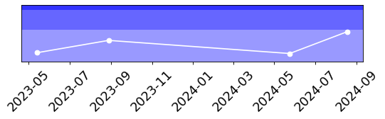
ME FO feed pumps
PMS: 703.04.01 | FO Feed Pump No.1 ME
2023-08-31 | 2024-05-24 | 2024-08-18 | No remark
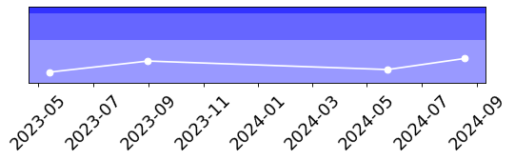
PMS: 703.04.01.01 | El.Motor ME feed pump No.1
2023-08-31 | 2024-05-24 | 2024-08-18 | No remark
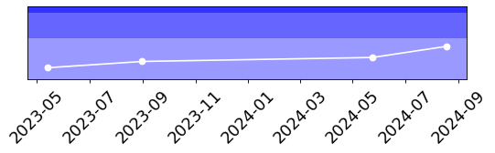
PMS: 703.04.02 | FO Feed Pump No.2 ME
2023-08-28 | 2024-05-24 | 2024-08-18 | Due to some measurement errors occurred the condition of the machine cannot be unequivocally assessed. Next measurement should be repeated at first opportunity.
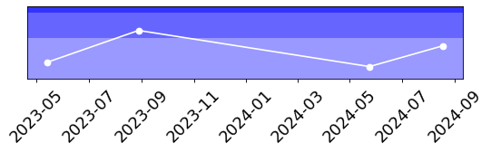
PMS: 703.04.02.01 | El.Motor ME feed pump No.2
2023-08-28 | 2024-05-24 | 2024-08-18 | Main signal is related with environment. No signs of deterioration. Next measurement should be done according to the interval recommended for pump.
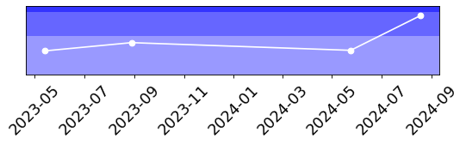
FO boiler pumps
PMS: 703.61.01 | FO Pump No.1 Boiler No.1
2023-08-31 | 2024-05-24 | 2024-08-17 | No remark
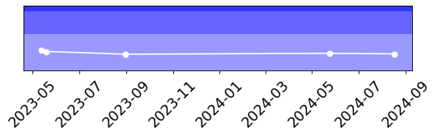
PMS: 703.61.01.01 | El.Motor Boiler FO Pump No.1
2023-08-31 | 2024-05-24 | 2024-08-17 | High signal only in one point and main signal is related with operation of the pump. No signs of deterioration. Next measurement should be done according to regular interval.
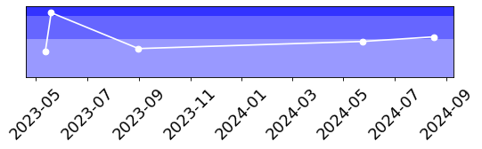
PMS: 703.61.03 | FO Pump No.1 Boiler No.2
2023-08-28 | 2024-05-24 | 2024-08-17 | No remark
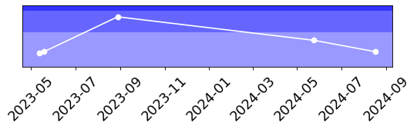
PMS: 703.61.03.01 | El.Motor FO Pump No.1 Boiler No.2
2023-08-28 | 2024-05-24 | 2024-08-17 | Main signal is related with operation of the pump. No signs of deterioration. Next measurement should be done according to regular interval.
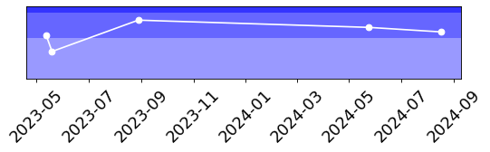
Exhaust water pumps
PMS: 756.06.01 | Exhaust Gas Boiler Circulating Pump No.1
2023-08-31 | 2024-05-24 | 2024-08-17 | No remark
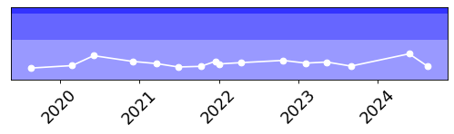
PMS: 756.06.01.01 | El.Motor Exhaust Gas Boiler Circulating Pump No.1
2023-08-31 | 2024-05-24 | 2024-08-17 | Main signal is related with rotational speed of machine. and environment. No signs of deterioration. Next measurement should be done according to regular interval.
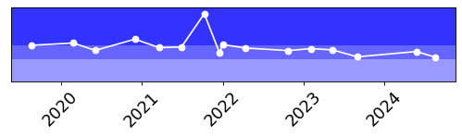
PMS: 756.06.02 | Exhaust Gas Boiler Circulating Pump No.2
2023-08-28 | 2024-05-24 | 2024-08-17 | No remark
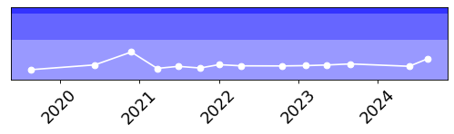
PMS: 756.06.02.01 | El.Motor Exhaust Gas Boiler Circulating Pump No.2
2023-08-28 | 2024-05-24 | 2024-08-17 | Main signal is related with rotational speed of machine. No signs of deterioration. Next measurement should be done according to regular interval.
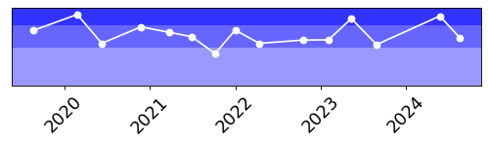
Fire & GS pumps
PMS: 813.01 | Fire/Genaral Service Pump
2023-09-01 | 2024-05-27 | 2024-08-25 | No remark
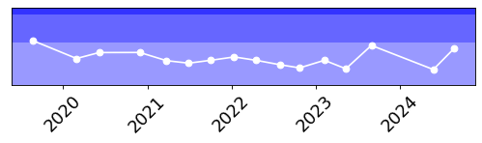
PMS: 813.01.01 | El.Motor Fire/Genaral Service Pump
2023-09-01 | 2024-05-27 | 2024-08-25 | High signal indicates a cavitation problem. Next measurement should be taken by week 42. Including pump. Please provide pump operating parameters.
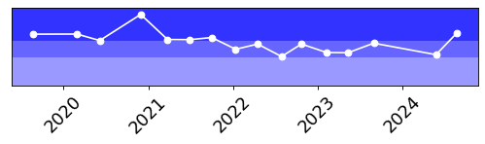
PMS: 813.02 | Fire/Deck Wash/Foam Pump
2023-09-01 | 2024-05-27 | 2024-08-25 | Main signal is related with rotational speed of machine. No signs of deterioration. Next measurement should be done according to regular interval.
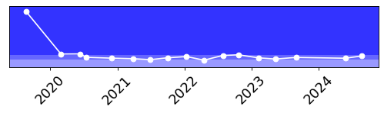
PMS: 813.02.01 | El.Motor Fire/Deck Wash/Foam Pump
2023-09-01 | 2024-05-27 | 2024-08-25 | Main signal is related with rotational speed of machine. No signs of deterioration. Next measurement should be done according to regular interval.
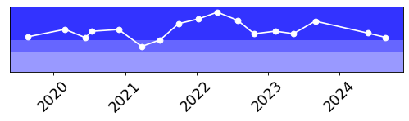
Emergency fire pump
PMS: 813.31 | Emergency Fire Pump
2023-08-26 | 2024-05-25 | 2024-08-25 | Vibration reduced from last reading. Please advise if work recommended in report 6294-2024 was performed:  1. All bolts responsible for stiffness of structure should be checked/retightened.  2. Next measurement should be done after performing work (please send with feedback).
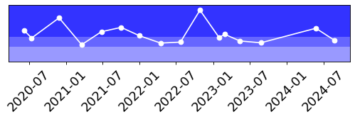
PMS: 813.31.01 | Hydraulic Motor Emergency Fire Pump
2023-08-26 | 2024-05-25 | 2024-08-25 | Vibration reduced from last reading. Please advise if work recommended in report 6294-2024 was performed:  1. All bolts responsible for stiffness of structure should be checked/retightened.  2. Next measurement should be done after performing work (please send with feedback).
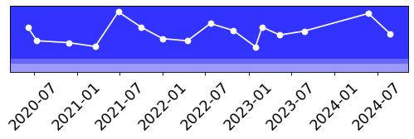
HPP for EM Fire Pump
PMS: 813.31.02.01 | El.Motor Power pack emergency fire pump
2023-08-26 | 2024-05-25 | 2024-08-25 | Main signal is related with flow pulsation. No signs of deterioration. Next measurement should be done according to regular interval.
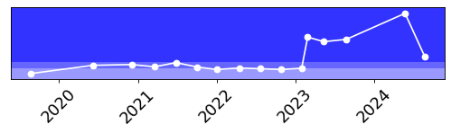
Framo pumps
PMS: 831.03.01 | Hydr. Power Pack No.1
2023-08-31 | 2024-05-28 | ERROR | Measurement errors occurred. Next measurement should be repeated at first opportunity. Including el. motor.
PMS: 831.03.01.01 | El.Motor Hydr. Power Pack No.1
2023-08-31 | 2024-05-28 | 2024-08-18 | No remark
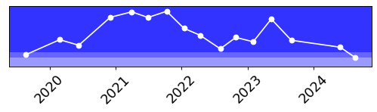
PMS: 831.03.02 | Hydr. Power Pack No.2
2023-08-31 | 2024-05-28 | ERROR | Measurement errors occurred. Next measurement should be repeated at first opportunity.
PMS: 831.03.02.01 | El.Motor Hydr. Power Pack No.2
2023-08-31 | 2024-05-28 | ERROR | Measurement errors occurred. Next measurement should be repeated at first opportunity.
PMS: 831.03.03 | Hydr. Power Pack No.3
2023-08-31 | 2024-05-28 | 2024-08-18 | Main signal comes from flow pulsation. No signs of deterioration. Next measurement should be done according to regular interval.
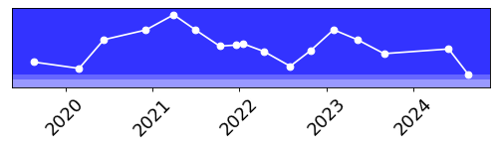
PMS: 831.03.03.01 | El.Motor Hydr. Power Pack No.3
2023-08-31 | 2024-05-28 | 2024-08-18 | Main signal comes from flow pulsation. No signs of deterioration. Next measurement should be done according to regular interval.
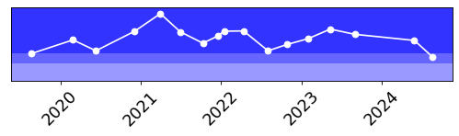
PMS: 831.03.04 | Hydr. Power Pack No.4
2023-08-31 | 2024-05-28 | 2024-08-18 | Main signal comes from flow pulsation. No signs of deterioration. Next measurement should be done according to regular interval.
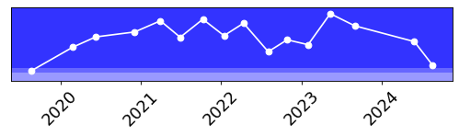
PMS: 831.03.04.01 | El.Motor Hydr. Power Pack No.4
2023-08-31 | 2024-05-28 | 2024-08-18 | Main signal is related with rotational speed of machine. No signs of deterioration. Next measurement should be done according to regular interval.
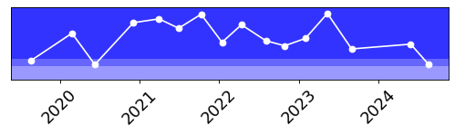
Measurement equipment:
Technical data
Maker: | Info Marine
Type: | MarVib DC750
Serial number: | 7503954
Measuring range: | 2Hz-30kHz / RPM = 60-20000
Indication error: | ± 0,5%
Equipment is calibrated, certificate for verification - if required.

Ship type:  Tanker | Main dimensions:  Length(b.p).......................................129,00 m  Breadth(B.)........................................19,20 m
Sea depth:
Least twice times greater than Vessel draught
Measurement method:
According to standard ISO 10816 : - procedure No. 2 Measurement report

Summary
Next measurements should be done in three month period to obtain trend value for each equipment, in some cases even one month period is preferable.
This report is prepared in good faith based on measurement diagnostic done on available running rotary machine and documentation submitted.

Prepared by: | Approved by:
Service Engineer | Tomasz Chuchra
Nagoor Basha Kalluri | mob: 0048 600052257

