Gdynia data wygenerowania
Created by:
Osoba która generowała

Case study - Confirmation of the validity of our diagnosis

Table of content
Spis treści 2
1. Test report no/Test machine name 3
2. Test report no/Test machine name 7

Test report no/Test machine name ---TUTAJ TYTUŁ ROZDZIAŁU W KOLORZE TŁA (TAK BY BYŁ NIEWIDOCZNY)
Vessel name | TEST VESSEL
Report no | TEST REPORT NO
Machine name | TEST MACHINE NAME

Vibration readings values before performing our recommendation:
Point | RMS velocity  $[\frac{mm}{s}$] | Bearing envelope $[\frac{m}{s^{2}}]$ | Report number | Measurement date | Remarks | Feedback

Vibration readings values after performing our recommendation:
Point | RMS velocity  $[\frac{mm}{s}$] | Bearing envelope $[\frac{m}{s^{2}}]$ | Report number | Measurement date | Remarks | Feedback

Trends:
Velocity RMS:
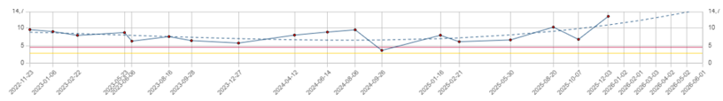
Bearing envelope PK:
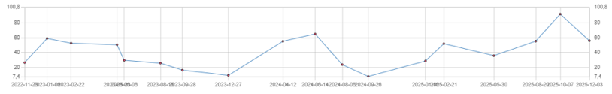

FFT spectra before and after performing our recommendation:
FFT velocity spectra at point wstaw nazwę punktu z najwyższą wartością vel RMS przed wykonaniem pracy
Before performing our recommendatin | After performing our recommendatin
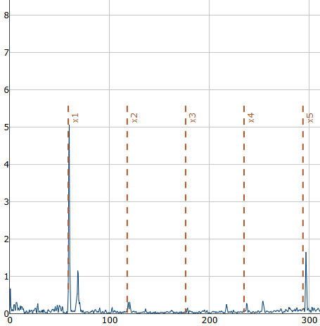 | 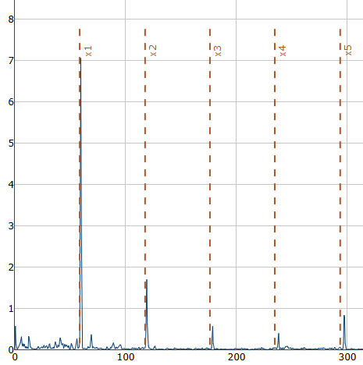
FFT bearing envelope spectra at point wstaw nazwę punktu z najwyższą wartością env PK przed wykonaniem pracy
Before performing our recommendatin | After performing our recommendatin
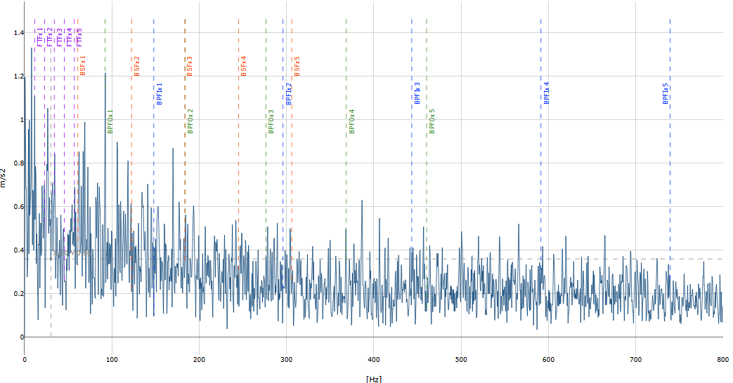 | 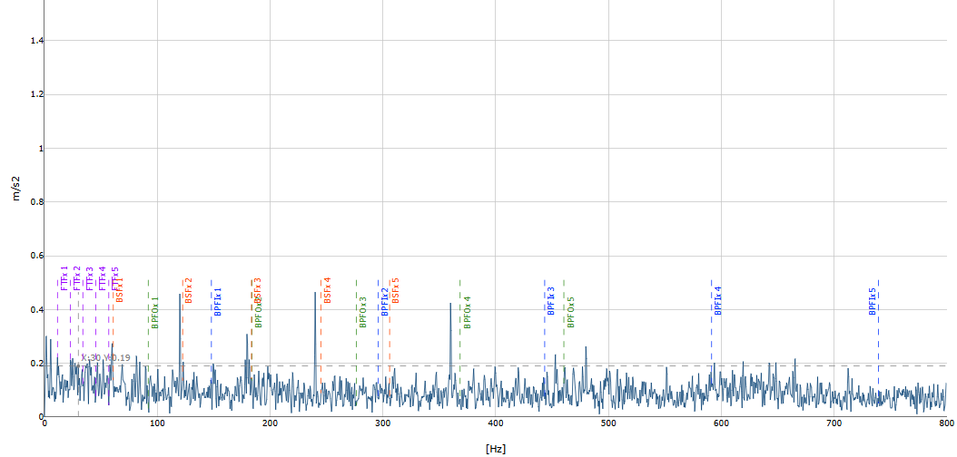

Short comment: (what was visible on the spectra before and after).
IM comments before recommendtaion: IM comments z tego raportu.
IM comments after recommendtaion: IM comments z tego raportu.

Saving costs:
Machine name | kW | Remarks | Work done & engineer observations | Price of work done | Lowest repair price of damage | Highest repair price of damage

Test report no/Test machine name ---TUTAJ TYTUŁ ROZDZIAŁU W KOLORZE TŁA (TAK BY BYŁ NIEWIDOCZNY)
Vessel name | TEST VESSEL
Report no | TEST REPORT NO
Machine name | TEST MACHINE NAME

Vibration readings values before performing our recommendation:
Point | RMS velocity  $[\frac{mm}{s}$] | Bearing envelope $[\frac{m}{s^{2}}]$ | Report number | Measurement date | Remarks | Feedback

Vibration readings values after performing our recommendation:
Point | RMS velocity  $[\frac{mm}{s}$] | Bearing envelope $[\frac{m}{s^{2}}]$ | Report number | Measurement date | Remarks | Feedback

Trend:
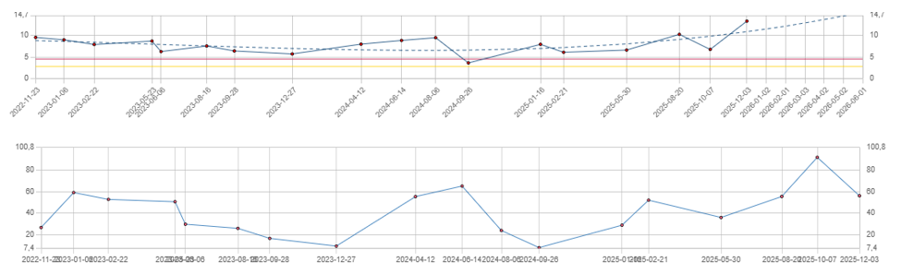

FFT spectra before and after performing our recommendation:
FFT velocity spectra at point wstaw nazwę punktu z najwyższą wartością vel RMS przed wykonaniem pracy
Before performing our recommendatin | After performing our recommendatin
FFT bearing envelope spectra at point wstaw nazwę punktu z najwyższą wartością env PK przed wykonaniem pracy
Before performing our recommendatin | After performing our recommendatin

Short comment: (what was visible on the spectra before and after)

Saving costs:
Machine name | kW | Remarks | Work done & engineer observations | Price of work done | Lowest repair price of damage | Highest repair price of damage

